The Pacorini Case Study: Deliberate and Emergent Strategy
CHAPTER
1
The business model as an interpretative tool for strategic evolution

ALBERTO F. DE TONI, MASSIMO BIOTTO AND LORENZO IOAN

1.1 Theory

1.1.1 APPROACHES FOR STUDYING COMPANIES' STRATEGIES
The field of strategic management is rich with theoretical contributions which, unfortunately, are often difficult to categorise. One reason for this difficulty is the duality between theory and practice and the need to meet the often conflicting expectations of stakeholders who are interested in these subjects (Pettigrew et al., 2002). Second, the field's current stage of development exists in a constantly changing context; contemporary strategic management is only 40 years old, during which time its practitioners have focused on laying down disciplinary foundations and building a reasonably consistent intellectual language in an attempt to establish some basic patterns in what is and is not known about strategic issues (Pettigrew et al., 2002). We can count several models and tools developed by business schools, universities and consulting companies, each of which captures only few strategic issues at a time because competition in business environments has multiple, interrelated facets (Mintzberg et al., 1998). Thus we believe it is only possible to talk about different approaches when interpreting the strategic choices of a company in terms of its own history.
The first aim of this case study is to underline the point that different approaches can be adopted simultaneously when analysing certain firms' strategic moves in a given industry. For example, Porter's (1980, 1985) three generic competitive strategies and Miles and Snow's (1978) four strategic typologies are well-recognised ways of interpreting and classifying companies' strategies. The second purpose of this case study is to propose a new way of interpreting those strategic moves. We call this the business model approach, and we believe it is effective in catching the real drivers of strategic actions when studying companies' evolution over time. We will dedicate the following paragraphs to describing and explaining these approaches. The Pacorini Group's case study will be analysed subsequently.

1.1.2 THREE GENERIC COMPETITIVE STRATEGIES
Generally speaking, we can say that competitive strategies represent a set of guidelines aimed at creating a sustainable competitive position within a certain industry and thus realising a economic superior result, on average, to that of competitors. The fundamental basis of such above-average performance in the long term lies in a company's sustainable competitive advantage. Though a firm can have lots of strengths and weaknesses with respect to its competitors, Porter (1980, 1985) recognises two fundamental types of competitive advantages: low cost and differentiation. These two basic competitive advantages, combined with the variety of activities through which a company seeks to achieve them, lead to three generic competitive strategies that companies may pursue (Porter, 1980, 1985):
- global cost leadership,
- product differentiation,
- focus.
In theory, a company could follow more than one strategy successfully at a time, but this is uncommon because each of these strategies requires a certain level of commitment and organisational effort, without which the chosen strategy would be weakened. Thus, the notion underlying the concept of generic strategies is that competitive advantage is at the heart of every strategy and achieving competitive advantage requires a company to make a set of choices.
Cost leadership is perhaps the clearest of the three generic strategies. When a firm designs, produces and markets a product more efficiently than competitors, it has implemented a cost-leadership strategy (Allen et al., 2006). The cost reduction strategies, mass production and distribution for gaining economies of scale, design for operations, learning curve benefits, and the like (Beheshti, 2004; Freeman, 2003; Mintzberg et al., 1998), along with other factors such as possession of exclusive technologies, preferential access to supply and distribution channels, favourable plant locations and so on, will further help a firm to maintain a low cost base. Generally speaking, there are several sources of cost advantages and they usually depend on an industry's structure (Porter, 1980, 1985). A low-cost producer will typically find and exploit all sources of cost advantage and sell a standard, no-frills product or service. A process that goes against cost minimisation should be outsourced to other organisations to maintain a low cost base (Akan et al. 2006). If a firm can achieve and sustain overall cost leadership, it will be an above-average performer in its industry, meaning that the company earns higher returns at equivalent or lower prices than its competitors (Porter, 1980, 1985). We want to remark here that the cost leader's objective is not necessarily to sell products at lower prices than its rivals but to obtain a favourable cost structure. Lowering prices could be a necessary move to increase sales if clients do not perceive the company's product positively relative to competitors. For relatively standardised products, which offer features acceptable to many customers, the lowest competitive price could be a competitive advantage, helping the company increase its market share (Porter 1979, 1986, 1987; Murray, 1988; Bauer and Colgan, 2001). However, low cost leadership often brings less customer loyalty (Vokurka and Davis, 2004) and relatively low prices may also result in customers' undervaluation of the product's quality (Priem, 2007). Such impressions may enhance a customer's tendency to choose a higher-price product that projects an image of quality. This phenomenon means that a cost leader must not ignore the basis of differentiation, or it risks nullifying the benefits of its favourable cost position (Porter, 1980, 1985). Therefore, a cost leader must achieve proximity in terms of product differentiation relative to its rivals. Parity on the basis of differentiation allows a cost leader to translate its cost advantage directly into higher profits than its competitors (Porter, 1980, 1985).
In a differentiation strategy, a firm seeks to be unique in its, industry along some dimensions that are of great importance to buyers. The company selects one or more attributes of this kind and uniquely positions itself in the industry to better meet buyers' needs. The firm is then rewarded for its uniqueness with a premium price (Porter, 1980, 1985). The means for differentiation are peculiar to each industry. We can count among them product design, brand and image, technology, functional features, after-sales services, delivery systems, marketing and promotion and a wide range of other factors (Porter, 1980, 1985). A firm that can achieve and sustain differentiation will be an above-average performer in its industry if its premium price exceeds the extra costs incurred by being unique. Thus a differentiator must always seek ways of differentiating that lead to a premium price greater than the cost of differentiating. Nonetheless, such a firm cannot ignore its cost position because its premium prices can be nullified by a markedly inferior cost position. A firm must truly be unique in some regard, or be perceived as unique, if it expects to receive a premium price (Porter, 1980, 1985). At the same time, the company has to reach cost proximity relative to its competitors by reducing costs in all areas that do not affect differentiation. The third generic strategy is focus. This strategy is quite different from the prior two because it entails the choice of a narrow competitive scope within an industry. The focuser selects a segment or group of segments within the industry and tailors its strategy towards serving them, to the exclusion of others. By optimising its strategy for the target segments, the focuser seeks to achieve a competitive advantage in its target segments even though it does not possess a competitive advantage overall. The focus strategy has two variants. In cost focus, a firm seeks a cost advantage in its target segment, whereas in differentiation focus, a firm searches for differentiation in its target segment. Both variants of the focus strategy rely on differences between a focuser's target segments and other segments in the industry (Porter, 1980, 1985). Segmentation can be conducted according to client behaviours, product or geographical area. Cost focus exploits differences in cost behaviour in some segments, whereas differentiation focus exploits the special needs of buyers in certain niches. Such differences imply that these segments are poorly served by broadly targeted competitors who serve them at the same time that they serve others. Table 1.1 summarises these three generic competitive strategies.
Table 1.1 Three generic strategies
 |  | Competitive advantage
 |  | Lower Cost | Differentiation
Competitive scope | Broad target | 1. Cost leadership | 1. Differentiation
Competitive scope | Narrow target | 3. Focus
Competitive scope | Narrow target | A. Cost focus | B. Differentiation focus

The three generic strategies are alternative approaches to dealing with competitive forces. If a firm attempts to achieve advantages on all fronts, it may achieve no advantage at all. For this reason, Porter (1980) argued that to be successful over the long term, a firm must select only one of these three generic strategies. Otherwise, firms that adopt more than one generic strategy will be 'stuck in the middle' and will not achieve a competitive advantage. A firm that is stuck in the middle will compete at a disadvantage because the cost leader, differentiators, or focusers will be better positioned to compete in any segment. Nevertheless, a stuck-in-the-middle company may earn attractive profits if the structure of its industry is highly favourable, or if it is lucky enough to compete with other stuck-in-the-middle companies. Nevertheless, Porter argued that firms able to succeed at multiple strategies often do so by creating separate business units for each strategy.
However, several commentators (Miller, 1992; Baden-Fuller and Stopford, 1992) have questioned the use of generic strategies, claiming they lack specificity and flexibility: a single generic strategy is not always the best one because customers often seek multiple dimensions of satisfaction within the same product, such as a combination of quality, style, convenience and price. Strategic specialisation may leave serious gaps or weaknesses in product offerings, ignore important customer needs or be easy for competitors to counter or imitate; in the end, this strategy can cause inflexibility and narrow an organisation's vision. In other words, pursuing a unique generic competitive strategy could mean ignoring new opportunities. Therefore, other authors' attention is given to the fact that successful strategies do not always need to follow strictly the three directions indicated by Porter. Instead, strategies may also be a mixture of choices that do not necessarily focus on a single competitive advantage but, on the contrary, enhance a set of unique skills and capabilities, avoiding the risk of losing resiliency and adaptability that goes along with concentrating on a single strength.

1.1.3 FOUR STRATEGIC TYPOLOGIES
Miles and Snow (1978) adopt a different perspective: instead of concentrating on the choice of competitive advantage and the right strategy to achieve it, they noticed that, within a single industry, patterns of behaviours are recurrent. In particular, four main archetypes of organisations are identifiable:
1. defenders
2. prospectors
3. analysers, and
4. reactors.
Defenders are organisations that have narrow product-market domains and usually do not tend to search outside of those domains for new opportunities. Because of this narrow focus, these organisations seldom need to make major adjustments in their technology, structure or methods of operation. In contrast, they primarily devote their attention to improving the efficiency of their existing operations (Miles and Snow, 1978). Thus defenders typically direct their products or services to a limited segment of the total potential market, and the segment chosen is frequently one of the healthiest of the entire market. By building strong and stable relationships with their clients, these companies are able to stabilise their operations with increasing efficiency. Consequently, defenders do well in competing based on either price or quality. Prospectors are organisations that almost continually search for market opportunities, and they constantly experiment with potential responses to emerging environmental trends. Thus these companies are often the creators of change and uncertainty to which their competitors must respond. For these types of organisations, maintaining a reputation as an innovator in product and market development may be as important as, and perhaps even more important than, high profitability. In contrast, due to their strong concern for product and market innovation, these firms usually do not show high levels of efficiency (Miles and Snow, 1978). The prospectors' domain is generally broad and in a constant state of development: the systematic addition of new products or markets, frequently combined with retrenchment in other parts of the domain, requires that these companies be flexible and adaptive. Analysers are organisations that operate in two types of product-market domains, one that is relatively stable and the other one changing. In their stable areas, these companies operate routinely and efficiently using formalised structures and processes. In their more turbulent areas, top managers closely observe their competitors to come up with new ideas and then rapidly adopt those that appear to be the most profitable (Miles and Snow, 1978). Thus, the analyser is a unique combination of the prospector and defender types. A true analyser is an organisation that minimises risk while maximising opportunities for profit through an adaptive approach where the key word is balance. The analyser's domain is therefore a mixture of products and markets, some of which are stable and established while others are changing and evolving. With the stable portion of its domain reasonably well protected, the analyser is free to imitate the best of the products and markets developed by prospectors. This practice is successfully achieved through extensive marketing surveillance mechanisms. Whereas the prospector is a creator of change in the industry, the analyser is an avid follower, aiming to exploit the most promising innovations without carrying the costs of extensive research and development (Miles and Snow, 1978).
Reactors are organisations in which top managers frequently perceive change and uncertainty occurring in their organisational environments but are unable to respond effectively. Because this type of organisation lacks a consistent strategy—structure relationship, it seldom makes adjustments of any sort until forced to do so by environmental pressures. A reactor exhibits a pattern of adjustment to its environment that is both inconsistent and unstable; this type of organisation lacks a set of response mechanisms that can be put into effect consistently when facing a changing environment. Consequently, reactors exist in a state of almost perpetual instability. Typically, their strategy arises when one of the three typologies mentioned above is improperly pursued (Miles et al., 1988). The reasons behind this attitude may be a lack of a clear and articulated strategy in the top management's mind, lack of fit between strategy and organisational structure and processes, aversion to change and a tendency to maintain the status quo. We say that reactors have no real strategy, apart from putting in place strategic choices solely in response to external pressures. According to Hambrick (1983, 1984), this typology suffers from the limitation of being a post hoc explanation of behaviour in a sample of firms; thus, the predictive and normative power of this typology is viewed critically.

1.1.4 THE BUSINESS MODEL APPROACH
The business model approach is a new perspective arising from a wide variety of areas, including e-business, strategy, technology and information systems. Good business for organisations is defined by a business model, the environment in which the business is run and the ability of the organisation to react to its changes (Deshmukh, 2000). Shafer et al. (2005) observe that while it has become fashionable to discuss business models, there is no widely adopted definition of the term. Rappa (2003), Afuah and Tucci (2001), Turban et al. (2002) and Gordijn et al. (2000) treat business models as `methods' that help organisations run their business. Timmers (1999) and DubossonTorbay et al. (2002) treat business models as 'architecture', while Krishnamurthy (2003) proves 'that business model is a path towards organisation's profitability'. It is clear that no single definition of the business model will satisfy every reader, but it is equally clear that people with a wide range of backgrounds are interested in the approach. According to Shafer et al. (2005), the business model concept can be understood according to four main topics: (1) strategic choices, (2) the value network, (3) creating value and (4) capturing value. Thus, the following definition is proposed: 'A business model is a representation of a firm's underlying core logic and strategic choices for creating and capturing value within a value network'. Osterwalder (2004) proposed a slightly broader definition:
A business model is a conceptual tool that contains a set of elements and their relationships and allows expressing the business logic of a specific firm. It is a description of the value a company offers to one or several segments of customers and of the architecture of the firm and its network ofpartners for creating, marketing, and delivering this value and relationship capital, to generate profitable and sustainable revenue streams.
Several authors (see Mitchel and Coles, 2004; Vlaar et al., 2005; Graf, 2005; Olofsson and Farr, 2006) state that a business model is the combination of the Who, What, When, Why, Where, To Whom, How and How much an organisation has committed to in serving its customers and stakeholders. Osterwalder et al. (2005) observed that authors writing about business models can be grouped into three categories:
- Authors who describe the business model concept through general and abstract definitions concluding with the proposal of meta-models;
- Authors who propose a taxonomy of abstract business models where each type, though general, describes a set of real businesses with common characteristics; and
- Authors who describe specific aspects of a particular real business model.
We believe that the adoption of a bottom-up perspective consisting of three steps is most suitable for capturing the essence of the business model concept:
- description of the company's way of doing business;
- interpretation through the proposal of a business model; and
- conceptualisation of a meta-model from different but similar business models. This conceptualisation process is expressed in Figure 1.1.

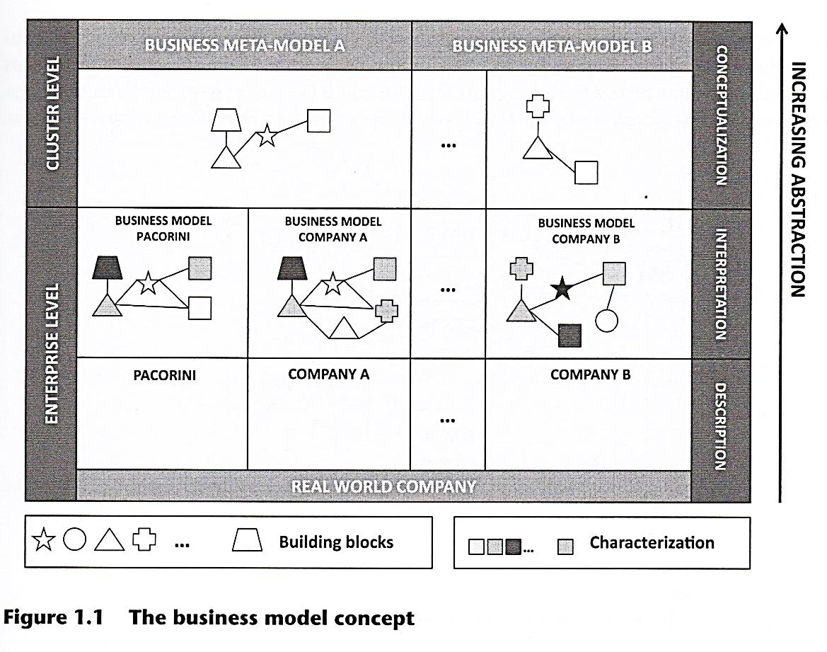
Starting from the bottom of the figure, what we encounter are a set of real-world companies, each one with its own particular way of running a business. A description of the activities taken by each company is the first step toward the interpretation stage. At this step, all procedures are interpreted and grouped together by some appropriate criteria to form the so-called building blocks of the business model. These constitute its main elements, or cornerstones. Once a business model is proposed for each company, a comparison among them can lead to the conceptualisation of a meta-model. The meta-model constitutes a recurrent set of building blocks in the observed sample of firms. Thus, generally speaking, it is possible to suppose that meta-models can be identified at the higher level of abstraction. These models should apply to a wide range of businesses and industries due to their generality. They provide an analytic framework for understanding the core logic that underpins different firms. However, this core logic has its own character for each company. Such peculiarities are captured by the business model of the specific company considered. In its turn, this business model represents an interpretation of the real way a company runs its business. Several authors (Morris et al., 2005; Chesbrough and Rosenbloom, 2002) state that the business model concept is useful because helps to identify the firm's value proposition and competitive strategy. In our study, we conceive the business model as a tool for analysing a firm's strategy. In this sense, we define the business model as the picture at time t_{o} of the way the firm is doing its business. Thus it is possible to state that the actual firm's business model is the outcome of the strategic choices made in each company's area up to that time. In this sense, the business model concept is useful in analysing and interpreting a firm's strategic evolution. Taking pictures at different points in time and comparing them is useful for understanding the historical sequence of strategic choices put in place by the enterprise. The underlying idea of this approach is that, starting from a certain business model at a certain moment in time, the company's strategy can move the firm toward a new and different business model (Figure 1.2).

SC 1
SC 4
BM 2

BM 1
BM 5

SC 2
SC 5
BM 3
SC 6
SC 3
BM 6

SC 7
BM 4

t₀ t₁ t₂ t
BM = Business Model SC = Strategic Choices

Figure 1.2 The business model as outcome of strategic choices

The figure raises also another point: the same business models can be reached through different paths. This point may sound counterintuitive with respect to strategic planning. In a typical linear and rational fashion, we implement strategies SC2 and SC6 to reach BM5; the awareness that implementing completely different strategies, say, SC3 and SC7, can also lead us to BM5 seems incorrect. Mintzberg (1978) and Mintzberg and Waters (1985) help us in understanding and resolving this dilemma through their distinctions between emergent, deliberate and realised strategy (Figure 1.3).
The intended strategy includes all choices that aim at realising the company's vision. However, not all of these choices are really put into place, thus the deliberate strategy represents the set of strategic choices as planned by the intended strategy, minus those choices that are not realised. Nonetheless, the realised strategy also includes those choices that have not been planned but emerge in a bottom-up fashion. The realised strategy can be considered as a vector resulting from two components: a deliberate strategy and an emergent one. The latter accounts for all the external influences that affect the planned strategic trajectory and cause the company to deviate from it. What we claim here is that the business model approach is the best candidate for capturing this component of strategy, which is usually missing from analyses that adopt Porter's or Miles and Snow's strategic typologies. Figure 1.4 clearly shows how the business model approach accomplishes this task.
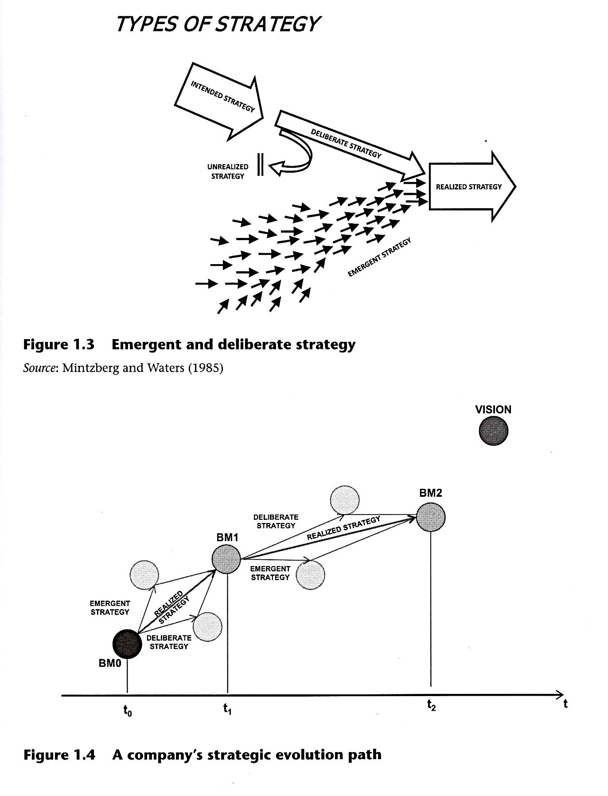

1.2 The Case Study

1.2.1 COMPANY PROFILE
The Pacorini Group is one of the biggest Italian groups operating today in the global markets of shipping, transportation, warehousing and handling of commodities, management of port terminals and industrial processing. Pacorini is a well-recognised international company with nearly 500 employees and consolidated revenues of about €160,000,000, 66 per cent of which was generated in Italy and 44 per cent abroad.
Through all its subsidiaries, it is present in three continents, fourteen countries and twenty-four locations around the world. The B. Pacorini S.r.l. holding currently operates in four different businesses: green coffee, non-ferrous metals, freight forwarding and general warehousing. The first two are considered strategic by the company and therefore represent the core businesses, generating nearly 60 per cent of revenue. This case study will focus on the green coffee and non-ferrous metals activities: however, the two other businesses are also important, and they show a significant synergy with the core ones, which are mostly characterised by the uniqueness of the service offered and a strong and focused customer orientation.
In the green coffee business, logistic services combined with value-adding industrial operations for the processing of green coffee led Pacorini to become the first logistic operator in Italy and the world. In the non-ferrous metals business, Pacorini has achieved a remarkable position in the logistics services industry, becoming the leader in the Mediterranean area and expanding its presence in northern European, North American and Asian markets.

1.2.2 COMPANY HISTORY
Our aim here is to give a rapid overview of the history and evolution of Pacorini, which is closely tied to the history of Pacorini family. The company was founded in 1933 in Trieste by Bruno Pacorini, a former employee of a small forwarding firm. The 1930s were a dark period in the history of the city: after its annexation by Italy, Trieste moved from being the most important port in the Hapsburg Empire to just one of many Italian port cities. Nonetheless, the main and real strength of the port of Trieste was (and still is) its status as a Free Port, which assures significant tax incentives for any imported goods by deferring VAT or duty payments up to 180 days from the date of import. In this context, the family-run business started to grow as a forwarding company for colonial goods (including cotton, dried fruit, coffee, natural rubber, citruses and wood).
Unfortunately, the following years proved to be very restrictive for entrepreneurial activities when the outbreak of the Second World War threw Europe into a six-year period of economic downturn. The situation in Trieste became even more dramatic when, at the end of the war, the surrounding territory was divided into two areas, one under the control of the Allies and the other under the Yugoslavian government. In 1954 Trieste was again annexed to Italy. Despite the fact that opportunities for development had been poor during the post-war period, Pacorini experienced a period of moderate growth in which it tried to strengthen its forwarding activities of handling and warehousing operations.
The 1960s represented the first turning point in Pacorini history: at that time, the founder's sons, Federico and Roberto, joined the company. As often happens, the second generation brought with them the enthusiasm and the will to create their own spaces within the organisation, together with new ideas and a new vision for the company. It was in that period that the decision was made to specialise in forwarding commodities, with particular focus on green coffee. The underlying reason for this decision was to offer a more focused service to the customer instead of sticking to traditional, general forwarding activities without adding value for the client. Nevertheless, in that decade the majority of operations continued to be based on traditional dock activities such as conventional ship unloading/loading for coffee, fruits and natural rubber. During this time Pacorini came to understand the importance of directly managing private warehouses and structures in order to offer an effectively customised service to its clients and to increase its operational efficiency. In fact, working in a public shed meant offering dock services identical to those of competitors, without the possibility of differentiating services. In 1971 Pacorini stipulated a long-term lease with the Port Authority of Trieste, an event that marked the beginning of a virtuous circle for the company. In the following years, Pacorini increased its investments and continued to lease docks and warehouses, also innovating the handling of coffee bags through the use of pallets, allowing faster handling and cost reductions.
In the 1970s, another event changed the operating logic of the company: the salvaging of coffee lots shipped in a break bulk vessel. After suffering water damage, almost an entire shipment of coffee was considered as irrecoverable. Pacorini wondered if it would be possible to recover part of the cargo, and so the company tried to dry the coffee. The results were encouraging and triggered a change in the company. After other experiments with cleaning and other value-adding operations, Pacorini started changing its business model from that of a pure logistics operator to a logistics and industrial model.
The choice to invest in infrastructure in the port of Trieste strongly affected Pacorini's business portfolio. Availability of warehouses, professionalism and Free Port advantages allowed Pacorini to make contact with the international trading world. Furthermore, at that time, trading houses were more numerous than today, and they traded in a larger number of products and commodities. It was during those years that Pacorini started widening its portfolio and working with non-ferrous metals. The company immediately found that the new business was synergic with that of green coffee — most of the operations, such as warehousing activities and relations with international traders, were quite similar. Pacorini decided to enter this new business and shifted its focus from being a simple international forwarder to becoming a logistics operator specialising in warehousing activities for green coffee and non-ferrous metals.
The decision and opportunity to specialise in non-ferrous metals coincided with the loss of two other businesses that had played an important role in the past; dried fruit and natural rubber disappeared from the port of Trieste and, as a consequence, from the Pacorini portfolio. The company had long been the sole supplier of raisins for all of the biggest Italian producers of panettone (a typical Christmas cake from Milan), such as Motta, Alemagna and Tre Marie (famous brands in Italy), but the amount of raisins processed by the Trieste port was reduced to zero due to the introduction of a innovative process at the port of Ravenna. A new system called Ro-Ro (roll on—roll off) made it possible to unload the freight directly onto rail trucks, eliminating the necessity of handling them through road haulage. Because this service was not offered in Trieste, in the space of one season all traffic of dried fruit, mainly from Turkey and Greece, was diverted to Ravenna.
Something similar happened in the case of the natural rubber business, where the introduction of the container as a means for holding goods completely changed the market. Thanks to each container's 20-ton capacity, rubber producers, mainly Malaysian, were able to offer to their clients, such as Pirelli or Michelin, a Deliver Duty Paid (DDP) service. This service enabled producers to avoid the use of intermediaries like Pacorini for receiving goods, testing product quality and warehousing. With a DDP, producers, or sometimes shipping companies, made agreements directly with clients for delivery to their plants. Avoiding intermediaries was also possible because the product's quality could be easily tested by customers once the goods were received.
In the 1980s, Pacorini strengthened its role in the non-ferrous metal business by obtaining certification by the London Metal Exchange (LME) to issue warrants for goods stored, and in 1991 obtained certification by London International Financial & Options Exchange (LIFFE), the main exchange for robusta coffee. Since then, Pacorini has grown constantly through a process of internationalisation.
The 1990s witnessed the end of the Soviet bloc and consequent access to Eastern European countries' markets. This fact, connected to the possibility of delivering goods better, faster and worldwide, was seen by the company as an opportunity, and the idea of becoming an international logistic operator with subsidiaries in every strategic area of the world began to develop.
However, it was some years before Pacorini could realise a concrete plan of coordinated actions for internationalisation, and the 1990s passed without noticeable strategic decisions. The company saw its competitiveness weakening compared to competitors in northern Europe during this period, due in part to the fall of the Berlin Wall and the progressive opening of Eastern European markets, which facilitated free goods circulation. That event was a turning point for all of the companies gravitating towards the port of Trieste as the city lost its privileged position at the border of the Eastern European countries and became a mere port in a non-relevant location, like the terminal part of the Adriatic sea. In addition, competition became more urgent, and northern European competitors found it necessary to expand their range of action toward the Mediterranean area. At the beginning of 2000, Pacorini decided to establish a delivery point in the port of Vlissingen Flushing (Holland), located at the mouth of the canal that leads to the port of Antwerp. At that time it would have been difficult for the company to settle in Antwerp, the biggest Belgian port, which was already garrisoned by the main European groups. The strategic issue in the choice of Vlissingen was that because it was a smaller port, it was possible to establish a more direct relationship with port authorities and offer terminal operator services at more competitive prices. This choice proved to be a success: it allowed Pacorini to understand the dynamics of the northern Europe area, and secondly, it permitted the company to offer its clients a European global service, providing access to the metals coming from the Baltic. The company was able to control the two main routes typically taken by metals on their way to Europe: the southern one, from the Black Sea through Italy and Spain, and the northern one, from the Baltic through Holland.
Pacorini understood that to become a worldwide leader in its businesses the internationalisation process should be pushed further. It has started opening branches in Europe, America and, since 2004, Asia.

1.2.3 PACORINI AND THE GREEN COFFEE BUSINESS
Green coffee is the commodity that has always been present in the history of Pacorini Group. It is also the product that allows Pacorini to be known and appreciated all over the world. Green coffee is the third most traded commodity in the world, after crude oil and soy beans. Over the years, Pacorini has specialised in the logistics and industrial processing of green coffee, becoming the industry leader with close to 10 per cent of worldwide imported volumes and close to 55 per cent of Italian coffee imports: Italy is the fifth-largest consumer of coffee in the world.
Pacorini is present in Italy (in the ports of Trieste, Genova and Gioia Tauro); in Slovenia (in the port of Koper), in Montenegro (in the port of Bar) and Serbia (in Beograd); in Belgium (in the port of Antwerp) and in the United States (in the port of New Orleans). Furthermore, Pacorini maintains a presence in two of the largest coffee-producing countries, Brazil (in the ports of Vitoria and Varginha) and Vietnam (in the port of Ho Chi Minh).
As we saw earlier, the entry of the two founder's sons into the organisation meant a change in the history of the company: it was then that the decision to specialise in the forwarding of raw materials, with a particular focus on green coffee, was made, a decision that proved to be successful. Until the mid-1990s coffee-producing countries often faced conditions of geopolitical instability and this increased uncertainty forced traders to move coffee towards the consuming countries as soon as possible, because keeping the goods in the country of origin was too risky.
In the 1970s, the focus on green coffee led Pacorini to find new innovative business solutions. The introduction of pallets for storing green coffee bags, the dedicated structure to manage and offer logistic services to clients, investments in human resources and the curiosity to understand this commodity in all its aspects pushed Pacorini to its current level of state-of-the-art services and expertise. Toward the end of the 1980s, Pacorini undertook significant developments; investing in building green coffee silos — Silocaf — in Trieste, with 10,000 tons of storage capacity divided into 147 bins, the ability to receive coffee either in traditional bags or in bulk and to deliver coffee in big bags with capacities ranging from 600 kg to 1 ton. The savings on logistics were significant. Furthermore, the plant was also equipped to run cleaning and upgrading operations (that is, elimination of impurities, colour sorting operations, densimetric tables, washing and steaming), thus creating value-adding services. Pacorini changed the way of conceiving the business model, shifting from offering logistic services for international forwarding, handling, warehousing and delivering of coffee, to more and more industrial services with added value. From this point the company's growth was stronger, gaining market share in Italy and setting up new operations abroad. In 1989, Pacorini opened in the port of Koper in the former Yugoslavia (now Slovenia).
In 1992 Pacorini faced a unique challenge. Having visited the Silocaf plant in Trieste the American multinational corporation Procter & Gamble decided to replicate the concept in the United States. The American MNE decided to outsource the set-up of the project to Pacorini, because Pacorini had the right capabilities to accomplish the task.
Silocaf of New Orleans, Inc. is still one of the largest plants in the world dedicated to the processing of green coffee, with a storage capacity of 40,000 tons, divided into 203 cells, and with an annual coffee volume that represents approximately 30 per cent of the North American coffee market.
In 2000 Pacorini invested in the Port of Vado Ligure (Savona) with a new Silocaf plant, and acquired new traffic that was handled in the north-west of Italy, south of France and north of Africa. This new traffic was the start of a process that seems to entail a shift in the centre of gravity for coffee traffic from the east, Trieste's area, to the west, Genoa/Savona. This new plant has a capacity of 4,200 tons, extendable to 4,800.
The twenty-first century saw an emphasis on globalisation: a key factor in a company's survival is to guarantee a pervasive and distributed presence in key areas of the world. This was clear to Pacorini, who recently embarked upon an explicit and organised internationalisation process. Since 2003, Pacorini has settled in the two biggest coffee production areas of the world: Brazil and Vietnam. Their stable social/political situations and continued development allowed for local investments and the shift of value-adding services, once offered only in the consuming countries, to the producing countries as well. This operation's aim was to offer pre-processing of green coffee before local producers began to offer this additional service and before the market saw a decline stage in Europe. Although neither of these plants gave the expected economic results in the short term, both proved to be of strategic importance: having a presence in key areas in the coffee business will assure Pacorini a high profile with trading companies.

1.2.4 PACORINI AND THE NON-FERROUS METALS BUSINESS
Italy is the second-largest market in Europe for the consumption and processing of metals. Pacorini has always been interested in this kind of commodity, although initially metals were simply another good among many products forwarded by the Italian company.
Pacorini's non-ferrous metals business is present in Italy, Holland, Spain, Montenegro, Serbia, Slovenia, the United States, Brazil, the United Arab Emirates and Australia, the latter giving the holding access to Singapore, Malaysia, South Korea, Thailand and China (Shanghai). Since the 1970s, when relationships with international traders became closer, Pacorini understood that it should be a logistics operator, working for the London Metal Exchange (LME), the world's main exchange for metals. This required Pacorini to make huge investments in improving its warehouses to respect the strict fixed parameters for obtaining LME certification. This process was completed with Pacorini's registration with the LME in 1981. Since then, the Italian company has been authorised to inspect inbound goods, certify their weight and quality, store them in one of its certified warehouses and issue a warrant, which is an official document that gives the holder the right to withdraw the underlying good being held in the company warehouse. Warrants are then traded by Exchanges' brokers. Being an emissary certified by the LME requires Pacorini to maintain an agency in London for issuing and delivering warrants: Pacorini opened a commercial office in London for the British market and thus made its first internationalising move in the non-ferrous metal business. This was a milestone in the evolution of the company's business model: Pacorini changed its mission from being a simple forwarder and warehouse operator for international and national trade to being an international logistics operator also serving the LME.
Shortly thereafter, the company immediately moved toward achieving of a dominant position in Italy. At the time Eastern European raw material producers were big industrial groups controlled by the government with no access to the international market: their sales and financing opportunities were limited and strictly regulated by politics. For these reasons, producers tended to sell their products Ex-Works (EXW) or Delivered at Frontier (DAF), thus exposing the buyer to risks and costs related to transport. Trieste was the first point of access to Western Europe for countries such as the former Yugoslavia, Bulgaria, Romania, Ukraine and Kazakhstan, which were already developed in the realms of metallurgy and non-ferrous metals production. Trieste was the obvious choice for buyers interested in acquiring goods from Eastern Europe who were eager to use an intermediary to avoid the risks of transportation and to compensate for a lack of knowledge of logistics in those countries. Furthermore, trading houses, which already made use of exchange instruments for financing stocks, considered it strategic to keep a point of delivery closer to the Eastern—Western Europe border. Pacorini recognised the need to be present abroad and offer international traders an alternative to the Italian ports of Trieste and Genova. Furthermore, competitors in northern Europe were becoming stronger every year and sound action had to be taken. Pacorini's idea was to present the harbours of southrtn Europe as an alternative entry point to European market and they opened branches in Koper (1989) and Barcelona (1993). Furthermore, according to Sergio Garbin, CEO of Pacorini Metals Italia:

these moves did rather follow a sort of Repubblica Marinara principle, that is to garrison ports, towers and cities for monitoring goods traffics and for offering different alternatives for traders, but always with the aim of protecting the 'headquarters' and the most relevant assets, like terminals, warehouses, and so on.
This was the underlying reason why Pacorini set up those branches: protecting the core business, which was still the Italian market. Garbin adds: 'It was a protectionist vision, likely wrong'.
At that point, the branches' geographical distribution on a global scale became even more of a key factor. Areas specialising in the mining and production of metals are numerous and the operative logic of the LME requires competences, assets and structures to be certified and approved; therefore, the choices of locations and types of facilities are more restricted. Under these circumstances Pacorini, exploiting its distinctiveness as an LME-licensed operator and leveraging a previously established relationship with a local freight forwarding agency (since 1997), opened an LME operation in Dubai (United Arab Emirates) in 2002. This harbour is growing at a fast pace, and the metals market in that area has been experiencing rapid development, particularly due to increasing demand in the internal real estate market, which is in turn due to the increase in tourism. Pacorini's management believes that in the near future Dubai will become a serious competitor with the first one in terms of volumes, Singapore.
At the same time the Italian company decided to open a similar operation in the United States, exploiting structures already implemented for the coffee business. This move permitted Pacorini to discover that the American market was not mature but still required more investments. Specifically, while the European market is usually based on Cost, Insurance and Freight (CIF) deliveries, which imply that the buyer manages the ship and decides where to dock and which terminal to serve, in the US, CIF conditions also include part of the terminal operations. That is, the ship itself decides how the terminal and unloading operations will be controlled, and these services are included in the charter freight. In other words, this means that to operate in the American market, the company's strategy should be changed from a light-asset to a heavy-asset one. Investing in a terminal was the right way to proceed, and Pacorini formed a joint venture with the American logistics company Global Services LLC, acquiring a general cargo terminal in New Orleans and thus obtaining a coastal outlet. This move inspired a new.consideration: it was no longer sufficient to control the loads' traffic by managing shipping companies and terminals. Latin America is the natural supply region for northern America; presence and sales in this region should be integrated with the Pacorini's brand and services diffusion in southern America. For this reason, a subsidiary was started up in Sao Paolo (Brazil) in 2003, widening the non-ferrous metals traffic but also increasing the group's potential in terms of general cargo activities and diversification of its offerings.
By the beginning of the twenty-first century only the Far East market remained excluded from the world areas garrisoned by Pacorini for its non-ferrous metals business. Among the alternatives for entering that market (Shanghai, Singapore and Hong Kong) Pacorini opted to be guided by the LME certified ports map and chose Singapore, starting a 50-50 joint venture with a local logistic company, SembLog, traded on the exchange and part of SembCorp, which in turn is related to a government investment fund. This marriage led Pacorini to spread its brand and services in this new area and to gain access to an established operative network in a market that is not usually easy to enter. After a couple of years this joint venture proved to be successful: Pacorini started to operate in Malaysia and Thailand, then opened a subsidiary in Shanghai and two warehouses in Busan and Uan Yang (South Korea), with a third warehouse soon to be opened in Incheon (South Korea). In 2006, SembCorp was acquired by Toll, an Australian logistics group. This event allowed the Italian company to keep its Far East network intact and, at the same time, to land indirectly in Australia. This new market, which has a well-developed, export-oriented mining industry (particularly for basic products like bauxite and aluminium) as well as an internal market for finished goods in the non-ferrous metal business, gives Pacorini interesting and diverse possibilities for growth.

1.2.5 BUSINESS MODEL EVOLUTION
To analyse Pacorini's business model evolution, we have decided to first determine which events signified points of discontinuity in the company's strategy. We consider these milestones to be the starting points of five different phases in Pacorini's history, as shown in Table 1.2.
According to these considerations, we have represented the business model's evolution over time with respect to these phases. For each phase, we have identified the business model and the two components of Pacorini's realised strategy: deliberate and emergent strategies (see Table 1.3). The next paragraphs will describe the identified business models in more detail.

Table 1.2 Pacorini's strategic milestones
Phase | Point of discontinuity | Realized strategy
From 1930s to 1950s | Foundation of the company | Forwarding company for generic colonial genres
In the 1960s | Entrance of the second generation of entrepreneurs into the organization | Forwarding company specializing in commodities
In the 1970s | Acquisition of a long-term lease from the Port Authority of Trieste for using and managing docks and warehouses | Forwarding and warehousing company
From 1980s to 1990s | Registration at the LME in 1981 and in 990 at LIFFE | Logistics and industrial company  recognized by the LME and LIFFE
In the 2000s | Beginning of a structured process of internationalization | Logistics company operating on a global scale offering terminal services and supply chain integrations

Table 1.3 Pacorini's strategy evolution
 |  | Strategy components
Phase | Business model | Deliberate  strategy (D) | Emergent  strategy (E) | Realized strategy (R)
From 1930s to 1950s | A | Founding a forwarding company in Trieste | Taking advantage of the free-port status of Trieste as incoming point for Far East routes | Forwarding company for generic colonial genres
In the 1960s | B | Choosing to specialize in commodities | Satisfying growing demand of the commodities trade | Forwarding company specializing in commodities
In the 1970s | C | Investments in private warehouses on public shed space Growing focus of attention on green coffee trade | Satisfying growing demand for warehousing services | Forwarding and warehousing company
From 1980s to 1990s | D | Becoming an exchange operator recognized by the London Exchange | Satisfying growing demand for exchange services | Logistics and industrial company recognized by the LME and LIFFE
In the 2000s | E | Opening more subsidiaries abroad Network and terminal control | Ability of the subsidiaries to work on more than one business at the same time | Logistics company operating on a global scale offering terminal services and supply chain integrations

Business model A, accompanying the first phase, is represented in Figure 1.5. In this first scheme, we can see that Pacorini's business model during those years was quite simple and intuitive. The area of business is represented by the forwarding building block, in which we can read the main activities involved. Another building block contains the products commercialised by the Italian company (in this case, just the colonial genres); it represents the main business in which Pacorini competed at that time.

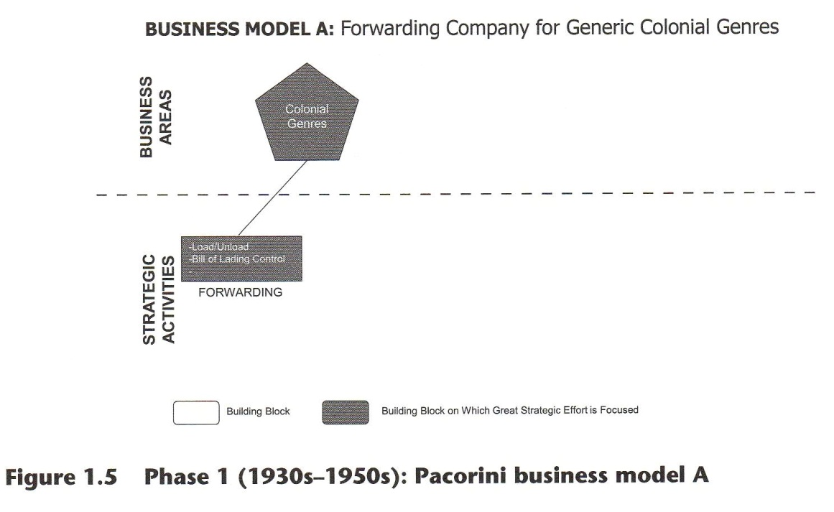

We have seen how new ideas brought into the organisation by the second generation of entrepreneurs caused the company to focus on commodities, which then became strategic products and business opportunities. We could say, according to Porter, that this strategic move was part of a differentiation focus strategy. In this view, though, we will probably miss the point that the company did not actually narrow its portfolio of goods but decided only to invest more and differently in part of its portfolio. That is why Pacorini changed its business model on the emergence of a new building block: commodities. Its emergence means that the company started to consider this market as relevant, giving raw materials a new status with respect to the company's strategic choices (Figure 1.6)
As can be easily understood from the building blocks, the core activity of the company is still freight forwarding, but commodities became important enough to be represented by an independent building block.
In the 1970s, the company changed appreciably. The long-term lease from the Port Authority of Trieste for operating port warehouses allowed Pacorini to develop new technologies for materials handling, such as the use of pallets for bags of green coffee. Adopting Miles and Snow's perspective, we could say that Pacorini let its prospector nature emerge, pursuing innovation with the intent to offer new, customised services to its clients. However, at the same time, Pacorini's strategy could be seen as typical of the defender profile, since focusing on commodities is a way of narrowing market scope. From yet another point of view, Pacorini's strategy could be seen as typifying the analyser profile, but notice that in this case, Pacorini played the role of the leader instead of the follower. Again, the business model approach harnesses the complexity of strategic choices by underlining the appearance in the company's business model of a new building block with its own strategic importance (Figure 1.7). Furthermore, we want to point out that this change was due to a casual event (the damaged coffee load) and not to a formalised and planned strategy. This emergent component of strategy could not be understood in terms of either Porter's generic competitive strategies or Miles and Snow's typology.

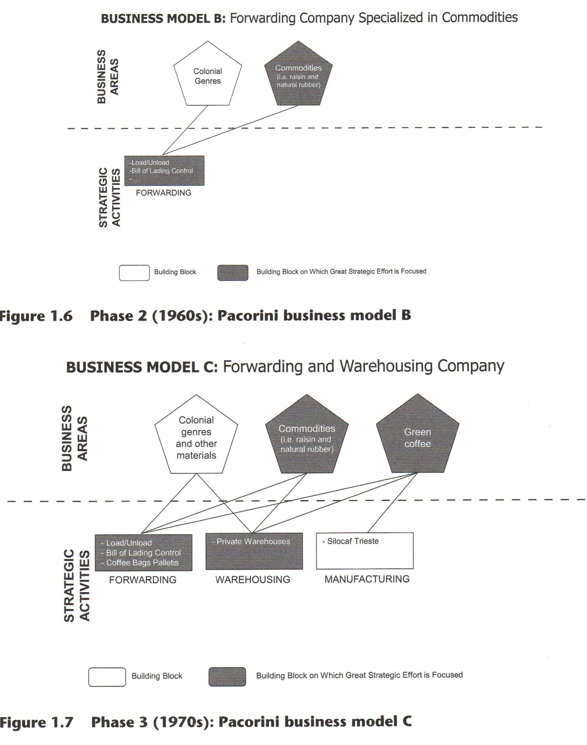

During this phase, two other building blocks appear (the manufacturing operation and the warehouses directly owned by the group), and new and important clients, such as Pirelli, enter Pacorini's portfolio.
Furthermore, relations with international traders allowed Pacorini to enter the metals market and, consequently, made the company change its structure to meet the demands of the LME. This development also entailed a change in the vision of the company. Being an exchange operator required the company to expand its market, horizon to offer worldwide service. In this period Pacorini understood that its vision should lead to becoming a logistics company operating on global scale. Thanks to the certification of its own warehouses and its registration at the LME, Pacorini's business model became more complex: new building blocks completed the whole picture and old ones lost their strategic importance (Figure 1.8). As we can see, the Silocaf New Orleans plant comes out in the manufacturing building block; green coffee and the new building block for non-ferrous metals are now connected with the exchange operations. The company's attention is now focused on these activities and these two commodities. The other goods traded and forwarded by the Italian company lost their importance in that period.

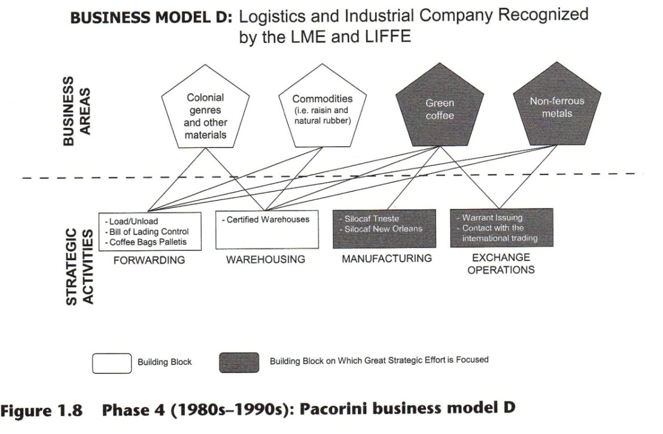

Finally, Pacorini's strategy changed significantly as a consequence of globalisation. Competition is now on a global scale, and offering terminal services and supply chain integration is seen as the only way to assure new possibilities of growth and development for the organisation. The company's business model changed once more and reached its current form (Figure 1.9). The final business model is the picture at time t_{o} of the way the firm is doing its business.
The control of the terminals, together with the partnership with SembCorp, has become a core building block with strategic importance.
The steady progression from family business to an international group has made Pacorini change its vision. Figure 1.10 shows how business models from A through C were based on the vision of Pacorini as a leading forwarding company in Italy, while business models C and onward illustrate Pacorini's changed vision of becoming a logistic company operating on a global scale.
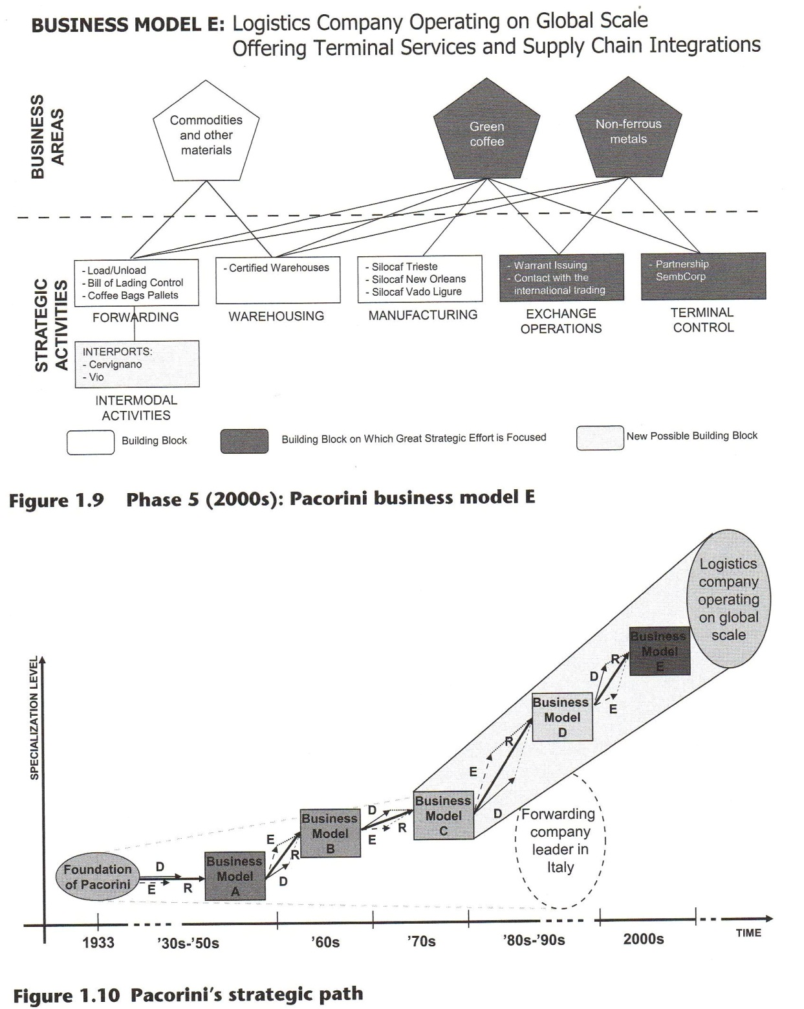
Recently Pacorini entered the sector of distribution parks, which consist of integrated platforms dedicated to warehousing, picking and distribution of perishable and industrial goods. Furthermore, an emerging business represents a new challenge for the company: intermodal activities (the Cervignano and Vado Ligure ports). Intermodal freight transport involves the transportation of freight in a container or vehicle, using multiple modes of transportation (especially rail and truck) without any handling of the freight itself when changing modes.
1.3 Conclusions
We have seen that using traditional strategic categories, that is, Porter's three generic strategies or Miles and Snow's four strategic typologies, is sometimes not enough to understand the strategic evolution of a firm. In contrast, the business model approach allows us to identify the main points of discontinuity in the organisation's strategy along with their consequent effects on the company's structure and culture, and it reveals the main building blocks that characterise the way a company runs its business in a given historical period. The innovative aspect of this analysis consists in its graphical visualisation of the evolution of a firm and in its ability to encompass in one single view the multiple facets of a company's behaviour with regard to its strategic path.
LESSON LEARNED
Do not miss the emergent strategy!
The Pacorini Group case study reveals on one hand, how strategic decisions affect a company's historical evolution, and on the other hand, how a company's historical evolution is partly independent from those strategic decisions. In other words, strategy has multiple facets and is path-dependent. This is even truer in an international context characterised by increasing complexity. Most of the strategic models and frameworks found in literature cannot harness strategic issues as a whole but generally highlight one or a couple of aspects at a time. Furthermore, most models generally do not consider the emergent component of a strategy. The business model approach, applied here for the Pacorini Group, represents a new tool for understanding a company's strategic evolution: by giving a more extensive comprehension of the past, it can also provide new hints and perspectives for developing future strategies.

QUESTIONS FOR STUDENTS:
- Which are Porter's three generic strategies?
- Which are Miles and Snow's four generic strategies?
- How can we conceive of the business model approach?
- Can Pacorini's strategic evolution be described by one of Porter's three generic strategies? Explain your answer.
- Can Pacorini's strategic evolution be described by one of Miles and Snow's four generic strategies? Explain your answer.
- What are the advantages of using the business model approach in describing Pacorini's strategic evolution?
OPEN DISCUSSION:
- The innovative aspect of this analysis lies in making the business model a conceptual tool for visualising the evolution of a company's strategy. Can this approach be applied successfully in a wide range of company types and industries?
- The business model approach harnesses the emergent component of a company's strategy. Identify and describe the main issues of today's competitive environment which give this component an important role in the strategy realisation.
References
Afuah, A., and Tucci, L. (2001). Internet Business Models and Strategies: Text and Cases. New York: McGraw-Hill.
Akan, 0., Allen, R., Helms, M. and Spralls III, S. (2006). Critical tactics for implementing Porter's generic strategies. Journal of Business Strategy, 27(2), 43-53.
Allen, R.S., Helms, M.M., Takeda, M.B., White, C.S. and White, C. (2006). A comparison of competitive strategies in Japan and the United States, SAM Advanced Management Journal, Winter, 24-34.
Baden-Fuller, C. and Stopford, J.M. (1992). Rejuvenating the Mature Business. The Competitive Challenge. London: Routledge.
Bauer, C. and Colgan, J. (2001). Planning for electronic commerce strategy: an exploratory study from the financial service sector. Logistics Information Management, 14(1/2), 24-32.
Beheshti, H.M. (2004). Gaining and sustaining competitive advantage with activity-based cost management system. Industrial Management and Data Systems, 104(5), 377-383.
Chesbrough, H. and Rosenbloom, R.S. (2002). The role of the business model in capturing value from innovation: evidence from Xerox Corporation's technology spinoff companies. Industrial and Corporate Change, 11(3), 529-555.
Deshmukh, R. (2000). Understanding the business models for the Internet economy. Retrieved 15 December 2004, from http://pegasus.rutgers.edu/-rajadesh/Project_reports.htm.
Dubosson-Torbay, M., Osterwaldeer, A. and Pigneur Y. (2002). E-business model design, classification and measurements. Thunderbird International Business Review, 44(1), 5-23.
Freeman, P. (2003). Are e-business models useful? Working paper, Swinburne University of Technology, Melbourne, Australia.
Gordijn, J., Akkermans, H. and van Vleit, H. (2000). Business modelling is not process modelling. In Conceptual Modeling for E-business and the Web. ECOMO, 1921(40-51) of LCNS, Springer.
Graf, L. (2005). Incompatibilities of low-cost and network carrier business models within the same airline grouping. Journal of Air Transport Management, 11(5), 313-327.
Hambrick, D.C. (1983). High profit strategies in mature capital goods industries: a contingency approach. The Academy of Management Journal, 26(4), 687-707.
Hambrick, D.C. (1984). Taxonomic approaches to studying strategy: some conceptual and methodological issues. Journal of Management, 10(1), 27-41.
Krishnamurthy, S. (2003). E-Commerce Management, Text and Cases. New York: Thompson Learning.
Miles, R.E. and Snow, C.C. (1978). Organizational Strategy, Structure, and Process. New York: McGraw-Hill.
Miles, M.B., Louis, K.S., Rosenblum, S., Cipollone A. and Farrar, E. (1988). Lessons for Managing Implementation. Boston, MA: Center for Survey Research: University of Massachusetts.
Miller, D. (1992). The generic strategy trap. The Journal of Business Strategy, 13(1), 37-41.
Mintzberg, H. (1978). Patterns in strategy formation. Management Science, 24(9), 934-948.
Mintzberg, H., Ahlstrand, B. and Lampel, J. (1998). Strategy Safari: A Guided Tour Through the Wilds of Strategic Management. New York: Free Press.
Mintzberg, H. and Waters, J.A. (1985). Of strategies, deliberate and emergent. Strategic Management Journal, 6(9), 257-272.
Mitchell, D.E.W. and Coles, C. (2004). Establishing a continuing business model innovation process. Journal of Business Strategy, 25(3), 39-49.
Morris, M., Schindehutte, M. and Allen, J. (2005). The entrepreneur's business model: toward a unified perspective. Journal of Business Research, 58(6), 726-735.
Murray, A.I. (1988). A contingency view of Porter's generic strategies. Academy of Management Review, 13(3), 390-400.
Olofsson, L. and Farr, R. (2006). Business model tools and definition - a literature review. VIVACE D_2.1.2_1 (VIVACE 2.1/VAC/T/06001.01).
Osterwalder, A. (2004). The business model ontology - a proposition in a design science approach. Unpublished Ph.d. Thesis. University of Lausanne, Lausanne, Switzerland.
Osterwalder, A., Pigneur, Y. and Tucci, C.L. (2005). Clarifying business models: origins, present, and future of the concept. Communications of the Association for Information System, 15(May), 1-43.
Pettigrew, A., Thomas, H. and Whittington, R. (2002). Strategic management: the strengths and limitations of a field. In Pettigrew, A., Thomas, H. and Wittington, D. (Eds), Handbook of Strategy and Management, London: Sage, pp. 3-30.
Porter, M.E. (1979). The structure within industries and companies' performance. The Review of Economics and Statistics, 61(2), 214-227.
Porter, M.E. (1980). Competitive Strategy. New York: Free Press.
Porter, M.E. (1985). Competitive Advantage: Creating and Sustaining Superior Performance. New York: Free Press.
Porter, M.E. (1986). Changing patterns of international competition. California Management Review, 28(2), 9-39.
Porter, M.E. (1987). From competitive advantage to corporate strategy. Harvard Business Review, 65(3), 43-59.
Priem, R.L. (2007). A consumer perspective of value creation. Academy of Management Review, 32(1), 210-235.
Rappa, P. (2003) Business models on the web. From http://digitalenterprise.org/models/models. html, accessed 17 January 2008.

Shafer, S.M., Smith, H.J. and Linder, J.C. (2005). The power of business models. Business Horizons, 48(3), 199-207.
Timmers, P. (1999). Electronic Commerce: Strategies and Models for Business-to-business Trading. Chichester: Wiley and Sons.
Turban, E., King, D., Lee, J., Warkentin, M. and Chung, M. (2002). Electronic Commerce; A Managerial Perspective, International Edition. Upper Saddle River, NJ: Pearson Education.
Vlaar, P., De Vries, P. and Willenborg, M. (2005). Why increments struggle to extract value from new strategic options: case of the European airline industry. European Management Journal, 23(2), 154-169.
Vokurka, R.J. and Davis, R.A. (2004). Manufacturing strategic facility types. Industrial Management and Data Systems, 104(6), 490-504.

Data as of 2007

