2
CHAPTER
Electrolux Case Study:
Competing on Time

Alignment of operations strategy with market requirements in an international context: applying lean production to increase delivery timeliness

ALBERTO F. DE TONI, CINZIA ATTISTELLA AND LORENZO IOAN

2.1 Theory
2.1.1 THE OPERATIONS FUNCTION
In all organisations (public or private, for profit or not, large or small, and so on), specific offices and departments are directly responsible for the production of goods and services that are delivered to customers. In managerial literature, the generic term 'operations' is used to 'refer to the function which produces goods or services in any organisation' (Schroeder, 1989). As the operations function exists in every industry (manufacturing, banking, retailing, and so on), operations management is not industry-specific. Stevenson (1990) remarks that the operations function consists of all activities directly related to producing goods or providing services. Therefore, an operations process can be modelled as in Figure 2.1 Inputs are used to obtain finished goods or services using one or more transformation (or conversion) process − storing, transporting, cutting, and so on -thereby adding value. To ensure that the desired outputs are obtained, measurements are taken at various points along the transformation process (known as feedback) and then compared to previously established standards to determine if corrective action is needed (Stevenson, 1990).
The operations function plays an important role in what Porter (1985) defined as the value chain: the collection of activities required to design, produce, market, deliver and support a company's products or services that illustrate how value is created by the firm for its customers. Some of these activities are primary, including operations, marketing, sales and service, while others play supporting roles, such as procurement, information technology management, technology development and so on. Competitive advantage exits whenever a firm creates value that exceeds the cost of creating it. Value is what customers are willing to pay for, and superior value stems from lower costs or unique benefits that more than offset higher prices.
Relying on the definition previously presented, the operations task obviously concerns the management of a cost centre: in fact this function accounts for a large portion of invested assets and usually has the largest budget within an organisation. Therefore, if operations budgets and output levels are met, the cost structure of the business will be sound. In other words, value is created. For this reason, it is necessary for the operations manager to be 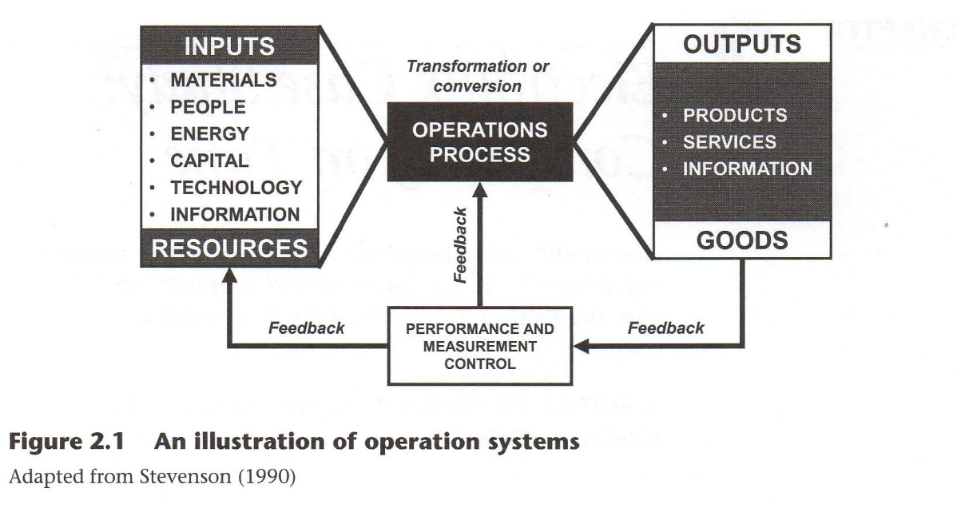
efficient in both the short and long term. Thus it is essential that the day-to-day activities are well controlled, coordinated and meet the planned output. At the same time, in a function controlling such a large portion of revenue expenditure, longer-term operations development needs to be given the necessary time and attention (Hill, 1991).
2.1.2 DEFINITION OF OPERATIONS STRATEGY: CONTEXT, CONTENT AND PROCESS
Given its longer-term implications and importance, operations management takes on a strategic role. This issue is well debated in the management literature (see Hayes and Wheelwright, 1984). For years, strategy has been associated exclusively with marketing and finance. The marketing function assesses the proper business positioning within an industry while the finance organisation calculates the costs and benefits of that position. Once these two processes are completed and fit together the strategy must then be implemented, and this is the role of the operations function. This view once dominated the management field, but the landmark paper by Skinner (1969) argued that manufacturing — what we now call operations — was the missing link in corporate strategy. Since then, scholars and practitioners have investigated the concept of operations strategy, considering it a necessary and fundamental step in strategy hierarchy (Figure 2.2).
Operations strategy finds its place at the functional level: it is less concerned with individual processes and more concerned with the complete transformation process that takes place in a certain business. In particular, it observes how the competitive environment is changing and what the operations division must do to meet current and future challenges. Therefore, the operations team refers to the long-term development of its resources and processes to best provide the basis for a sustainable competitive advantage. Slack and Lewis (2003) define operations thus: 'operations strategy is the total pattern of decisions that shape the long-term capabilities of any type of operation and their contribution to overall strategy through the reconciliation of market requirements with operations resources'.

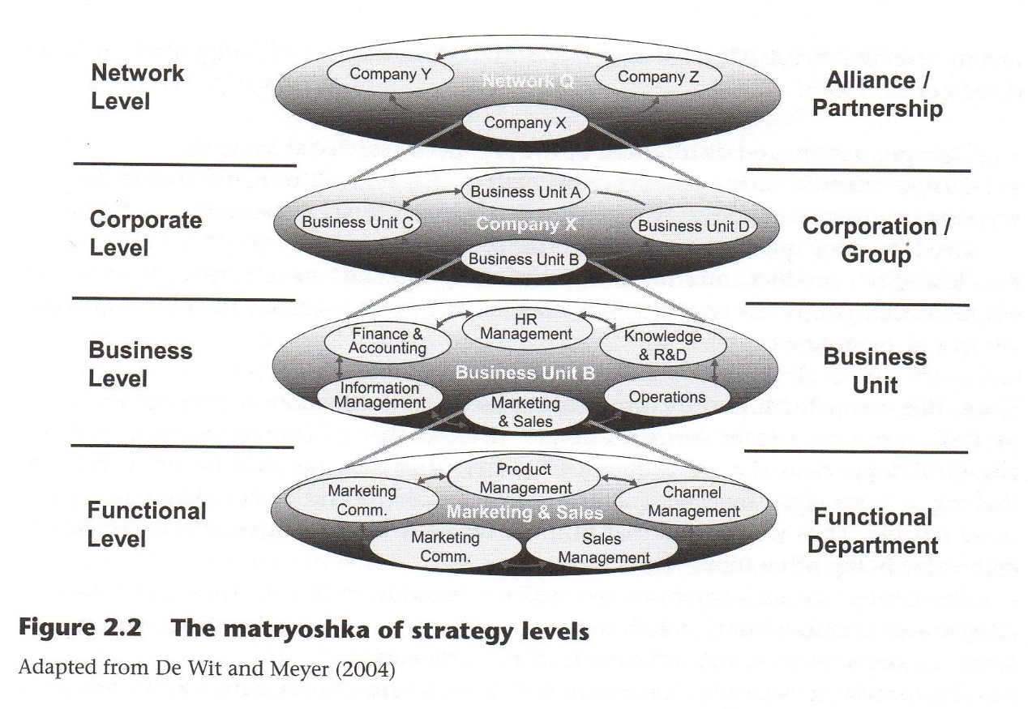

Because of the diversity in operations practices and the integral nature of strategy, general research results are often difficult to obtain in this field (Swink and Way, 1995). Nevertheless, a well-accepted distinction is made in managerial literature between the context, the content and the process of an operations strategy. The context represents the 'where' of a strategy and is concerned with the environment in which the firm is embedded. Some researchers (Ward and Duray, 2000) have demonstrated that context variables' effects on operations are mediated by the higher strategy levels (that is, business and/or corporate). The content represents the 'what' of a strategy (the objectives to be reached), while the process represents the `how' (the way, a firm pursues the stated goals). Fahey and Christensen (1986) describe the distinction between content and process affirming: `content focuses on the specifics of what was decided, whereas process addresses how such decisions are reached in an organisational setting'. They add that 'this distinction is useful, in spite of the obvious interactions between the two in organisational life'. Relying on Swink and Way (1995), the most important elements of the content model of an operations strategy can be captured in two broad categories:
- competitive priorities
- decision areas
Competitive priorities are also referred to as performance criteria, operations strategic dimensions, performance dimensions and strategic priorities (Slack and Lewis, 2003). However, competitive priorities may be defined as a consistent set of goals for operations as far as the performance requirements are concerned. In other words, when a company decides to focus on a particular type of performance, it becomes a competitive priority. A
literature review reveals a level of agreement on the following list of competitive priorities (Leong et al., 1990):

- Cost: production and distribution of the product or service at low cost;
- Quality: manufacturing products with high quality and performance standards;
- Time: delivery dependability (meeting delivery schedules or promises) and delivery speed (reacting quickly to customer orders);
- Flexibility: product mix flexibility (reacting quickly to changes in types of manufactured products) and volume flexibility (reacting quickly to volume changes in a given product mix).

A fifth competitive priority, innovativeness (the introduction of new products and processes), can be a focus for firms despite the fact that it has not received as much empirical support as the other metrics. In fact, it can be pursued by firms that are looking to lower costs, improve quality, increase flexibility and make delivery faster and more reliable. Thus we can say that innovativeness is a competitive priority implicitly embedded in the other four metrics.
The content of an operations strategy is concerned not only with the choice of competitive priorities but also with the set of decision areas. We can distinguish between structural decision areas and infrastructural decision areas.
The former are typically characterised by a long-term impact, difficulty in reversing or undoing the decision and the fact that a substantial capital investment is required to alter or extend them. The latter are generally considered more 'tactical' in nature because they encompass myriad ongoing decisions; they are linked with specific operating aspects of the business and typically do not involve highly visible capital investments. Nevertheless, these decision areas are considered within an operations strategy because their cumulative impact can be just as difficult and costly to change as those belonging to the structural category (Hayes and Wheelwright, 1984). Although it is possible to distinguish between structural and infrastructural areas, we would like to remark that these decisions are closely interrelated.
Structural decision areas include, for example, selecting the location and layout of plants and facilities; defining the amount of production and storage capacity; choosing the correct process technologies for producing goods and services and improving existing ones; deciding whether to vertically integrate and in what direction (upstream versus downstream); determining the span of integration (narrow versus wide) and balancing the resulting vertically linked activities (that is, totally dedicated versus non-totally dedicated suppliers). Infrastructural decision areas include choices on the type of production planning and material control systems (material requirements planning, kanban - the Japanese scheduling system for inventory management - reorder points, economic order quantity, and so on); design and implementation of quality processes (total quality management, total productive maintenance, statistical quality control, and so on); design of the organisational structure (functional, divisional, matrix, and so on) and human resources management policies (centralisation versus decentralisation, autonomy versus control, wage and incentive systems, and so on).

2.1.3 COMPETING ON TIME: DELIVERY PERFORMANCE AS A MEANS OF COMPETITIVE ADVANTAGE
In the last few decades, time has proved to be a new source of success for many companies. Literature describes it enthusiastically as the common denominator of all things vital to long-term competitiveness and, therefore, `the next battle ground' or `the next strategic frontier' for most firms (De Toni and Meneghetti, 2000).
In the modern competitive environment, the meaning of time can be analysed from two different viewpoints. It can be related to the external configuration of the firm (that is, products and services provided) or to the internal one, concerning the set of resources used by the firm to perform its task (Azzone et al., 1991). Thus two classes of time performances can be identified: external (also visible to consumers) and internal (measurable only by the company, but not manifested to customers) (De Toni and Meneghetti, 2000). Moreover, a further distinction can be made considering the type of operations involved in time performance measurement. Figure 2.3 shows this classification of time performances.
External time performances, delivery speed and delivery dependability are fundamental sources of differentiation for a firm. Generally speaking, speed indicates the time between the beginning of an operations process and its end (Slack and Lewis, 2003) - thus it is an elapsed time. This may relate to externally obvious events (for example, from the time a customer requests a product or service to the time when the same customer receives it). Similarly, it may be used internally in the operations (for example, the time between when material enters a certain process and leaves fully processed). In other words, delivery speed measures the sum of the sourcing lead time, manufacturing lead time and distribution lead time. As far as dependability is concerned, it has to deal with 'keeping promises' in terms of time (that is, punctuality and observing due dates) and mix/quantity (that is, reliably delivering the right mix and quantity as promised). Dependability and speed represent two sides of the same coin; they are often linked in some way. For example, one could theoretically achieve high dependability merely by promising long delivery times. In this case, the difference between the expected delivery time and the actual delivery time is used as insurance against a lack of dependability within the operations.
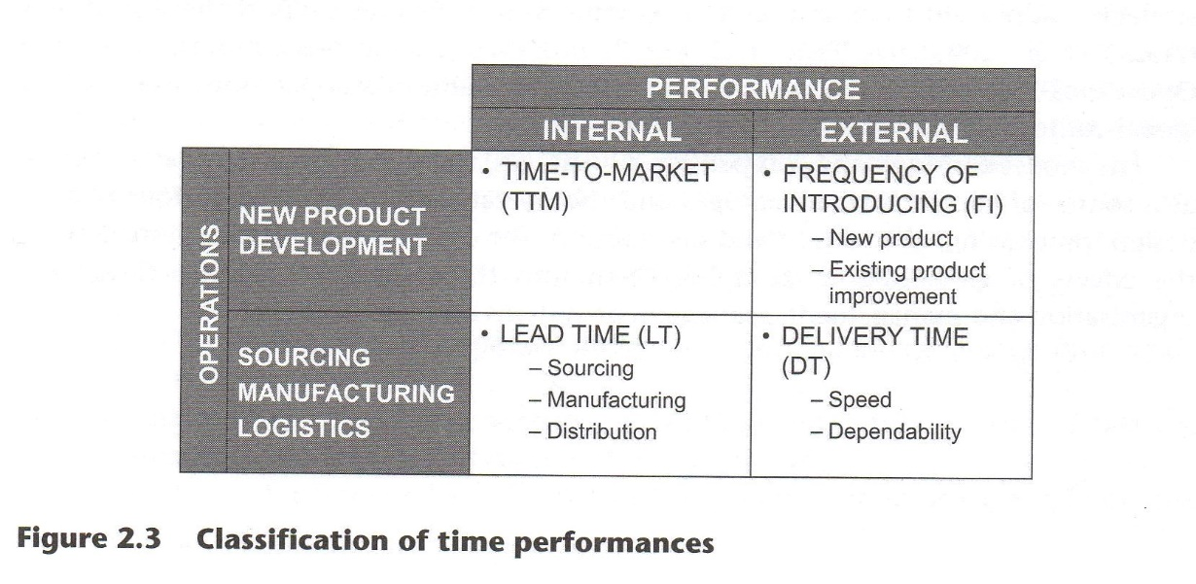
Modernity has made clients prefer a quick response so that no time is wasted on meeting their requirements. Demand also reveals elasticity to time: a customers' preference is conditioned by how fast their purchase orders can be carried out (De Toni and Meneghetti, 2000). The ability of a firm to quickly satisfy customers' needs can be represented by delivery performance. These actions can truly differentiate a company from its competitors because they contribute to modification of the price-quality relationship perceived by the consumer (De Toni and Meneghetti, 2000). A firm that provides a quick response to customers' needs is able to attract more clients and encourage brand loyalty, increasing its market share; it can even earn a price premium for the speed and reliability of its deliveries. A certain degree of elasticity to delivery time characterises both consumers' and intermediaries' demand due to lower risk for less anticipated replenishment orders. As a consequence, the great potential of time as a source of competitive advantage leads to new strategic orientations, giving companies a modern weapon with which to fight. This, in turn, leads to a growing relevance even from the perspective of the internal configuration of the firm. The results of empirical research conducted by Schmenner (1988) on both US and European plants show how throughput time reduction stimulates several complementary actions that enhance productivity and lead to positive indirect effects, quantifiable mainly as cost reductions. As Stalk (1988) asserts, as a strategic resource, time is the equivalent of money, productivity and even innovation, and for several companies it will become the indispensable weapon to fight with.
2.1.4 DEVELOPING AN OPERATIONS STRATEGY IN AN INTERNATIONAL CONTEXT
So far, we have stressed the importance of an operations strategy in terms of being the missing link between the market requirements and the firm's resources, and, among the variables that constitute its content, we have focused our attention on time performances as a source of competitive advantage in today's competitive arena. Nevertheless, another important element to be considered is the internationalisation process that many firms have increasingly begun to undertake. The nature of global markets makes the risks associated with strategic errors even more significant. Therefore, companies wanting to compete on a worldwide scale must spend more time formulating effective operations strategies, adhere to them and employ resources in ways that support these strategies (Prasad et al., 2001). De Toni et al. (1992) proposed a conceptual model, called the Operations Value Chain (Figure 2.4), for the development of an operations strategy in a global context.
The model considers the competitive advantages, the operating system performance as a source of competitive advantages and the operations articulated into four phases: design, purchasing, production and distribution. For each of them, the authors derived the effects of globalisation, grouping them into three strategic decision categories: organisation and management, management systems and technologies.
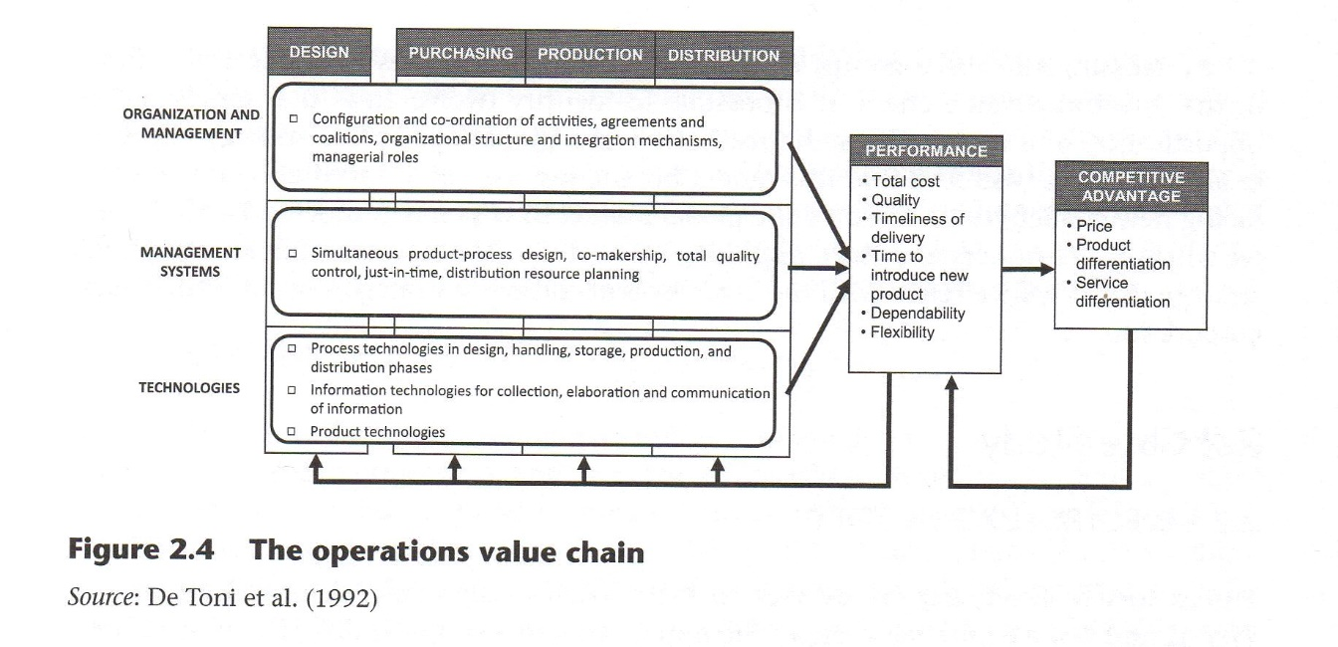
According to the authors, this model makes it possible to observe the influence of decision categories on the performance of the operating system and on the competitive advantages the company can obtain as a result. The phases considered along the operations value chain are design and development of new products, purchasing of raw materials and components, manufacturing of components and assembly of finished products and distribution. The production phase includes the inbound logistics while the distribution phase can be thought of as outbound logistics. As far as the performances are concerned, the authors group the performances, which can be obtained from the operations, mostly into the same classes we've previously seen. The model considers three types of competitive advantage (price, product differentiation and service differentiation) because, in general, consumers choose among several product alternatives on the basis of the price-quality relationship. Finally, they consider three groups of strategic decisions which, even with different classification criteria, overlap with the decision areas previously presented.
The first area is organisation and management and includes elements that can be traced back to the external and internal organisational structure of the company (that is, configuration and coordination of activities, the level of concentration/decentralisation of activities in the value chain, agreements and coalitions, internal organisation structures and integration mechanisms, and so on) and the managerial roles (the role of the manager in integrating activities). The second group of strategic decision categories is represented by management systems, considered both as approaches to process management and as formal techniques and procedures (that is, simultaneous product-process design, coproduction, total quality control, just-in-time, and so on). The third and final group is represented by technologies. These can be divided into three categories:
- Process technologies of all the phases: design, transport, handling, storage, production and distribution;
- Information technologies for collection, elaboration and communication of data and information (information and communication systems);
- Technologies incorporated in the product and aimed at improving quality and reducing costs.
By crossing the three groups of strategic decision categories with the four phases of the operations value chain, it is possible to identify twelve areas that represent the opportunities and decisions for the realisation of a global operations strategy (De Toni et al., 1992). We will find that this model fits the real case of a multinational company facing new challenges imposed by the global market in which it competes. Furthermore, we will come to understand the complexity associated with implementing an operations strategy that is truly aligned with the business and corporate strategies of a multinational corporation.
2.2 Case Study
2.2.1 ELECTROLUX'S HISTORY
The history of Electrolux traces back to 1908 when a salesman, Wenner-Gren, visited Vienna and saw a Santo Staubsauger vacuum cleaner in a shop window. He soon realised that was the product he had long been looking for. Because a vacuum cleaner was needed in every home and because they were produced only in the US, Wenner-Gren put all of his energy and resources into developing and selling vacuum cleaners in Europe. In 1912, he returned to Sweden where two companies, Elektromekaniska and AB Lux (a manufacturer of kerosene lamps at the time), had begun to manufacture their own version of the American Santo vacuum cleaner. With the outbreak of the First World War in 1914, vacuum cleaner exports came to a standstill, and Wenner-Gren felt there was now a need to design a small, portable vacuum cleaner with a universal motor. He presented the new vacuum cleaner to Lux, but they did not believe it would work, so in 1915 he started his own company, Svenska Elektron AB, and sold his new vacuum under the Elektron brand name with great success. This success increased Wenner-Gren's market share, and, as a result, he began to look for ways to strengthen his position through acquisition. Specifically, he wanted to merge with AB Lux, which had unused production capacity. The negotiations lead to a merger in 1919. Concurrently, it was announced that the company was to be renamed AB Electrolux. In autumn 1919, sales branches were established in Denmark, the Netherlands, Switzerland and France, and the company also sold products in the United Kingdom and Norway. Demand for the new Electrolux vacuum cleaners was tremendous. Meanwhile, the company launched a new product developed by two Swedish engineering students at the Royal Institute of Technology in Stockholm, Baltzar von Platen and Carl Munters. This machine, which was driven either by electricity or gas, was able to produce cold air from heat using a revolutionary application of the absorption process. The refrigerator was first produced in 1923; however, because demand was rapidly increasing, the decision was made to establish factories abroad. The first production plant for vacuum cleaners outside Sweden opened in 1926 at Tempelhof in Berlin. The following year, Electrolux opened factories in Luton, England and Courbevoie, France: these plants were eventually equipped to produce refrigerators. The success of these products made Electrolux a 60 million Swedish kroner (SEK) company by the end of 1928, paving the road for its flotation on the London Stock Exchange (and later on the Stockholm Stock Exchange). Production for the American market began in Old Greenwich, Connecticut in 1931, and five years later, Electrolux opened its first production plant for vacuum cleaners, refrigerators and floor polishers in Australia. At the end of the Second World War, the group continued to expand by acquiring new technologies and products and by building new plants and facilities around the world. An important milestone occurred in 1984 with the acquisition of Zanussi, an Italian company founded in 1916. This made Electrolux the clear leader in the European market for household appliances and foodservice equipment. By the end of the 1990s, the group had begun a restructuring programme and developed a new brand policy to' focus resources on a smaller number of big and well-defined brands.
2.2.2 COMPANY PROFILE
Today, Electrolux is a world leading manufacturer of appliances, producing cookers and cook tops, ovens, refrigerators and freezers, dishwashers, washing machines, tumble dryers, room air conditioners and vacuum cleaners, both for home and professional use. In 2008, the group generated net sales of SEK 105 billion (approximately €10.5 billion) selling 40 million products in more than 150 countries and employing nearly 55,000 people. That implies a sales run-rate of two products purchased from Electrolux every second, every day of the year. Table 2.1 shows the firm's consolidated results from 20072009.
Table 2.1 Electrolux consolidated results: three-year review

 | 2009 | 2008 | 2007
Net sales | 10,913 | 10,479 | 10,473 | €m
Operating income | 376 | 118 | 447 | €m
Margin | 3.4 | 1.1 | 4.3 | %
Income after financial items | 348 | 65 | 403 | €m
Income for the period | 260 | 36 | 292 | €m
Earnings per share | 0.92 | 0.13 | 1.04 | €
Return on equity (ROE) | 14.9 | 2.4 | 20.3 | %
Return on net assets (ROA) | 19.4 | 7.2 | 20.9 | %
Net debt/equity ratio | 0.04 | 0.28 | 0.29 | --
Capital expenditure | -222 | -316 | -343 | €m
Average number of employees | 50,633 | 55,177 | 56,898 | --

Source: Electrolux Consolidated results 2009

The Electrolux corporate strategy, as stated in the 2009 report, is to pursue a competitive production system, innovative products based on consumer insight and a strong global brand to generate industry leading margins and profitability. Five elements constitute the basis of this strategy: 1) cost efficiency, which allows for the 2) development of innovative products and the 3) development of a strong global brand. This, in turn, will lead to 4) sales growth, finally resulting in 5) improving the firm's operating margin.
Electrolux's organisational structure is segmented at the product level between consumer durables, which includes major appliances (for example, kitchen, laundry) as well as floor care and small appliances for home use, and professional products, which includes mainly appliances for professional use (for example, foodservice and laundry equipment, and outdoor products such as chain saws and power cutters). Operations are divided into six main business areas. Consumer durables comprises four regional divisions (Europe, North America, Latin America, Asia/Pacific and rest of the world), while professional products constitutes a single global business area. Figure 2.5 illustrates the firm's product categories and the share of sales in geography.

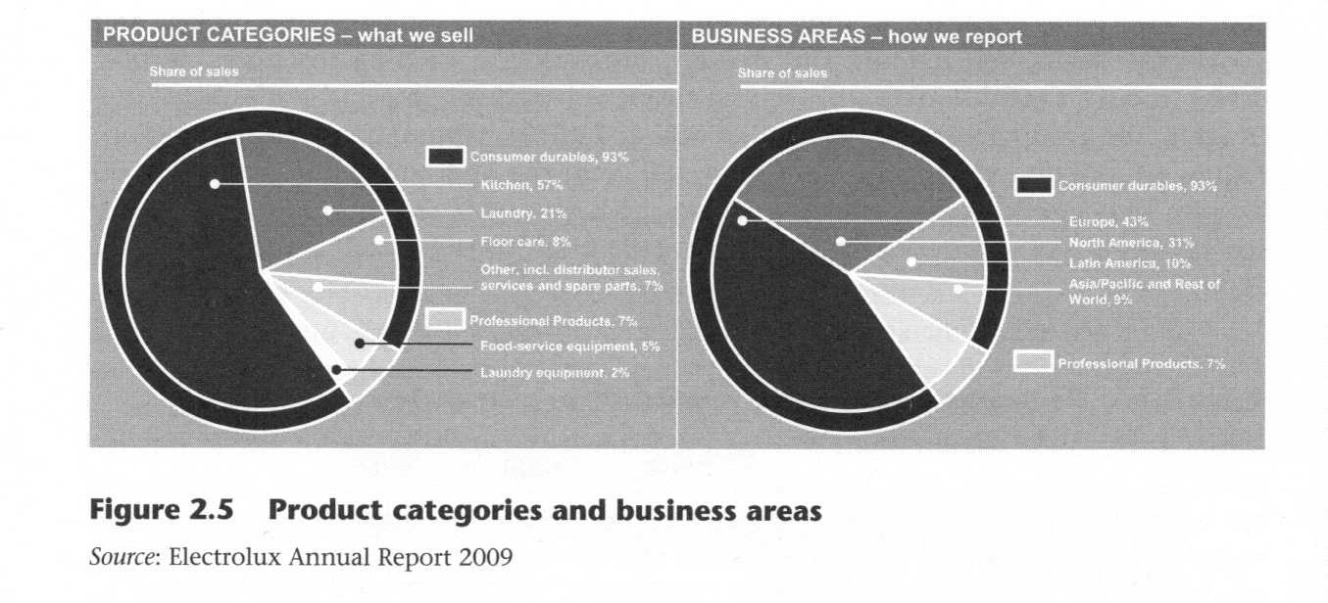

Approximately 50 per cent of products are sold under the Electrolux brand, while the others use local well-known brands (for example, AEG-Electrolux, Frigidaire and Eureka for consumer durables; Molteni and Zanussi Professional for professional products). This case study focuses on the Professional Products division and is specifically concerned with the Zanussi Professional Foodservice plant in Pordenone, in north-east Italy. The plant is dedicated to the production of foodservice equipment and is divided into four product platforms, which constitute totally autonomous organisational units:
- dishwashers
- cooking ovens
- refrigerators
- modular cooking

The last platform will be of interest in this study: Table 2.2 shows the main features of this organisational unit.

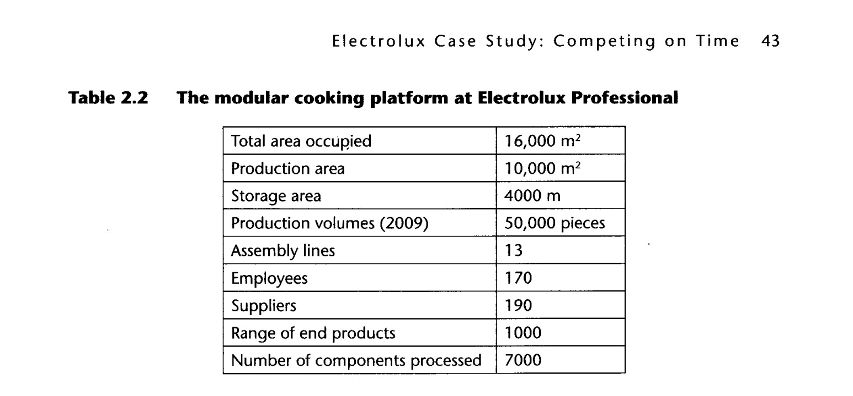
The modular cooking platform, as with the other platforms, exemplifies the plantwithin-a-plant idea proposed by Skinner (1974). Most of the issues that will be discussed in the next sections of this case study concern this organisational unit, even though some of them affect other product platforms in the plant.
2.2.3 THE FOODSERVICE EQUIPMENT MARKET
According to the 2009 Electrolux Annual Report, the market for professional foodservice equipment, which is a business-to-business (B2B) market, generates approximately SEK 125 billion (€12.5 billion) of annual sales. Global growth is approximately 2-3 per cent annually with the fastest growth occurring in Asia, Latin America and Eastern Europe. Nearly 50 per cent of all foodservice equipment is sold in the North American market, which is twice as large as the European market. The US market is characterised by the presence of large restaurant chains, which are responsible for the increasing demand. US-based chains are also expanding rapidly in emerging markets such as China and Eastern Europe. In China, restaurant chains still have little market share, with only 7,000 locations out of a total of 3.5 million establishments globally. This implies a substantial growth opportunity for producers of foodservice equipment that sell to restaurant chains.
The structure of the market in Europe is different and slightly more complex and is dominated by smaller independent restaurants. Competitors are also more fragmented and often specialise in one product or segment. Nevertheless, the ongoing standardisation of legislation and regulation across the European Union favours the larger producers, who can adapt more easily to new and tougher standards. Structurally, demand is driven by regional trends (for example, an increase in the number of visits to restaurants by consumers). Electrolux Professional supplies complete suites of equipment and service solutions, including ovens, dishwashers, refrigerators, cookers and hoods and generates its largest share of foodservice equipment sales through dealers. This strategy has proved to be more successful and cost efficient than direct sales due to the complexity of the customer base. As already noted, the group's products for professional kitchens are sold mainly under the Electrolux brand, which is consistent with the firm's brand reduction strategy for economies of scale in production and marketing. Molteni is another niche brand for exclusive cooking ranges. The globalisation of the market has increased the variety and variability of demand because of country-specific factors that affect buyer behaviour. This means that manufacturers must offer a high level of flexibility. Moreover, clients are increasingly focused on hygiene and energy-efficiency criteria as well as access to a comprehensive service network. The latter aspect particularly affects the time performances required by manufacturers. We are examining a B2B market here; for this reason, service and timeliness of deliveries are key factors. For example, if a restaurant needs its kitchen to be replaced or renewed, the punctuality and speed of delivery are essential to let the client run its business with no interruption (that is, without losing money). Figure 2.6 shows the composition of Electrolux Professional incoming orders over the last six years.
As we can see from the diagram, in a five-year period the demand composition trend has changed completely. In 2000, the percentage of orders requiring delivery within 3 weeks was just 42 per cent. In 2005, the situation was reversed; nearly 70 per cent of incoming orders required delivery within 20 days. These data reflect the effects of market globalisation and confirm the importance of delivery time to customers.
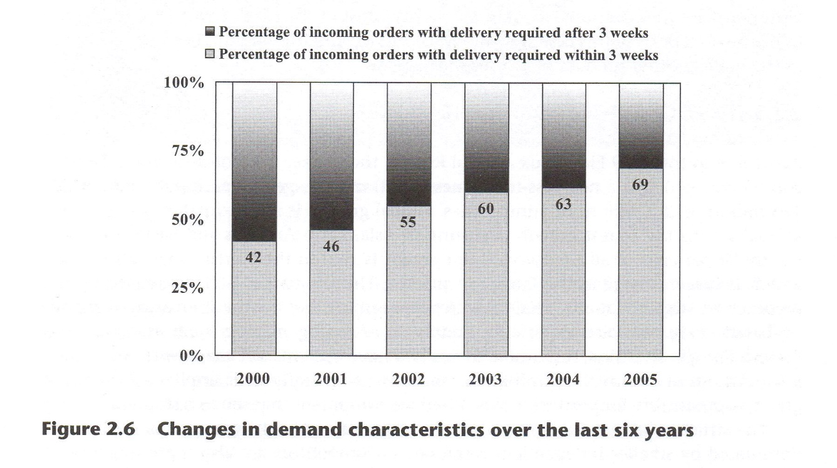
2.2.4 DEVELOPING AN INTERNATIONAL OPERATIONS STRATEGY: THE ELECTROLUX PROFESSIONAL CASE STUDY
The complexity that results from operating as a large player in a global market makes Electrolux Professional an interesting case for understanding the criticality of developing an international operations strategy. On the market side, we have seen an increase in variety and variability of demand in recent years due to country-specific factors and heterogeneity among different geographical areas. Furthermore, customers are increasingly requiring fast deliveries and a high level of service. On the corporate side, the intended strategy aims at being more customer-oriented, providing both a higher level of service and more innovative products. At the same time, the firm must focus on cost efficiency to improve its operating margin and profitability. Thinking back to the operations value chain model theory, Electrolux's competitive advantage is principally product and service differentiation. The performance goals, however, are mainly focused on cost and time, assuming the company achieves a satisfactory level of quality and innovation. However, as we have seen before, defining competitive priorities is not the only aspect of an operations strategy. Areas of intervention must be identified and actions must be put into place to reach such performance goals. Again, we'll rely on the operations value chain model to describe some of the activities undertaken by Electrolux, with a particular emphasis on the Zanussi Electrolux Professional plant, which is focused on making its operations a competitive and strategic weapon.
2.2.5 ORGANISATION AND MANAGEMENT
In 2002, Electrolux launched a new programme called the Electrolux Manufacturing System (EMS), designed to emulate the famous Toyota Production System (TPS) and employ lean production; this requires a synchronising of production with the real-time market demand, obtaining the general result of 'producing more with less'. Electrolux management is aware that simply copying the best practices used by the Japanese automotive firm does not necessarily imply successful results: thus the EMS was conceived as a holistic philosophy that should be widespread within all levels of the corporation. After a two-year period of data gathering and studies, the EMS was deployed in 2004: Figure 2.7 shows its structure.
The roof of the temple represents the company's long-term goals; the pillars constitute the main principles to be followed; the basement represents the concepts and tools required to faithfully pursue EMS. The pillars contain the following ideals:
- Total flow management: creating a flow production system that employs 'pull logic' (that is, production is guided by the real-time market needs). It requires implementing a just-in-time production system through a proper plant layout, flexible processes, kanban production control, proper levelling of working centres loads, total productive maintenance, and so on
- Built-in quality: designing high-quality processes to produce high-quality products. It concerns the use of error-proof techniques, poka-yoka systems, quality circles, and so on
- Product development: designing high-tech, robust products that are easier to use. It involves the use of quality function deployment, co-design approaches, failure mode and effect analysis (FMEA) techniques, and so on
- Continuous improvement: making people aware of the importance of continuously improving performances and standards. It is a cultural imprinting that must be widespread across the entire organisation.
People involvement and empowerment are at the base of the temple because only 'people make it happen'. None of the pillars or long-term goals can be reached without the collaboration between all the employees. Inefficiencies and waste (muda in Japanese) cannot be eliminated solely by applying plan do check act (PDCA) cycles, SS techniques — sort, set in order, shine, standardise and sustain — or visual management tools; effective teamwork is required to achieve these results.
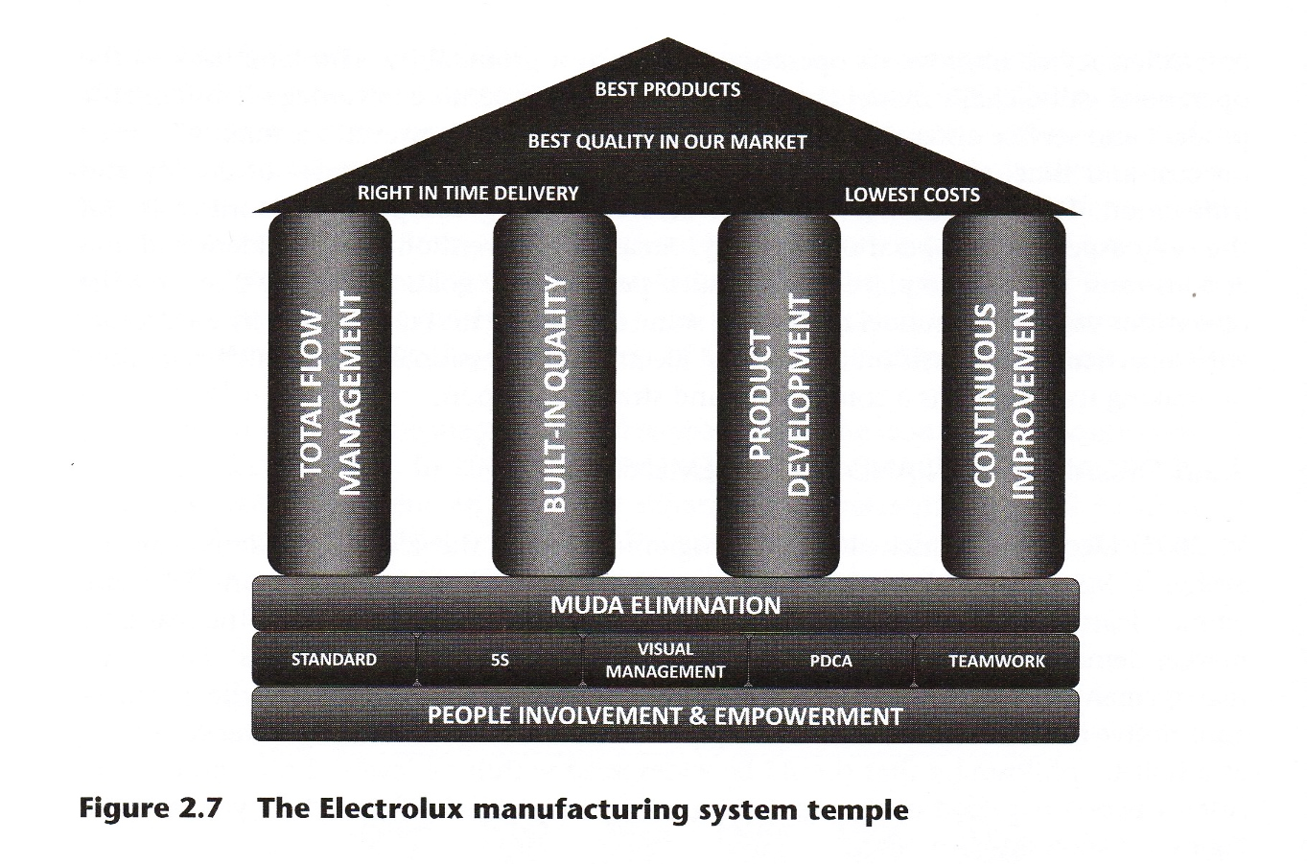

The EMS is not only a philosophy but also an effective organisational approach shared by all each of Electrolux's plants and facilities. In fact, a new organisational staff structure has been created to support and develop the EMS among all Electrolux divisions. As a consequence, new managerial roles have been created — EMS manager, EMS trainer, and so on — to coordinate activities that fall under the 'lean production' perspective. Furthermore, this organisational structure requires a dedicated technical office that is responsible for the design and implementation of technical solutions developed by the EMS teams across the corporation. This new organisational structure provides easier access to institutional know-how, knowledge and ability transfer, and the spreading of kaizen — continuous improvement in Japanese — principles within the entire company. All of these activities are a perfect fit in the operations value chain model proposed by De Toni et al. (1992). Moreover, the EMS is an effective vehicle for integration and procedure standardisation and an important support mechanism for internationalisation process management. The establishment of such a structure is an infrastructural strategic decision aligned with the goals fixed by the operations strategy, which, in turn, are aligned with defined corporate objectives and market needs.
Another interesting issue, specific to Electrolux, is the use of teamwork as a means for problem solving, increasing people involvement and showing commitment to the EMS. Periodically, workshops are organised for specific production areas including line operators, technicians and managers from different organisational functions. These workshops may last up to three days, are focused on specific issues and rely on the principle of 'training on the job'. The workshop methodology usually follows three steps:

- analysis of a certain process to determine its criticalities (that is, the muda or waste in the process);
- prioritisation of criticalities;
- PDCA cycle application: identification of possible solutions and proper solution selection (Plan), implementation (Do), control (Check) and standardisation (Act).
The activities of these workshops are performed directly on site, using visual management techniques. For example, if a new layout for an assembly line has to be developed, the design phase is not performed with the help of a computer-assisted design (CAD) system but rather through the use of throwaway packages and empties; these objects identify specific areas in the assembly line (for example, a working centre, a storage area, and so on), are deployed on the ground and then rearranged and recombined to form the desired new layout. According to Electrolux managers, the workshop approach is more effective because it:
- guarantees a reduction in time spent in problem framing and solving due to the simultaneous presence of different actors involved in the processes;
- guarantees an early identification of problems because operators can, in real time, test the new working centres' layout and the flows necessary to perform each activity;
- increases management's awareness of the productive processes;
- guarantees a higher level of consensus around the solution and a higher level of commitment due to its multidisciplinary character.
The use of workshops also allows the establishment of shared standards in operations. The creation of standards allows for an easier achievement of stated goals (a standard defines specific levels of quality, cost and time performances); reduces process variability (the primary source of muda); constitutes a point of reference for audit, diagnosis and personnel training; preserves the company's know-how and favours the diffusion of best practices within the entire corporation. Electrolux believes that continuous improvement broadly begins with continuous improvement of standards.
The diffusion of the EMS within the plant has lead to several changes, some of which will be described in this and the next sections. Almost all of them fall in line with the primary performance goal Electrolux Professional's operations strategy, which is the improvement in the timeliness of delivery with a particular focus on speed. As we have seen, this competitive priority is consistent with the market requirements. In fact, in recent years clients have increased the percentage of orders that require delivery within three weeks of the order's placement. The speed of delivery is an external time performance that is profoundly affected by and directly connected to three internal time performances: sourcing lead time, manufacturing lead time and distribution lead time. In this case study, we will focus on the reduction of manufacturing lead time, which is defined as the time between the entry of an input into the production system and its exit as an end product. Reducing manufacturing lead time is not an easy task because it involves redefining:
- processes and layouts (for example, assembly lines, storage areas and so on);
- production planning and control logics and techniques (for example, reorder point logic [ROP], kanban and so on);
- the internal logistics flows coherent with the two previous issues.
The redesign of the plant layout is another organisational issue taken into consideration by Electrolux Professional. Furthermore, this is typically a structural decision in the development of an operations strategy. The redefinition of the plant layout is closely related to the EMS objectives. The increase in the timeliness of deliveries depends heavily on manufacturing lead time, which, in turn, is a function of machinery layout and process length. Electrolux Professional has dedicated its year-long 'Hectare Project' to this task. The required investment was €1.5 million with an expected payback period of three years. The plant has been reorganised from a job-shop layout into a line-flow layout, grouping products by families that share similar technological processes and assigning each assembly line to one or more of them. The final result is a reduction in the average length of an assembly line, which implies a time reduction as far as manufacturing lead time is concerned (Figure 2.8).
Due to the new layout and the waste reduction, each assembly line is now 20 per cent shorter with approximately one hectare of total space saved.

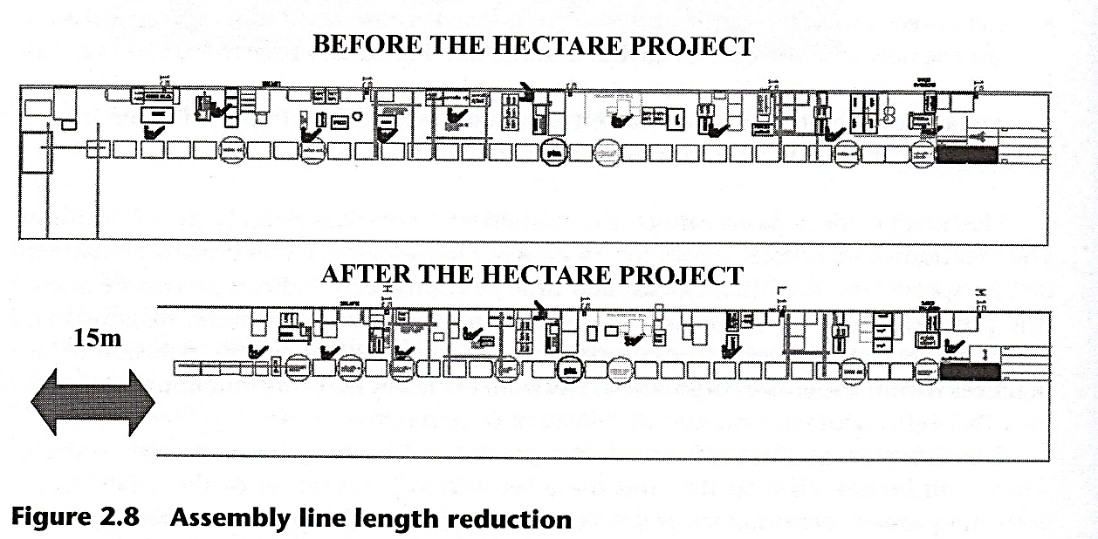
2.2.6 MANAGEMENT SYSTEMS
The current ('as is') production planning system in Electrolux Professional is based on a three-week frozen period; clients' orders can be modified only until 20 days prior to the delivery date. In other words, orders delivered during week four have been planned during week number one, implying that the system is unable to respond to changes in demand which occur in weeks two and three. The ultimate consequence of this management system is that approximately 60 per cent of products are manufactured relying on forecasts, and only 40 per cent of products are produced on the basis of the confirmed orders. This has many effects along the entire supply chain:

- A higher probability of losing a client's orders if they require delivery in fewer than 20 days
- The need to increase finished goods inventory (and thus costs) by relying on forecasts to face demand changes. There is also little certainty of having the right finished good, at the right time and for the right delivery
- An increased risk of product obsolescence
- Misalignment between production and demand because the former tends to be focused on the replenishment of inventory rather than on client orders (this creates machine saturation and production volume levelling problems)
- Bullwhip effect (that is, amplification of variability upwards in the supply chain), increasing the risk of later deliveries by suppliers, which may cause assembly line stoppages in the plant.
Production planning and control system
Management's objective is to reach a maximum response time of eight days: currently the maximum time between receipt of a client's order and delivery is 20 days. The response time reduction is generated by the redefinition of the production planning and control systems. Figure 2.9 shows the Gantt diagram for the current production planning system phases.
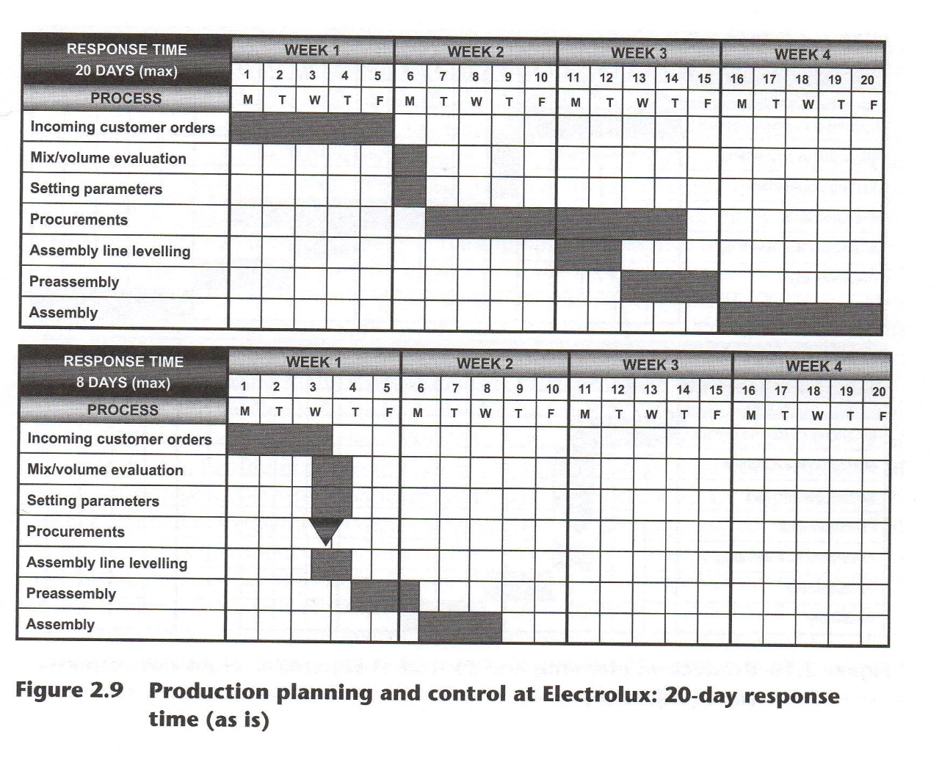
Incoming orders are processed once per week, requiring five days to complete; afterwards, the materials requirement planning (MRP) is run to generate the purchase orders. Suppliers must deliver the required orders by the end of week three. In the meantime, the engineering office plans the proper assembly line levelling, and preassembling operations are undertaken. Finally, assembling operations are performed, requiring five days to complete. To achieve the objective of a maximum response time of eight days, nearly all the phases represented in Figure 2.10 have to be shortened. In particular, the two most critical processes are procurement and assembly line levelling and, as shown in Figure 2.10, the most significant time reduction involves these two activities.
In the new production planning and control system, incoming orders are processed twice a week. 'Pull logic' replaces MRP logic for purchasing order placement. Only finished good volumes are manufactured by relying on forecasts. Orders for subassembly and raw materials are based on a blend of kanban and ROP logic. The kanban system determines the requirements of an item upwards through the supply chain on the basis of the consumption of the item immediately downwards in the chain. A demand for one unit of a specific product generates the 'consumption' demand and, as a result, a manufacturing order is placed. Therefore, items are produced only when demand requires it, and the production flow is synchronised with customers' needs. Essentially this system requires three changes:
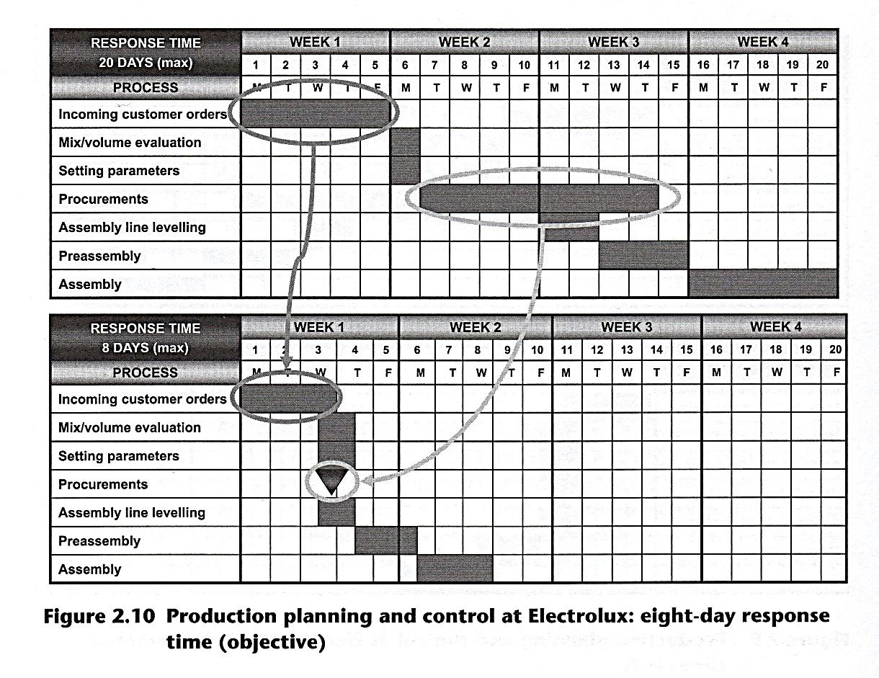
- Reorganisation of inventories and storage areas
- Redefinition of replenishment logic for the assembly line
- Appropriate assembly line levelling
Inventories and storage areas in a 'pull' perspective
To handle inventory, warehouses have been redesigned, adopting a supermarket structure. This requires that specific areas are dedicated to the same type of material or component and that storage areas for different items are clearly separated from each other (as in a supermarket where products are grouped by their general category into different shelves). This guarantees that a precise location is assigned to each component or material. Furthermore, racks and frames are kept at reasonable height to facilitate the picking processes, which reduces the time spent searching for items. Finally, the supermarket structure helps to determine the reorder point by simply looking to see if the shelf is empty, encouraging prompt replenishment. Therefore, stocks can be kept at lower levels and inventory turnover increases. A previous analysis of the logistic and production flows within the plant pointed out that nearly 60 per cent of manufacturing lead time was spent searching for materials and components in the racks and frames. The application of the supermarket structure storage areas reduced this figure dramatically.
Materials handling and replenishment logic
The shortening of assembly lines implies that materials and components can no longer be stocked in large quantities near the working stations. Therefore internal logistics must provide for more frequent replenishments to ensure that only the necessary items for the required production mix are present. For this purpose, the 'milk-run' has been adopted. Instead of handling materials with a forklift truck and supplying the working stations one at a time, a dedicated train, consisting of different wagons containing the items to be brought across the assembly lines, has been built. This train runs along a fixed route across the plant and leaves the wagons in the appropriate areas near the working stations. As a result, the operation of pouring objects from the forklift to the assembly line shelf is eliminated, reducing the time required for component replenishment. The train leaves the filled wagons and takes back the empty ones. It is important to note that the wagons were designed by the EMS technical office, applying ergonomic principles to the design of each wagon according to the types of items to be transported.
According to the Electrolux managers, the milk-run system increases control over material flows and allows for material handling standardisation. In addition, the operator becomes the first controller of line throughput by being the first to see any irregularity in the production flow. All these activities are performed under kanban logic. Replenishments are not planned beforehand and then pushed downward, they are 'pulled' upward. That is, when a certain component or material is out of stock, a card is placed to signal a replenishment need for that item. During the milk-run, the logistics operator collects all the kanban cards, each of which contains a description and quantity of the needed item. When the milk-run is completed and all the materials are left at the assembly lines, the operator returns to the supermarket area and prepares the next train according to the requirements on the next set of kanban cards. A logistics train currently makes, on average, 25 milk-runs per day. Thus far this logic applies to the internal materials handling, but Electrolux intends to roll out this system with each of its suppliers
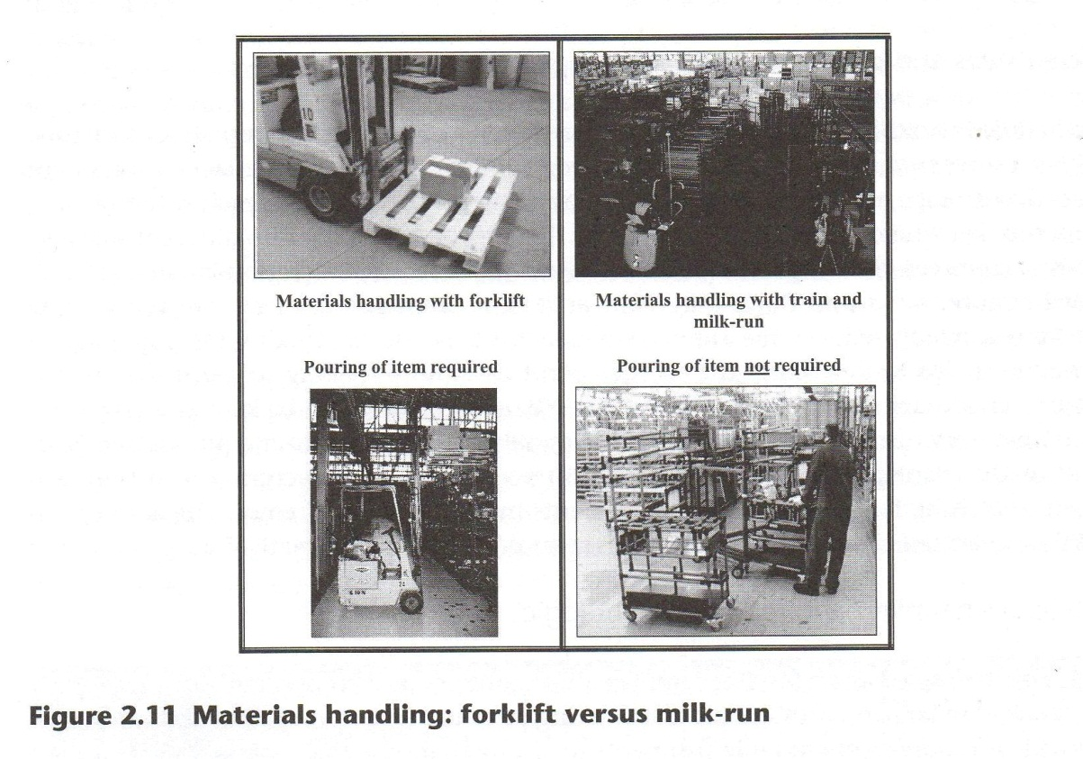

Assembly line levelling
The last important issue to reach the goals put in place by Electrolux management has to do with assembly line levelling. Creating a pull production system requires synchronising the throughput time with real-time customer demand. If, for example, the total work time for a certain assembly line is eight hours per day and we assume that the actual demand for finished goods on that day is sixteen units, a production system synchronised with the customers' needs must create one end product every 16/480 minutes, or once every 30 minutes. This value represents the so-called takt time for that assembly line. The main purpose of assembly line levelling in a pull production system is to guarantee a throughput time that is as close as possible to the takt time of that assembly line. The solution adopted by Electrolux is represented in Figure 2.12.
In Figure 2.12 (A) represents the 'as is' situation in most assembly lines in the Electrolux Professional plant. Here, at every work station, different products require different process run times. Given a certain production mix (that is, a sequence of products to be processed in the assembly line), buffers (storage areas) between two adjacent work stations are necessary to adapt to the different run times required at every step for the same product. For example, let us suppose that the production mix requires products A, B, C and D to be assembled in that order. The operator at the station one processes item A, passes it to station two and begins processing item B. At the same time, the operator at station two starts processing item A. However, the time required at station two for processing item A is less than that required by station one for processing item B. This means that the operator at station two has to wait a certain amount of time before receiving item B and resuming work. The time spent waiting is muda.
The new assembly line levelling logic applied by Electrolux management requires variability to be concentrated in only one station, as represented in Figure 2.12 (B). This logic was first implemented in a pilot assembly line. To achieve this objective, the engineering function, together with the job leaders, analysed each product processed in the pilot assembly line and grouped them by similarity of run times and structural similarity. As a result of this process, each item produced in this pilot assembly line was grouped into one of seven different product families. This standardisation operation, together with the redesign of certain process phases in the assembly line, has concentrated variability — as far as run times are concerned — at one station, which is called the mura station (variability in Japanese). In the remaining stations, independent of the type of product manufactured, the run time required is the same. As a result, the throughput time is nearly equal to the takt time: consequently, buffers have been kept upstream and downstream of the mura station. This has contributed to the overall shortening of the assembly line. Concentrating variability in a certain point along the assembly line makes it easier to face sudden changes in the production mix and any drawbacks that may result (such as a breakdown, absence of materials for a certain product, and so on). From the run time perspective, this solution allows products to be more interchangeable because most of the stations along the line have the same run time. 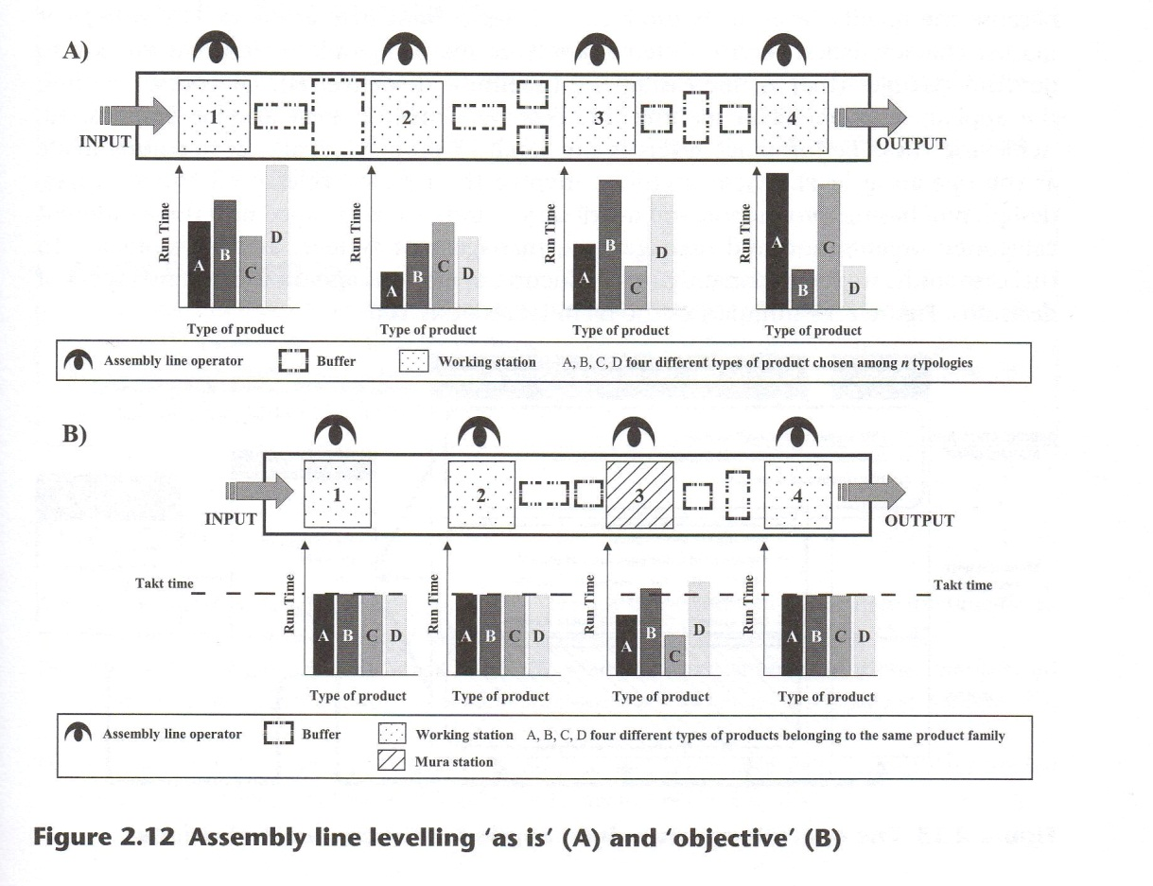The definition of the right production sequence plays a crucial role for the functioning of the entire levelling process. In fact, it is through this sequence's definition that variability is correctly managed at the mura station to guarantee that its throughput time is very close to the takt time.
2.3 Conclusions
The development of an international operations strategy is far from being a simple strategic issue or a pure engineering task: it is both of these at the same time. An operations strategy must be aligned with the company's main strategy objectives, which, in turn, must fit actual market needs and requirements. Moreover, an operations strategy is not only the manifestation of a competitive strategy in the field of operations, but a device for gaining a real competitive advantage. As a result, it must play an active role in assuring the company's success. For this reason, every opeiations strategy decision must be aligned With the goals and objectives of the entire corporation. Given the international context in which most firms currently compete, the operation value.chain by De Toni et al. (1992) helps to determine the right steps in the development of an international operations strategy. The case study analysed in this chapter provides an example of how this model closely resembles the reality currently faced by many companies.
The Electrolux Professional competitive strategy focuses on service differentiation because the quality level of its products satisfies current market needs. Given current market characteristics, service differentiation means being able to respond quickly to demand changes (that is, increasing the timeliness of deliveries). Of course, because the appliances market is a mature one, cost performance must also be emphasised. Achieving these performance levels is the result of proper managerial decisions made at the operating level. These decisions involve the primary operations (for example, design, purchasing, production and distribution) and can be grouped into three different categories: organisation and management, management systems and technologies. In this case study, we focused mainly on production operations and on the first two types of decisions. Figure 2.13 summarises the main issues described.

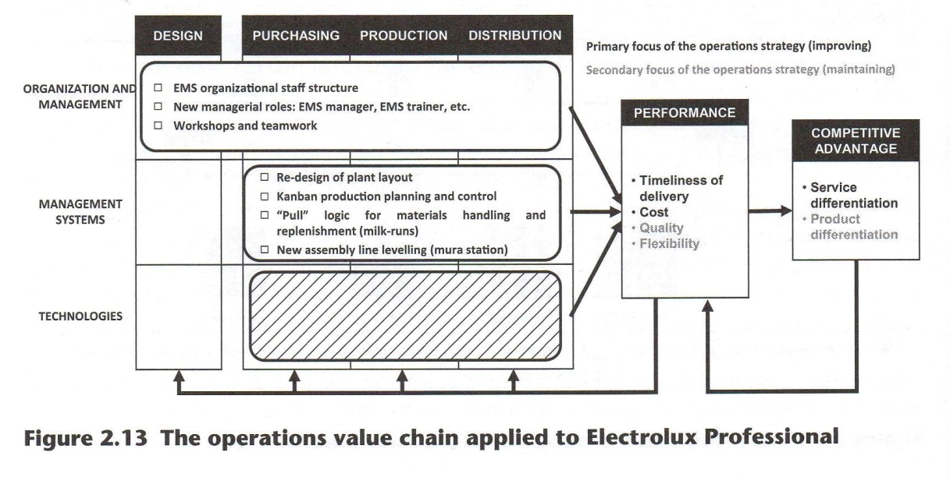
LESSON LEARNED
Coherence between operations strategy and international market requirements
The Electrolux case study suggests how satisfying real market needs, especially in an international context, requires that a company develops its operations to be a competitive and strategic weapon. The international pressure for better service levels required an operations strategy focused on reducing internal time performances. Thus a company aiming to increase its level of service can rely on lean practices to improve time performances and, at the same time, generate significant cost savings. This reduction of delivery time requires action on multiple levels: redesign of the plant layout, rethinking of materials handling and replenishment logics and kanban production planning and control systems.
Any decision made at the corporate or business level has an impact at the operations level. Clearly understanding this implication allows the organisation to leverage its operations to transform every decision made at the divisional or plant level into a competitive advantage for the entire corporation.

QUESTIONS FOR STUDENTS
- How can the time performances be classified?
- What are the fundamental aspects of the Electrolux Manufacturing System (EMS), and how are they related to the decision areas of an operations strategy?
- What is the most important action introduced by the EMS as far as the management systems are concerned? Why?
OPEN DISCUSSION
- Analyse Electrolux's strategy using the strenghts, weaknesses, opportunities, threats (SWOT) framework, and then try to depict possible alternative operations strategies.
- What if the market was a business-to-consumer one? Try to depict the main differences and effects on the operations strategy.

References
Azzone, G., Masella, C. and Bertele, U. (1991). Design of performance measures for time-based companies. International Journal of Operations & Production Management, 11(3), 77-85.
De Toni, A.F., Filippini, R. and Forza, C.(1992). Manufacturing strategy in global markets: an operations management model. International Journal of Operations & Production Management, 12(4), 7-18.
De Toni, A.F. and Meneghetti, A. (2000). Traditional and innovative paths towards time-based competition. International Journal of Production Economics, 66(3), 255-268.
De Wit, B. and Meyer, R. (2004). Strategy. Process, Content, Context. An International Perspective. Mason, OH: Thomson South-Western.
Fahey, L. and Christensen, H.K. (1986). Evaluating the research on strategy content. Journal of Management, 12(2), 167-183.
Hayes, R.H. and Wheelwright, S.C. (1984). Restoring our Competitive Edge: Competing Through Manufacturing. New York: Wiley.
Hill, T. (1991). Production/Operations Management. New York: Prentice Hall.
Leong, G.K., Snyder, D.L. and Ward, P.T. (1990). Research in the process and content of manufacturing strategy. Omega, 18(3), 109-122.
Porter, M.E. (1985). Competitive Advantage: Creating and Sustaining Superior Performance. New York: Free Press.
Prasad, S., Babbar, S. and Motwani, J. (2001). International operations strategy: current efforts and future directions. International journal of Operations & Production Management, 21(5 / 6), 645-665.
Schmenner, R.W. (1988). The merit of making things fast. Sloan Management Review, 30(1), 11-17.
Schonberger, R.J. (1986). World-Class Manufacturing: The Lessons of Simplicity Applied. New York: The Free Press.
Schroeder, R.G. (1989). Operations Management. Decision Making in the Operations Function. Singapore: McGraw-Hill.
Skinner, W. (1969). Manufacturing - missing link in corporate strategy. Harvard Business Review, 47(3), 136-145.
Skinner, W. (1974). The focused factory. Harvard Business Review, 52(3), 113-121.
Slack, N., Chamber, S. and Johnston, R. (2001). Operations Management, 3rd edn. Harlow: Pearson Education.
Slack, N. and Lewis, M. (2003). Operations Strategy. Upper Saddle River, NJ: Pearson Education. Stalk, G. (1988). Time: the next source of competitive advantage. Harvard Business Review, 66(4), 41-51.
Stevenson, J. (1990). Production/Operations Management. Homewood, IL: Irwin.
Swink, M. and Way, M.H. (1995). Manufacturing strategy: propositions, current research, renewed directions. International Journal of Operations and Production Management, 15(7), 4-26.
Ward, P.T. and Duray, R. (2000). Manufacturing strategy in context: environment, competitive strategy and manufacturing strategy. Journal of Operations Management, 18(2), 123-138.

