3
CHAPTER

Ford Case Study:
The Network Evolution
from Extended Enterprise
to Virtual Enterprise

The path followed by a leading company belonging to the automotive sector in the transformation from extended to virtual enterprise
ANGEL ORTIZ-BAS, RUBEN DARIO FRANCO, FRANCISCO-CRUZ LARIO AND PEDRO GOMEZ-GASQUET
3.1 Theory
3.1.1 OVERVIEW OF THE EXTENDED ENTERPRISE AND VIRTUAL ENTERPRISE MODELS
In the past, manufacturing has been organised primarily on a local level, in towns and cities. With the development of transport facilities and logistic distribution-shipping nets, both the market and production have widened their scope of connection to suppliers and customers on a regional level, country and, eventually, continent (Walters, 1997). The growth of information and communication technologies has also contributed to this large change in manufacturing processes. Boundaries are no longer limited by continents and products are now crossing the continents frontiers to be present around the world.
In the context of advanced manufacturing concepts such as extended enterprise and virtual enterprise have emerged as an answer to the new challenges imposed by an enterprise environment in which it is essential to respond quickly and effectively to the changes of customer demands.
A brief description of these concepts is now presented in order to recall them and to introduce the case study that will be dealt with in this document.
The extended enterprise model
The term extended enterprise (EE) model is used frequently in business literature to reflect the high level of interdependence that exists between organisations when they conduct business, not only in the manufacturing industry but also in other business areas (Browne and Zhang, 1999). However, the goal of the EE is much more ambitious than automated transaction processing and reduced cost (O'Neill and Sackett, 1994): EE is a concept applied to manufacturing business operation that looks at all of the participants in the product manufacturing process (Sehdev et al., 1995).
Thus the extended enterprise can be regarded as a kind of `enterprise' which is represented by all those organisations or parts of organisations, customers, suppliers and subcontractors, engaged collaboratively in the design, development, production and delivery of a product to the end user (Browne et al., 1996).
Figure 3.1 represents the basic idea of the EE model. It proposes an enterprise structure where there is a company, a dominant player that is highly centric in the structure, which decides to extend its boundaries to other actors of its supply chain (partners, customers, suppliers, intermediaries and market), thus leaving the pure single enterprise dimension and moving to a networked enterprise dimension.

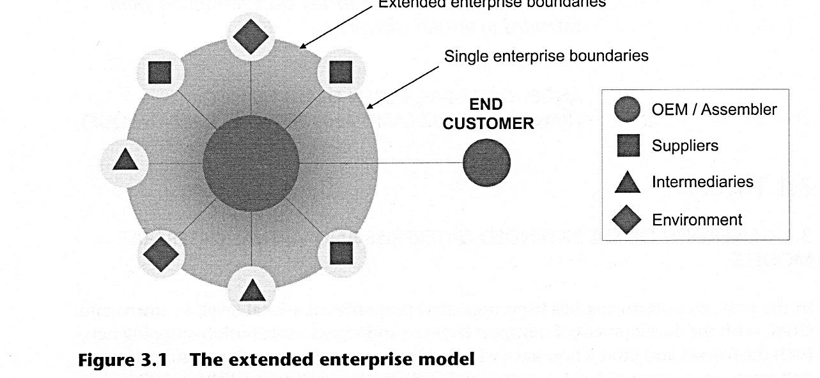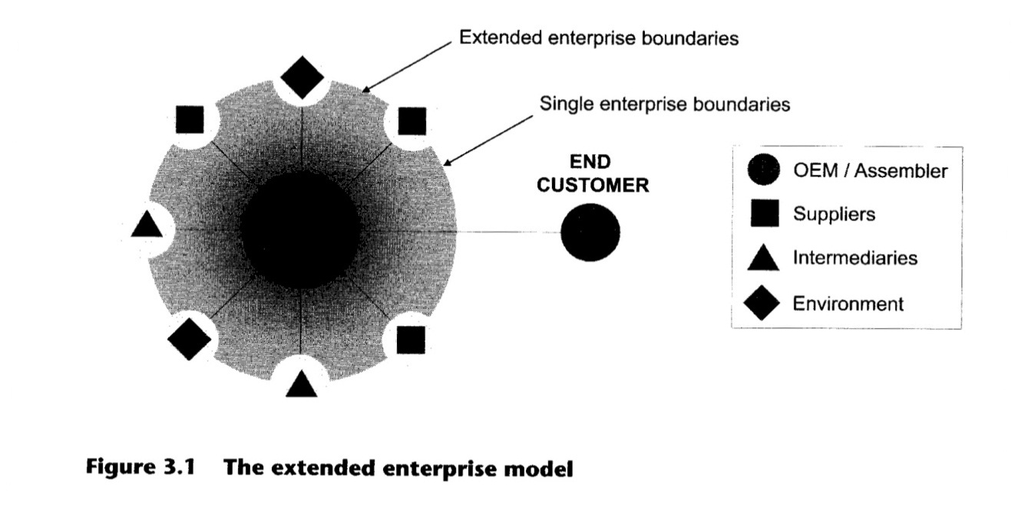

The extension of the dominant company is achieved through the development of long-term agreements and partnerships with other enterprises and patterns of behaviour based on communication are necessary to support the coordination, collaboration and cooperation between the EE actors (Browne and Zhang, 1999).
Within an EE, partners have the opportunity to work and specialise in the fields in which they provide operational excellence, have core competencies and offer a competitive advantage (Petersen and Szegheo, 2000), and manage to deliver jointly more added value than the sum of each partner acting separately.
On the other hand, as is well known, each single enterprise has defined a strategy, and to achieve its strategy it has a set of integrated capitals — human, operational, knowledge, technological, structural, financial, relationship capital and so on). These enterprises' capitals could be combined partially within the EE model (there remains some non-combined capital). This is caused because, supported by its value chain governance, the dominant company forces the extension of its capitals to include those of its partners. However, as the extension is governed by one side (the dominant company) and mostly' imposed upon the other actors, it only leads to a partial one-way extension that builds a master—slave disequilibria between the parts which compromises the development of a two-way complete and harmonious combination of their capitals.
Therefore, if a company expects to belong to an extended enterprise, it must coordinate its internal systems and activities with other systems in the supply chain, and must be flexible and ready to adapt to change (Martinez et al., 2001). The main purpose is to share engineering, planning and production information; improve knowledge transfer; improve business collaboration, and reduce time to market and costs.
Table 3.1 Summary of characteristics of the extended enterprise concept
Relationship | Participants | - Dominant enterprise (normally manufacturer and product owner) (Browne and Zhang, 1999)  - Suppliers, customers and other subcontractors (Browne et al., 1996; Gott, 1996)
Relationship | Nature | - Long-term with key suppliers and customers (Browne and Zhang, 1999)  - An EE is a partnership among enterprises (Petersen and Szegheo, 2000)  - Interdependence between the firms (Browne and Zhang, 1999)  - Patterns based on communication, coordination, collaboration, distributed cooperation (Browne and Zhang, 1999)
Relationship | Time extent | - Usually long-term oriented (Browne and Zhang, 1999)
Management issues | Management philosophy | - Focus on core competencies (Petersen and Szegheo, 2000)  - Dominance of one company that extends its boundaries to all or some of its suppliers (Camarinha-Matos and Afsarmanesh, 1999)
Management issues | Objectives | - Increase returns (Childe, 1998)  - Provide competitive advantage (Petersen and Szegheo, 2000)  - Reduce costs (Sehdev et al., 1995)  - Improve adaptability to changes and innovation (Martinez et al., 2001)  - Reduce time to market (Browne et al., 1995)  - Improve product life cycle (Browne et al., 1995)  - Improve business collaboration (Browne and Zhang, 1999)  - Improve information communication technology (ICT) integration (Zhang, 1998)  - Improve knowledge transfer (Boardman and Clegg, 2001)
Management issues | Organisational form | - Network of companies with a predominant role (CamarinhaMatos and Afsarmanesh, 1999)
Management issues | Sharing | - Mainly consists of engineering, planning and production information (Sehdev et al., 1995)
ICT | IT role | - Support for inter-enterprise communication  - Support for inter-enterprise integration (Browne and Zhang, 1999)

The virtual enterprise model
The term virtual enterprise (VE) model has become prevalent in multidisciplinary research and development initiatives ranging from virtual reality developments to information resource management trends. In the industrial context, the VE concept is assumed to be an evolution from EE where the partners are trying to establish a more democratic (or federated) approach in managing information, goods, decision and control flows.
Several definitions have been proposed to explain the meaning of VE. In order to describe the scope of the term, the following definitions are included:
- A virtual enterprise is 'a temporary alliance of enterprises that come together to share skills or core competencies and resources in order to better respond to business opportunism, and whose co-operation is supported by computer networks' (Camarinha-Matos and Afsarmanesh, 1999).
- 'A virtual corporation is a temporary network of independent companies, suppliers, customers, even erstwhile rivals linked by IT to share skills, costs and access to one another's markets' (Davidow and Malone, 1992).
- 'The Virtual Enterprise consists of a series of co-operating nodes of core competence which form a supply chain in order to address a specific opportunity in the market place' (Walton and Whicker, 1996).
Figure 3.2 presents the basic idea of the VE model. A VE could be seen as a set of enterprises (and its capitals) which are integrated in a federated model where no partner can assume any preponderant role and there is a balanced decision-making process.
The main objective of a VE is to allow a number of organisations to rapidly develop a common working environment; hence managing a collection of resources provided by the participating organisations toward the attainment of some common goals. Because each partner brings a strength or core competence to the consortium, the success of the project depends on all cooperating as a single unit (Martinez, 2001).
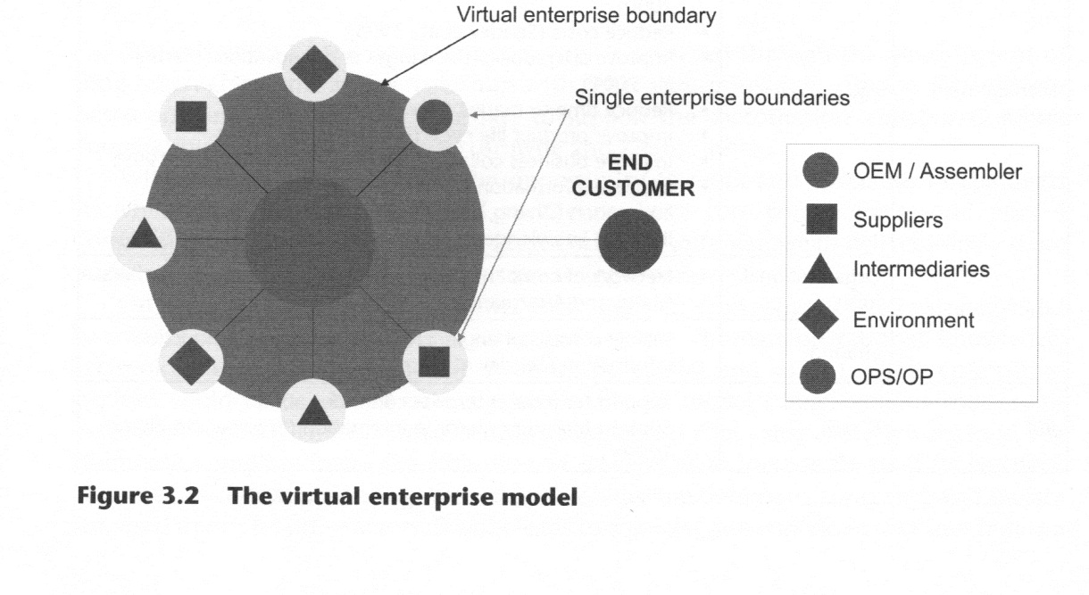
The VE life cycle has to be highly dynamic. It must allow the partners to easily redefine the VE structure, goals and functionality in order to achieve higher levels of performance and efficiency. The aim must be to improve and enhance the coordination, collaboration and cooperation mechanisms that allow the companies to develop sustainable competitive advantages, focusing theirs capabilities and resources on those tasks that will increase the customers' perceived value. Then the enterprises can access complex market opportunities.
On the other hand, the VE model has a limitation: being dynamic and flexible, the major benefits of VE, could produce very short life cycles in some VE structures. Nevertheless, this fact is not a general rule. The VE can be considered as a short-, medium-or long-term alliance.
Table 3.2 Summary of characteristics of the virtual enterprise concept
Relationship | Participants | - The virtual infrastructure at meta-enterprise level (Vernadat, 1996)  - Original equipment manufacturing (OEM), suppliers, customers and other subcontractors (Davidow and Malone, 1992)
Relationship | Nature | - Higher interdependence between the firms  - Patterns based on coordination, collaboration and integration (Walton and Whicker, 1996)  - Dynamicity and flexibility are pursued (Katzy, 1999)
Relationship | Time extent | This dimension has no agreed reference in the literature. Some authors refer to it as a temporal kind of relationship while others offer no discussion at all. In either case, without explicit consideration, a VE can be considered as a short-, medium- or long-term alliance.
Management issues | Management philosophy | - Distributed business process layout and execution (Hardwick and Bolton, 1997)  - Balanced decision-making process  - Federated organisational form where no one member has predominance over the rest (Davidow and Malone, 1992)
Management issues | Objectives | - To share skills, costs and markets (Davidow and Malone, 1992)  - Capture emerging business opportunities (Katzy, 1999)  - Create a collaborative environment
Management issues | Organisational form | - Network of cooperating nodes (Walton and Whicker, 1996)  - Consortium, alliance or corporation (NIIIP, 1996)  - Joint venture
Management issues | Sharing | - Skills • Costs  - Core competences • Assets  - Access to one another's markets (Hardwick and Bolton, 1997)
ICT | IT role | - Support for inter-enterprise communication  - Support for inter-enterprise integration (Camarinha-Matos and Afsarmanesh, 1999)

3.1.2 THE MIGRATION PATH FROM THE EXTENDED TO THE VIRTUAL ENTERPRISE
As already mentioned, virtual enterprises tend to be a more democratic organisational models (Camarinha-Matos and Afsarmanesh, 1999), where partners increase their visibility within the network and a complementary decisional flow emerges to represent a balancing power that acts as a win—win relationship enabler. According to Martinez and colleagues (2001), the main objective of a VE is to allow a number of organisations to rapidly develop a common working environment; hence managing a collection of resources provided by the participating organisations towards the attainment of some common goals. Based on the previous considerations, it is possible to state that the VE approach offers a wide range of benefits and performance improvements. In some cases it may be more convenient to adopt a VE approach rather than an EE approach. Enterprises (mostly the EE) are discovering the advantages of adopting a VE model.
The purpose of a migration path from the extended to the virtual enterprise will now be presented.
The migration space
According to the literature, there are two dimensions to consider when analysing the migration from EE to VE:
- Business dimension. This is focused on covering business topics, for instance, the changing role of the participants (moving from a dominant role to a more federated approach), the evolving nature of the relationship (from centralised and static environments to collaborative and dynamic networks), the transformation of the management philosophy (from a centralised model to a more democratic one), and so on. For a thorough analysis see Camarinha-Matos et al. (2005); Karvonen et al. (2005) and Volpentesta and Muzzupappa (2005).
- ICT dimension. In contrast, this dimension is fully technological and ICT related. It considers that, additionally to the business evolution, the information systems and technological platform must evolve also in order to support the VE life cycle effectively and efficiently. Through ICT the enterprises can achieve a high level of integration and noticeably improve business process execution. For a thorough analysis see Mo et al. (2005); Petersen et al. (2005) and Pinheiro and Rabelo (2005).
Either of these perspectives has advantages and disadvantages, and the evolution from EE to VE should be carried out taking these two dimensions into account in an integrated way. Based on these considerations, it is possible to construct the migration space model depicted in Figure 3.3. First, it underlines that there are many migration paths that can lead from EE to a VE model. Secondly, the two axes of the migration space represent mutual interdependence between both dimensions, so that moving only one axis is not possible and the migration path must evolve on both business and ICT dimensions. Finally, the migration space defines several frontiers in the evolution both in terms of business and ICT:
- Acknowledgement. It represents the edge of the existence of the VE, where it begins to be accepted and targeted by the involved organisations.
- Communication. The first level towards inter-enterprise SC integration. It allows the change from knowledge 'islands' to knowledge 'highways'. Thus, two different companies are capable to communicate with each other and exchanging knowledge.
- Visibility. The second level towards inter-enterprise supply chain (SC) integration. The goal is to give visibility to the SC and planning the activities and responsibilities from each SC node.
- Synchronisation. The third level toward inter-enterprise SC integration. It determines the optimal way that companies have to exploit their visibility to cooperate in a common mission.
- Collaboration. The fourth level towards inter-enterprise SC integration. The maximum
collaboration is obtained when win-lose/lose-win relationships move to win-win.
- Eldorado. The idealistic paradise city of VE, where the highest level of virtualisation is achieved within the networked enterprise.
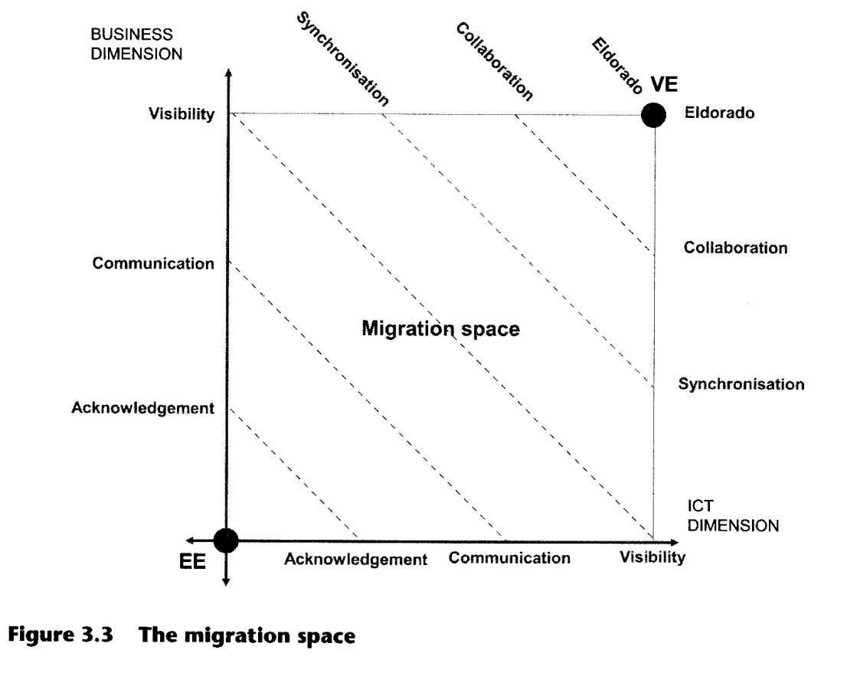
The proposed migration path
The migration path (MP) is different for each case (Figure 3.4). According to the circumstances or the conditions of the environment, the MP is more focused on covering business topics or ICT topics. Thus it is possible to find multiple MP (MP1, MP2... MPn) and it is therefore better to identify 'stages' in moving from an EE to a VE. The following six stages have been proposed by Ortiz and colleagues (2003):
- S1 - the extended enterprise (basic and advanced). This stage represents the initial step in the evolution, which matches the characteristics already introduced for the EE concept. There are two different kinds of EE: advanced (more complex flows, relationships and strategies between the involved partners), and EE (much simpler and incipient).
- S2 - the acknowledged virtual enterprise. At this stage, the predominant company recognises that companies involved in the EE must evolve together iri order to improve their collaboration. The VE model provides the networked organisation with an improvement path, through which the VE paradigm starts to gain members at the strategic level inside each involved company, and an incipient culture appears. A knowledge and discovery process also begins.
- S3 - the communicating virtual enterprise. The first step toward the VE is the achievement of the communication integration level within the networked organisation. The issues here are mainly technical and technological.
- S4 - the visible virtual enterprise. The second step toward the VE is the achievement of the visibility integration level within the networked organisation. It is based on the capacity to communicate that exists between the enterprises. The issues here are still highly technical and technological, but business starts to gain importance.
- SS - the synchronised virtual enterprise. The third step toward the VE is the achievement of the synchronisation integration level within the networked organisation. It is also based on the capacity to communicate and the visibility. The issues here are increasingly business-oriented.
- S6 - the collaborative virtual enterprise. The final stage in this path implies full VE accomplishment and integration. Its independence as a single business entity is established. The benefits have been achieved, the drawbacks overcome, and all of the actors have a VE-centric organisational culture. The meta-enterprise gains complete recognition and governance.
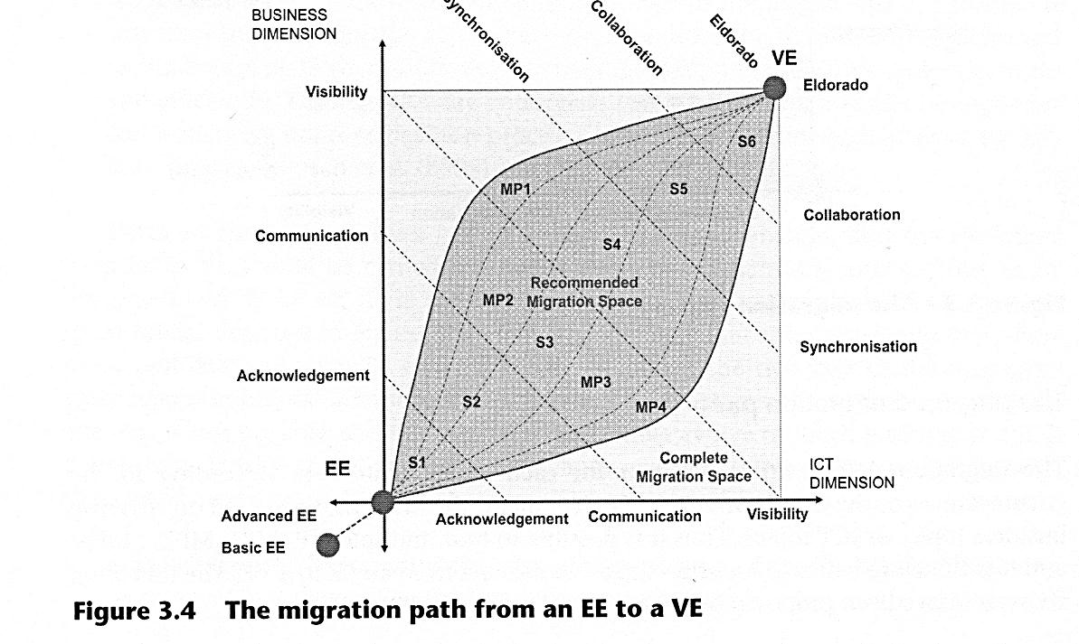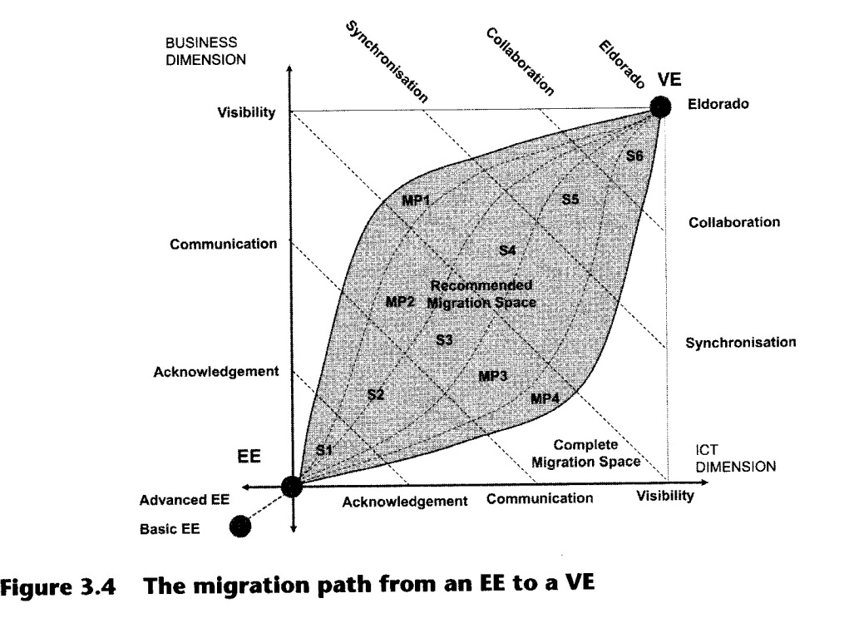
3.2 Case Study
3.2.1 COMPANY PROFILE
Main contributions from this case study have been developed in one of the pilots of the European project V-CHAIN — Virtual Enterprise for Supply Chain Management, GRD1- 2000-25881-EC, GROWTH PROGRAMME, which was aimed at improving supply chain operations by evolving conventional SC practices towards a Virtual Enterprise-based paradigm.
Ford Motor Company is a global automotive industry leader manufacturing and distributing vehicles in 200 markets across 6 continents. Founded in 1903 by Henry Ford in Detroit, USA, over the years it has become one of the world's largest producers of cars and trucks and one of the largest providers of automotive financial services. Today the company offers a wide range of vehicles with alternative fuels and also is a leader in the use of recycled goods to manufacture its vehicles.
Ford Motor Company has been working jointly with other prestigious vehicle manufacturers such as Aston Martin, Jaguar, Lincoln, Land Rover, Mercury, Mazda and Volvo. Thanks to agreements between Ford Motor Company and two of its main competitors, General Motors and Daimler Chrysler, they joined their strengths to revolutionise the e-business between the organisations (B2B), creating the biggest marketplace for the automotive industry, called Covisint, by providing procurement, supply chain and product development functionality. The objective of Covisint is to assist the automobile industry in increasing the efficiency of the supply chain both by creating digital markets and increasing coordination among buyers and suppliers.
Ford Motor Company in Europe
In 1921, Ford started its manufacturing plant activity in Dagenham, Great Britain, and in 1931 began operations in Cologne, Germany. Currently, in Europe the Ford Motor Company has:

- Sixteen sales companies
- Eighteen manufacturing plants
- Six motor and gearbox plants
- , Seven plastic and other components plants
- Four pilot plants
- Three R&D centres
- One transmissions plant
- Two central offices

These installations employ 100,000 workers and roughly generate an annual production volume of 1.8 million vehicles. The plants are located in different European countries: the UK, Germany, France, Russia, Turkey, Belgium, Spain and Sweden.

Ford Spain
Ford Spain is 20 km from Valencia. It was opened in 1976 and today produces around 1,810 vehicles per day. The factory is composed of seven plants: spares, presses, motors, bodies, paint, assembly and pilot plant.
Ford Spain built an industrial park beside its plant in 1996. They are connected by closed air tunnels (conveyor) which are completely computerised to deliver some components at the exact point of use in the line (just-in-time). The aim was to bring the suppliers nearer to the Ford plant and to optimise the material flow. It allows Ford Spain to increase the sequence of deliveries, outsource subassemblies, optimise the transport in the plant, increase the product quality, have a quicker response to solve incidences by product defects, and so on. There are also environmental savings: because the air tunnels deliver the material sequentially, it is possible to save 268 trucks daily and to reduce the stock zone from the lines. Moving most of their suppliers to the industrial park has created a new kind of relationship between them and Ford, based on a more collaborative model. A Logistics Operator is in charge of the management of the logistics between the OEM/assembler (Ford) and some suppliers.
A logistics centre (CLASA) was also created next to the assembly plant and is in charge of the production planning, raw material control and supplying the production lines. The main objective is to further reduce the quantity of components at the warehouse. Now pieces are at the warehouse for approximately 2.5 days. Trucks arrive at the logistics centre and an external enterprise carries out the process of continuous supply. Small pieces are unpacked and placed on the different assembly points.
Figure 3.5 gives a brief description of the vehicles manufacturing process and the interaction between Ford's plants and suppliers from the industrial park.
The Body and Assembly Operations (BAO) are the set of activities directly related to the manufacturing process and they are split into four plants: presses, body, paint and assembly. The motor plant is not considered within this process, as it is regarded as a supplier to the assembly plant.

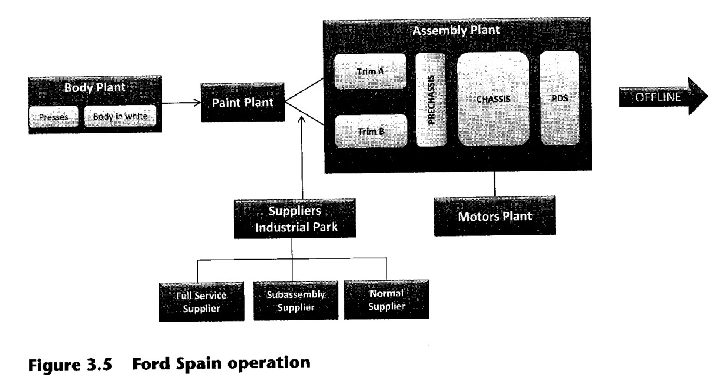
On the other hand, all the suppliers from the industrial park (full service suppliers, subassembly suppliers and normal suppliers), are continuously supplying components to the plants (specially the assembly plant). Some of them use the air tunnels and others work with wheelbarrows and other vehicles.
3.2.2 THE EXTENDED ENTERPRISE MODEL OF FORD'S SUPPLY CHAIN Ford's partnership strategy
The joint strategy between Ford and its partners depends on the partnership and the agreements between them. Thus, Ford plays a leadership role within the supply chain (SC) and works with different kinds of suppliers depending on the collaboration level, the decision capacity and the economic agreements:
- Full service supplier (and high-level subassembly). This is a first tier supplier who is responsible for its own logistics: it independently chooses its own suppliers, the components of its products, and so on. The goal is to fully utilise supplier expertise in product development through a collaborative relationship. This involves working in partnership with Ford and its full service suppliers to perform product design, engineering, testing, and manufacturing activities. It is mandatory that a full service supplier gets the Q1 quality certificate.
- Subassembly supplier (on consignment). A first tier supplier performing both assembly and manufacturing operations. This supplier receives part of their supplies from a second tier supplier and these materials are stored on consignment in its facilities (although the materials are bought by Ford Spain, S.A., which also owns the equipment and know-how in some cases). Just like the full service suppliers, subassembly suppliers are deeply involved with Ford and its business.
- Normal supplier. A first tier supplier which manufactures its parts and sends them to Ford Spain, S.A. The product is standardised, so there is no cooperation between Ford and the supplier: Ford must choose a product from the supplier catalogue. Examples are tires or steel.
Inter-enterprise flow
Ford and its partnerships have established a wide range of mechanisms and strategies to share among them important engineering, planning and production information. On the other hand, they have also established methods for material and products transportation and delivery:
- Material and products delivery. There are different methods to transport materials and products between suppliers and the OEM (see Figure 3.6). The method depends on the supplier location and the characteristics of the product/material:
- Direct automatic delivery (DAD): a sequenced delivery method in which a conveyor system (a tunnel) takes the component from the supplier's point of assembly directly to the point of use in Ford's assembly line, eliminating all intermediate handling (in some cases handling is synchronised).
- Sequenced supply: a delivery method carried out according to the sequence of vehicle in the assembly line, allowing the line worker to assemble the parts without checking the build tag. The sequence suppliers deliver their materials to Ford through a logistics operator according to shipment characteristics sent to them by the logistics operator.
- JIT supply: a delivery method based on smaller and more frequent parts shipments throughout the day. The main objective is to reduce stock accumulation on the assembly line and to adjust the material supply to the real demand. The JIT suppliers deliver their materials to Ford through a logistics operator according to shipment characteristics sent to them by that operator.
- Traditional supply: other traditional delivery methods
- Information flow. Ford sends and receives information from suppliers and the logistics operators (see Figure 3.6). The main documents that Ford sends and receives are:
- Release for production material: an electronic document, sent via Odette file transfer protocol (OFTP) and with electronic document interchange (EDI) format. This document specifies the quantity required for the next six months for every part number. The first three months are detailed for each week and the document is sent every week.
- Daily call in (DCI): this communicates the daily needs for every part number for the next ten days. Ford sends it and checks it every day.
- Predicted sequence: shows the manufacture order for the next five days. Ford sends it and checks it every day. This information is only useful for sequenced and some DAD suppliers.
- Trip and pick-up sheet: indicates where the carriers have to go to and which materials they have to pick. These sheets must be according to manufacturer's demand.
- Advanced shipping notes (ASN): indicates the materials that are going to be sent to the manufacturer from the relevant supplier.
- Knowledge flow. In some cases, Ford sends its design specifications for the manufacture of the subassembly and shares its know-how with the supplier. In other cases, Ford must choose a product from the supplier catalogue. Ford is also concerned about suppliers' process of continuous improvement and its specialists visit suppliers to apply their knowledge in solving some suppliers' problems.
- Communication systems. The utilisation of ICT allows a fluent and constant relation between Ford and its suppliers, and even between the suppliers themselves. Thus the inter-enterprise communication and integration are ensured. The more developed technologies are the ones operating between Ford Spain and the industrial park suppliers:
- The material call-in server, together with the Production Vehicle Scheduling (PVS) and the In-plant Material Flow (IPMF) allow connection - through the communications centre - with the suppliers, using a fibre optics link, which is protected by a firewall router.
- The supplier receives the information through a router connection via ethernet, having the option of using its own local area network for in-house communications.
- The fibre optics link is backed up by a leased line.
- In case of failure of both the fibre optics link and the back-up line, there exists the possibility of establishing an emergency connection via the global system for mobile communications (GSM).
- To communicate with suppliers which do not belong to the Industrial Park, there are other communication systems, such as an extranet, point-to-point line, public Internet or a modem with an emulator.
5. The industrial park, the logistics centre and the logistic operator. Working with these entities, Ford Spain has achieved benefits:
- Bringing the suppliers near, therefore the JIT and sequence deliveries can increase
- Outsourcing subassemblies
- Optimising transport in the plant
- Substitute carton packaging with durable packaging
- The use of three tunnels (conveyors) to join some suppliers with Ford. This allows synchronised deliveries.
After the analysis of the main features of the Ford SC, it is possible to conclude that Ford and its industrial partners form an EE. The description of this SC fits with the EE definition.

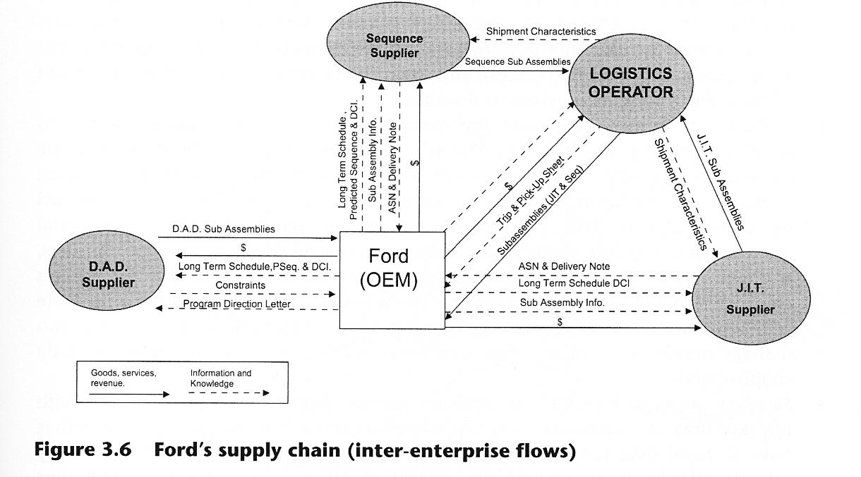
Main potential areas that can be improved
Although Ford Spain and its suppliers have managed to build a strong EE, there are still some areas that must be tackled in order to improve the SC performance. Both Ford and its partners have recognised some problems associated with the SC management and with the relations established among them which could be classified into four categories:
- Supply planning and sequencing. The production plan is one of the key elements on which the supply chain processes depend. However, this plan may be affected by the supply chain members. Regarding supply planning and sequencing, Ford's partners have found problems such as lack of quality, complexity and reliability of the information, irregularity of supplying plans, differences among the quantities required and the capacity of the packages, reduction of the guaranteed periods for the plans by the manufacturer and deficient delayed cars management. Ford has identified problems such as non-fluent communication from supplier to manufacturer to inform promptly about lack of parts, quality and maintenance problems or incidents, failure to keep the scheduling and excess of materials (more stock than calculated and authorised). In addition, there are other problems that have been indentified jointly and they are: the frequent and important changes in production scheduling and sequencing, the ignorance of supplier's constraints and capacity, and a lack of information about supplier's quality rejections.
- Information system and flow. Within the supply chain, information must flow effectively between all the partners involved. The use of real-time communication tools facilitates information exchange between all the actors. Ford and its partners are aware of the information's visibility advantages, but there are still some problems. Suppliers feel that information is not personalised and would like to have data more related to their area of concern. They also find the current user interfaces slow and difficult to manage from a user point of view. On the other hand, Ford and its suppliers also recognise the existence of information flow inconsistency and overlapping (the same information is in two places), and some of the integration problems presented when a new information system is installed.
- Collaboration in the supply chain. For companies such as Ford Spain is essential to adopt a collaborative approach. The whole supply chain must work as a single element to successfully achieve the synchronisation of activities and the sequence of manufacturing information. Some deficiencies in this area have been identified by Ford's suppliers. They say that there is an inadeguate and obsolete material management, a disagreement between the supply chain decisions and the suppliers, and a gap between delivered cars and sold cars. Furthermore, Ford and its suppliers consider that the relationship between the assembler and suppliers must be more collaborative and win—win. Ford also found it is important to define a model that can manage supplier's constraints and capacity in order to avoid problems in the daily supply chain.
- Suppliers' outbound logistics/Ford's inbound logistics. Within Ford's SC there is a high physical flow of materials among several members. On the one hand, the suppliers have to hand over the finished product to the OEM. To achieve this, they carry out activities such as warehousing, order fulfilment, transportation, distribution management and so on. On the other hand, Ford has to control this delivery process through activities that include receiving, storing, inventory control of input materials, transportation scheduling and so on.
The following problems have arisen with regard to these problems: deficient container management, over-shipment not authorised, lack of containers in supplier site, delivery of obsolete material, some carriers arrive at the suppliers with insufficient capacity, different quantities of material to that expected are delivered, lack of coordination between the
manufacturer and suppliers to manage temporal changes of packaging unit and mistakes on the material that must be loaded in a day.
3.2.3. APPLYING THE MIGRATION METHODOLOGY TO FORD'S SUPPLY CHAIN
The migration path defined for Ford's supply chain is described in Figure 3.7. It starts with an advanced EE stage and reaches the collaboration space, which is only partially covered. The migration path goes through six stages:
- S1 advanced extended enterprise (starting stage)
- S2 acknowledged virtual enterprise (intermediary stage)
- S3 communicating virtual enterprise (intermediary stage)
- S4 visible virtual enterprise (intermediary stage)
- S5 synchronised virtual enterprise (intermediary stage)
- S6 collaborative virtual enterprise (ending stage)

The migration path reveals that the initial focus is highly business-oriented (S1), then moves primarily to ICT issues (S2, S3, S4), progressively coming back once again to business issues. This highlights the fact that the launching of the improvement initiative must be fully governed by the business areas. Then quick wins and improvements are provided by ICT, which enable the discourse to come back to the full business dimension, thus providing major industrial achievements and added value.
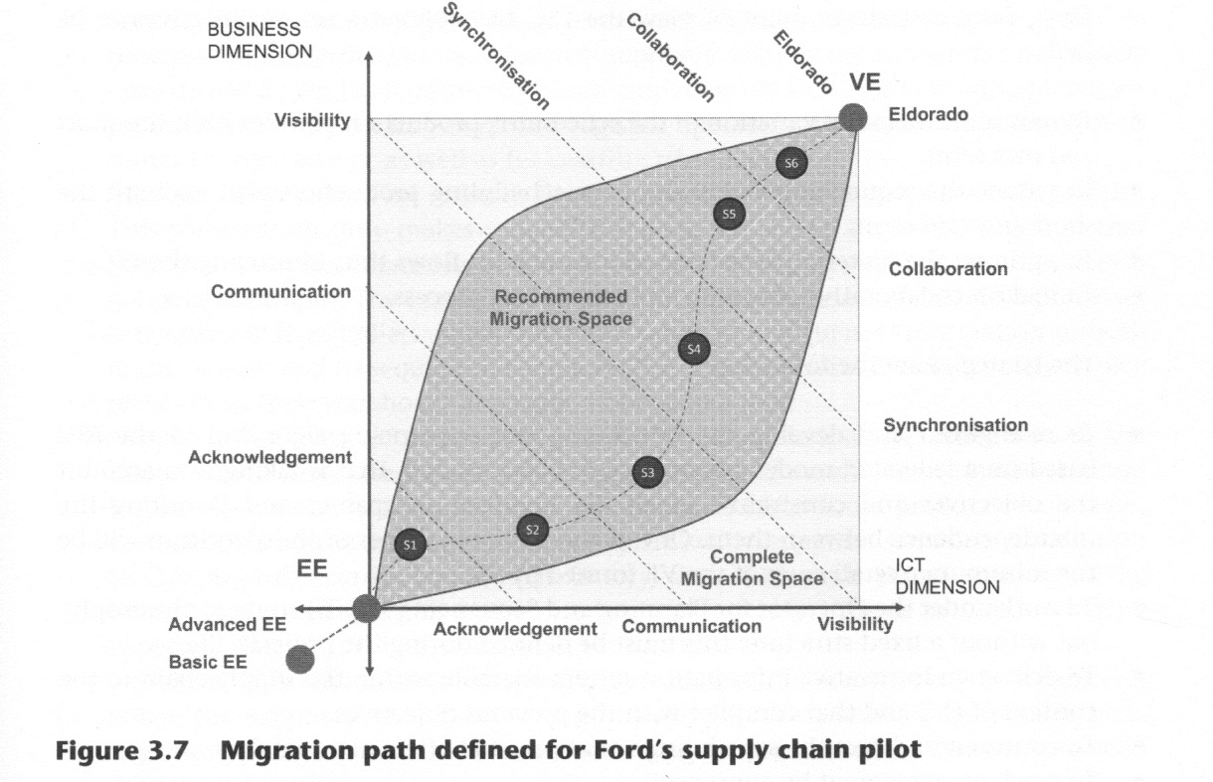

The scope of the migration project was limited following three main aspects:
- Tiers: the scope has been limited mainly to Tier 0 (Ford) and Tier 1 (Johnson Controls, Dynamit Nobel, Grupo FSegura), but also involves Tier 2 (Grupo FSegura). Exel makes the link between Tier 0 and Tier 1.
- Nodes: five nodes of the SC are directly involved in the project (Ford, Exel, Johnson Controls, Dynamit Nobel, Grupo FSegura) that belong to three categories (OEM, logistics operator, suppliers). The nodes involved represent several different families of suppliers, thereby adding value to the broadness and applicability of results. Furthermore, the suppliers have been intentionally selected to range from large multinational companies (Johnson Controls) to smaller multinational ones (Dynamit Nobel) and finally to local small and medium-sized enterprises (SMEs) (Grupo FSegura).
- Processes: two main business processes are covered — planning and sequencing. These processes have been selected because they are critical in the relationship between OEM, logistics operators and suppliers.
3.2.4. THE VIRTUAL ENTERPRISE MODEL OF FORD'S SUPPLY CHAIN Objectives and strategies
Different enterprises that make up Ford's supply chain (FSC) have a clear understanding about the advantages of VE. They are aware that cooperation, collaboration and integration are the best mechanisms to increase the customer's perceived value.
Thus, from a strategic point of view the FSC has defined a set of objectives to be reached:
- To reduce the demand variation of the scheduling production plan for both the short and mid term.
- To reduce the sequencing variation of the scheduling production plan for both the short and mid term.
- To optimise the material, decision and information flows thus improving the FSC.
- To make a collaborative planning and scheduling process.
The strategies are the following:
- To re-engineer and develop the scheduling and sequencing algorithm in the FSC based on a federated model (versus a centralised model), that is taking into account the objectives and constraints of all the involved companies and favouring the interdependence between them. One of the main objectives of the algorithm will be the minimum overall costs of the VE formed by FSC.
- To work under the Operator for Planning and Sequencing's (OPS) strategy philosophy but without a fixed structure; this must be defined during the project's life.
- To deliver an innovative information system sharable within the supply chain in the context of FSC and that complies with the previous objectives.
- To control and detect the scheduling variations that affect material flow.
- To reach an agreement by consensus.
Inter-enterprise flows improvement
Most inter-enterprise flows needed in the VE supply chain model are common to the existing ones in EE model (for instance material flow). Nevertheless, there is a big difference in the way the information flows along this new SC because it is very important to guarantee the dynamicity and the flexibility of the system. For this reason, the following information flows have been redefined:
- Long-term demand plan (strategic plan). This is the estimated demand for the long term (one to six months) that manufacturer sends to the OPS. The manufacturer creates this information based on its own sales strategy and forecast, market inputs and so on. The OPS processes this information together with suppliers' constraints and sends a new long-term demand plan to all partners. Usually, suppliers use this information to plan their provisioning for next months and send their own long-term demand plan to their suppliers (2+ tier suppliers).
- Mid-term demand plan (tactical plan). This is the estimated demand for the mid term (one to four weeks) that manufacturer sends to the OPS. The manufacturer creates this information based on its own tactic of distributing production among its different factories. The OPS processes this information together with suppliers' constraints and sends a new mid-term demand plan to all partners. Usually, suppliers use this information to validate their capacity plans for next weeks and send their own midterm demand plan to their suppliers (2+ tier suppliers).
- Short-term demand plan (operational plan). This is the estimated demand for the short term (one to seven days) that the manufacturer sends to the OPS. The manufacturer creates this information based on its own materials needs for every factory. The OPS processes this information together with suppliers' constraints and sends a new short-term demand plan to all partners. Usually, suppliers use this information to plan their production for the coming days. The logistics operator uses this information to plan routes for the carriers, as well as for creating trip sheets.
- Sequence information. This refers to the manufacturer's production the coming hours. This information only makes sense if there are sequenced suppliers (suppliers that have to deliver their materials in the same order that the just-in-time manufacturer is going to use them). The manufacturer sends this information to the OPS; it processes it together with suppliers' constraints and sends new sequence information to both manufacturer and its sequenced suppliers. The suppliers normally use it solely to pick pieces from their warehouse and order them into a line.
- Shipping notes. This information indicates the materials that are being sent to the manufacturer from one supplier. Normally, this should match the estimated demand for the short term, but sometimes it differs due to last-minute production changes, not enough room in the transport, and so on. Usually, suppliers send this information to OPS once the carrier leaves their factory, then OPS sends shipping notes to the manufacturer and logistics operators. Logistics operators use it to check whether expected materials will be available in time or not.
- Trip sheets. This sheet shows the specific route for a carrier, in other words, it indicates where the suppliers' carriers have to go to and which materials they have to pick. Logistics operators make these sheets according to manufacturer's demand and send them to the carriers.
- Constraints. This information indicates the production and capacity constraints that one supplier has to fulfil manufacturer's estimated demand. Suppliers send this information to OPS. It consolidates constraints coming from every supplier together with demand from the manufacturer, thus generating a new sequence and demand plans.
- Invoices. Suppliers send invoices to the manufacturer for materials they have sent.
ICT improvement
When an EE model becomes a virtual enterprise supply chain, the traditional existing systems (like communications, information exchange and back-end systems) are not enough to support new ways to work, communicate and relate. Therefore, new types of systems are needed in addition to those existing in the EE model.
Ford utilises an integration platform called Operator for Planning and Sequencing (OPS). It is responsible for the integration of all VE members' systems, as well as routing all information flows among them. It is conceived as the technological tool that makes partners interconnections possible. In order to be successful, this OPS system is based on six main key IT concepts:
- Intra-enterprise systems integration. It is necessary for information to be inserted and extracted from the back-end systems of every actor, in order to share it with the rest of members of the supply chain. To achieve this, a new concept has arisen: Enterprise Application Integration (EAI). EAI integrates systems within the company frontiers. It is based on an element called the integration bus and all applications are connected to it. Thus, the applications are integrated using only one interface (normally online) with the integration bus. This reduces complexity, decreases maintenance and operation costs and provides business people with a complete and unified vision of the business processes.
- Inter-enterprise systems integration. In the new VE model, there are many more information flows among all actors involved in the supply chain. That information should flow in a fast and easy way. Therefore, a system is required that can control how and when this information should go from one actor to another. To integrate systems that belong to different companies, it is necessary to use standard information formats (like EDI, XML, VDA, and so on) and communication protocols (HTTP, FTP, OFTP and so on) because normally each company has its own and these cannot be imposed by one of the actors. Business-to-Business Integration (B2Bi) offers all the tools to cover these aspects.
- Distributed Business Processes Management (BPM). In the VE model, business processes are spread among all members of the supply chain. There is no principal actor that controls the others and imposes all its processes, now all actors collaborate to improve the process and therefore the supply chain (it is a more federate model). BMP is a tool to model, automate, monitor and analyse business processes that can be made of any combination of both manual and automatic steps, and that can be spread among different systems within a company or even in different companies. BMP has a graphic interface that allows managers and analysts to implement and maintain business and integration logic without any coding. Also, it is integrated with EAI and B2Bi tools, and supports components reusability by supporting nested business processes and submodels calls.
- Multi-channel access. In the VE model there is a lot of information flowing, so it is important to hold multiple channels and interfaces to access the information and systems, depending on the type of information, the place, the importance of this information and so on. These new channels include web browsers, mobile telephones, PDAs and e-mail. It is also indispensable to integrate all these channels with each other and with back-end systems.
- Real-time data analysis. This allows both business and IT people to analyse and react to events as soon as they appear, to define and monitor key performance indicators (KPIs) to see whether a new change in a business process improves it or not, and finally to automate decisions in time-dependent business environments.
- Security. As there are a lot of information flows and a lot of actors and systems dealing with it, it is necessary to have a secure system. The actual secure system ensures that: information is neither corrupted nor lost; there are no unauthorised people that can eavesdrop, access or modify information; every transaction is logged for both monitoring and disaster recovery purposes; people can only access the information they are allowed to; there are replicating and load-balancing mechanisms that provide high performance and high availability, and so on.
Ford's virtual enterprise supply chain today
Following the migration path proposed in a previous section, and comparing it with the actual characteristics from Ford's VE supply chain, it is possible to state that Ford Spain and its partners are now in an advanced stage within the migration path. The entire organisation has built a high-level communication structure, and thus achieved a great synchronisation integration level within the organisation.
The reached achievements are these:
- There is a clear definition of the objectives and strategies along all the SC.
- The main core competencies of each actor have been put together (including university and consulting firm core competencies) and the result has been a significant added value increase.
- All the organisation's members carry out the Service Level Agreements (SLA) which have been established to ensure the QoS (Quality of Service).
- The organisation has designed a clear business map that covers most of the intra- and inter-enterprise operations.
- There is a set of tacit and explicit knowledge, both intra- and inter-company.
- Ford and its suppliers have achieved to synchronize direct material requirements to cope the dynamic demand.
- The organisation relies on an EAI/B2Bi platform which allows integration among different IT solutions thanks to the use of standard programming languages and also the possibility of adding filters to manage different types of data, coming from different internal or external sources. This platform manages the functional and information flows along the SC and makes it possible to share any kind of information between all the systems.
Although Ford and its suppliers have invested a great deal of effort and resources to become a solid EE and then to migrate to a VE model, there are still some aspects in need of improvement. The most important challenge now is to evolve to a more collaborative organisational model, where all the actors can be integrated as a real single business entity.
LESSON LEARNED
Opportunities in becoming a virtual enterprise
This case study depicts the relationships between different partners in the evolution from an extended enterprise (characterised by the dominant role of a single company) to a virtual enterprise (in which all the partners have a similar position in the network with more value added for everyone). It highlights the opportunities of this transformation.

QUESTIONS FOR STUDENTS
- Which are the main characteristics that identify Ford Spain and its suppliers as an EE?
- Why is it necessary for Ford Spain to change from EE to VE?
- What do you think about the Ford's VE supply chain model? Does it fulfil the VE model requests? Why?
OPEN DISCUSSION
- Identify those aspects which could limit the migration process from EE to VE.
- Can you propose another strategy to achieve the FSC's objectives?
References
Boardman, J.T. and Clegg, B.T. (2001). Structured engagement in the extended enterprise. International Journal of Operations & Production Management, 21(5/6), 795-811.
Browne, J., Harhen, J. and Shivnan, J. (1996). Production Management Systems: An Integrated Perspective. Harlow: Addison-Wesley Publishers Ltd.
Browne, J., Sackett, P.J. and Wortmann, J.C. (1995). Future manufacturing systems — towards the extended enterprise. Computers in Industry, 25(3), 235-254.
Browne, J. and Zhang, J. (1999). Extended and virtual enterprises: similarities and differences. International Journal of Agile Management Systems, 1(1), 30-36.
Camarinha-Matos, L.M. and Afsarmanesh, H. (1999). The Virtual Enterprise Concept in Infrastructures for Virtual Enterprises. Alphen aan den Rijn, NL: Kluwer Academic Publishers.
Camarinha-Matos, L.M., Silveri, I., Afsarmanesh, H. and Oliveira, A.I. (2005). Towards a framework for creation of dynamic virtual organizations. In Camarinha-Matos, L., Afsarmanesh, H. and Ortiz, A. (Eds), Collaborative Networks and their Breeding Environments, New York: Springer, pp. 69-80.
Childe, S.J. (1998). The extended enterprise - a concept of co-operation. Production Planning & Control, 9(3), 320-327.
Davidow, W.H. and Malone, M.S. (1992). The Virtual Corporation: Structuring and Revitalising the Corporation for the 21st Century. New York: HarperCollins Publishers.
Gott, B. (1996). Empowered Engineering for the Extended Enterprise - A Management Guide. Cambridge, UK: Cambashi Ltd.
Hardwick, M. and Bolton, R. (1997). The industrial virtual enterprise. Communications of the ACM, 40(9), 59-61.
Karvonen, I., Salkari, I. and 011us, M. (2005). Characterizing virtual organizations and their management. In Camarinha-Matos, L., Afsarmanesh, H. and Ortiz, A. (Eds), Collaborative Networks and their Breeding Environments, New York: Springer, pp. 193-204.
Katzy, B.R. (1999). The value system designer - an infrastructure for building the virtual enterprise. In Camarinha-Matos, L. and Afsarmanesh, H. (Eds), Proceedings of the IFIP TC5 WG5.3/PRODNET Working Conference on Infrastructures for Virtual Enterprises - Networking Industrial Enterprises. Alphen aan den Rijn, NL: Kluwer Academic Publishers, pp. 409-420.
Martinez, M.T., Fouletier, P., Park, K.H. and Favrel, J. (2001). Virtual enterprise: organisation, evolution and control. International Journal of Production Economics, 74(1), 225-238.
Mo, J., Beckett, R. and Nemes, L. (2005). Technology infrastructure for virtual organization of toolmakers. In Camarinha-Matos, L., Afsarmanesh, H. and Ortiz, A. (Eds), Collaborative Networks and their Breeding Environments, New York: Springer, pp. 492-500.
NIIIP (1996). The NIIIP Reference Architecture. Retrieved 21 November 2009 from www.niiip.org. O'Neill, H. and Sackett, P. (1994). The extended manufacturing enterprise paradigm. Management Decision, 32(8), 42-49.
Ortiz, A., Franco, D. and Alba, M. (2003). V-chain: migrating from extended to virtual enterprise within an automotive supply chain. In Camarinha-Matos, L. and Afsarmanesh, H. (Eds), Processes and Foundations for Virtual Organizations, Alphen aan den Rijn, NL: Kluwer Academic Publishers, pp. 154-152.
Petersen, S.A. and Szegheo, 0. (2000). A Model-based Methodology for Extended Enterprise Engineering. Working Paper, Department of Computer and Information Science, Norwegian University of Science and Technology, Trondheim, Norway.
Petersen, S.A., Paganelli, P. and Schallock, B. (2005). Feature-based analysis framework for inter-operability in networked organisations. In Camarinha-Matos, L., Afsarmanesh, H. and Ortiz, A. (Eds), Collaborative Networks and their Breeding Environments, New York: Springer, pp. 467-474.
Pinheiro, F.R. and Rabelo, R.J. (2005). Experiment on grid computing for VE-related applications. In Camarinha-Matos, L., Afsarmanesh, H. and Ortiz, A. (Eds), Collaborative Networks and their Broding Environments, New York: Springer, pp. 483-490.
Sehdev, K., Fan, I.-S., Cooper, S. and Gareth, W. (1995). Design for manufacture in the aerospace extended enterprise. Word Class Design to Manufacture, 2(2), 28-33.
Vernadat, F.B. (1996). Enterprise Modelling and Integration: Principles and Applications. London: Chapman and Hall.
Volpentesta, A.P. and Muzzupappa, M. (2005). The formation of collaborative chains for conceptual design. In Camarinha-Matos, L., Afsarmanesh, H. and Ortiz, A. (Eds), Collaborative Networks and their Breeding Environments, New York: Springer, pp. 89-96.
Walters, H.M.J. (1997). Management and improvement of the extended enterprise. The Institution of Electrical Engineers Digest, 5,511.
Walton, J. and Whicker, L. (1996). Virtual enterprise: myth and reality. Journal of Control, 2(8), 22-25.
Zhang, J. (1998). An Architectural Approach to Modelling the Extended Enterprise. Unpublished Ph.D. Thesis, National University of Ireland, Galway.

