CHAPTER
4
Dongfang Electric
Corporation Case Study:
Virtual Enterprise in
Contract and Services
Project
An example of the creation of an international virtual business network in a contract and service project
JUN LI, NAIYI YE AND PENG GUO
4.1 Theory
4.1.1 NETWORK ORGANIZATION

The partners of a network organization share information, resources, goals and opportunities. As described by Smith et al. (1995) and Thorelli (1986), networks are constituted by two or more firms, at least in part autonomous, which give rise to an exchange relationship. It includes the relationships of an enterprise, horizontal and vertical, with other organizations. Power and confidence relations are created by means of different organizations exchanging influences and resources. Jarillo (1988) has noted that networking is a fashionable topic that 'lacks a generally accepted framework, with enough theoretical depth to help understand the plentiful anecdotal evidence'.
Several factors can promote cooperation between enterprises or organizations:
- Cost: entering new business or markets with less investment (for example in innovation and development costs).
- Risks: improving information/knowledge flow in the value system can reduce the uncertainty level.
- Dependency: collaborations can reduce dependency between its members,
encouraging open competition and the establishment of alternative agreements.
- Innovation: collaborations can bring new ideas to improve product design levels, change actual design or redesign processes to reduce the time of new product design.
- Position in the market: sharing resources generates economies of scale, confirming mutual protection alliances between the network members, increasing the negotiating power to third parties (suppliers or customers).
- Flexibility: sharing resources and skills between members; using the other members' basic competences; increasing product offers.
- Agility: the possibility of conforming easily reconfigurable processes; increasing interoperability between similar networks.
- Specialization: stimulates focalization.
- Regulation: allows organizations to better respond to changing market regulation.
- Social aspects: allows recognition of other parties; develops social responsibility; reinforces common values.
There are different organizational forms of network depending on the relationship between the actors of the network itself and its objectives:

- Association: this is the organizational form closest to a market relationship; it has low compromise and sporadic relations.
- Internal network: organizational units created inside the organizations; it is aimed at reaching the group goals.
- Outsourcing: two entities collaborate with some intensity or frequency, but keep their individual goals intact.
- Spin-off: makes an organizational unit independent and allows it to pursue its own goals while keeping its hierarchical relations with the main organization.
- Franchise: weak link but the franchiser and franchisee pursue a common goal.
- Joint venture: cooperative agreement between two or more organizations through equity investment.
- Consortium: creation of an infrastructure for a group of entities to develop a project together.

The classification of organizational networks can be defined as shown in Figure 4.1 (Cravens et al., 1996):
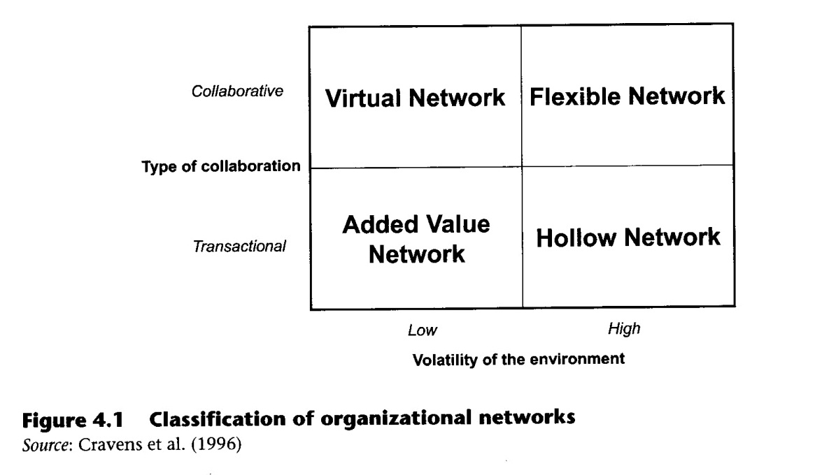
- Hollow network: a transaction-based organizational form, associated with highly volatile environments. It allows a fast reconfiguration of relations in order to attend to a new opportunity in the market.
- Flexible network: associated with conditions of high environmental volatility, but is characterized by intra-organizational links that tend to be collaborative and long term in duration.
- Added value network: more likely to be associated with markets where preferences are diffused and segments may be difficult to define, but environmental volatility is relatively low. The relation between members is about collaborative aspects. In these circumstances network relationships are likely to be transactional.
- Virtual network: likely to be a more limited re-formation of the traditional organization. This form is linked to situations where environmental volatility is relatively low, and the core organization seeks to establish collaborative relationships with other firms.
4.1.2 VIRTUAL ENTERPRISE
Abundant researches on virtual enterprise (VE) have been carried out since the 1990s. Barnett et al. (1994) recognized that the VE is a set of collaborative business processes to produce services and products, and presented a VE architecture based upon an object-oriented business process modelling approach. A large number of studies have tried to establish flexible and generic infrastructures to support the formation and the operation of practical VEs, such as the studies of Camarinha-Matos and Afsarmanesh (2003) and Gou et al. (2003). Specifically, the largest and most significant effort in the VE was made by the American National Industrial Information Infrastructure Protocols (NIIIP) which defined an open infrastructure to support basic information exchange and coordination needs throughout the life cycle of the enterprise (Kim et al., 2006).
Kim and et al. (2006) defined the term 'virtual enterprise' as follows:
In order to realize the common business goal which is to secure business opportunity, the VE is an active collaborative organization structure which is temporarily made up of value chains. Each value chain consists of loosely-coupled business processes of distributed business partners who offer the core complementary functionality and resources.
Camarinha and Afsarmanesh (1999) suggested that there are several roles that VE members can assume:
- in terms of coordination: VE coordinator, VE member;
- in terms ofproduct/service: client, supplier;
- in terms of support services: network directory service provider, electronic commerce service provider, technical advise service provider.
In summary, a possible definition is: a virtual enterprise is a single business entity in which some companies share capital and maintain dynamic and agile relationships in order to enhance their customers value proposition and to create and exploit complex market opportunities in a timely fashion.
The concept of the VE is illustrated in Figure 4.2. The VE is made up of the higher-level value chains and each value chain is made up of the collaborative business processes
for business execution in a loosely coupled way. Each business process is considered as the core competitive functionality of the lower-level VE, and the lower-level VE is composed of the further lower-level value chains. The composition of the VEs, the value chains and the collaborative business processes is continuously divided.
The value chain perspective is mostly connected with Porter's (1980) definition of value chain: a market-oriented sequence of productive (that is, value added) activities leading to a firm's success. This concept, however, was further developed in economics and management and the basic idea was used in the first theories on retailing value chain or on distribution channel systems.
If the VE is created to exploit emerging markets or to be custumer-focused it concentrates on exploiting a set of strategic core competencies, improving the relationships of a virtual enterprise, improving the collaboration and cooperation between partners, improving the global value chain and capturing business opportunities in a global market.
The VE members are temporarily aligned to share skills or core competences and resources in order to better respond to business opportunities (deals with their client and supplier). The goals of VE are to share skills, costs and market opportunities, to capture emerging business opportunities and to create a cooperative environment. From the perspective of strategic management, a dominant company has no preponderant role in the strategic management of the alliance (the `no one in the driver's seat' condition) and all the participants can share their resources. The creation of a VE can not only speed up commercial transactions but also increase the degree of integration of the value chain. In this way, every chain member can get new and better services from the other members (suppliers, manufacturers, transport companies, dealers and customers) and improve the value of the product or service that is offered to the final customer. Ease of

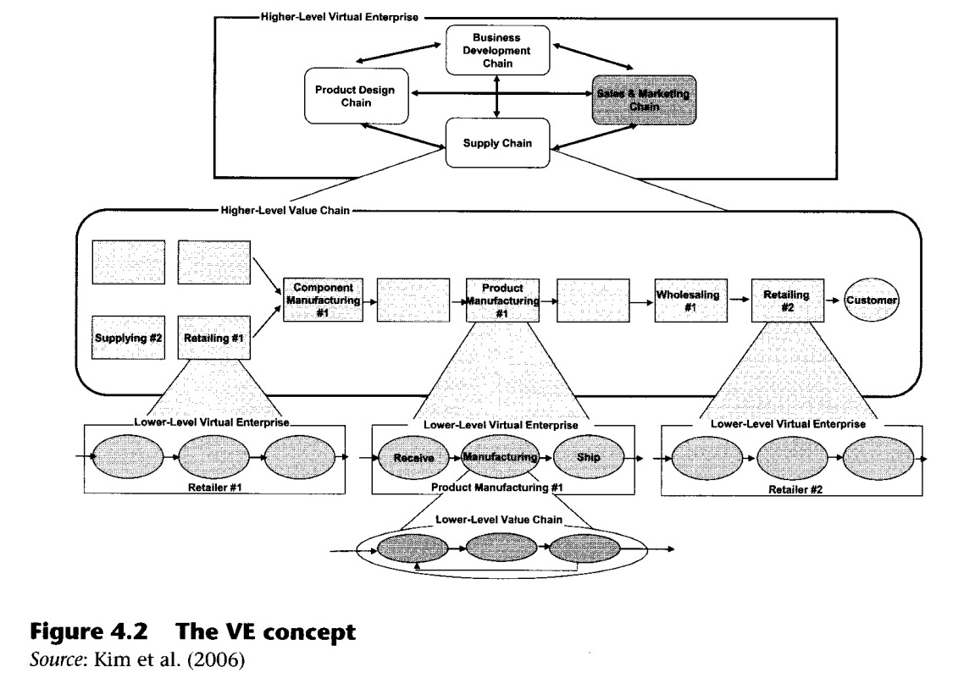
access to information such as the state of the order, certain products stock levels (either a supplier's or a customer's), and so on in any moment and from any place will accelerate the companies' reaction speed to market activity (Chalmeta and Grangel, 2003).
In conclusion, the main advantages VE offers are:
- response and adaptation of the VE to market changes is faster;
- profits are extended to all the partners of the VE, usually in proportion to their participation level in the alliance (mutual benefits);
- the business risks are lower and shared across all of the partners of the VE.
The success of the VE depends on the cooperation of all partners as a synergic unit, because each partner brings his strengths or core competence to the VE. This means that the competitive advantage that can be achieved by the VE depends on how well the individual organizations complement each other and on their ability to integrate with one another (Meade et al., 1997).
As mentioned by Fitzpatrick and Burke (2001), VE constitutes a natural outgrowth or evolution of both tapered and non-integration strategies and network-organizational structures. Companies gain competitive advantages by providing customers with better and faster services. In practice, many manufacturers have begun to gain and maintain a competitive edge through VE.
4.1.3 THE LIFE CYCLE OF VE
The value chains are closely related to the life cycle of the VE. According to Kim et al. (2006), the life cycle of the VE probably has strong relationships with the creation and the destruction of the value chains which are based on business processes. As illustrated in Figure 4.3, the authors classify the life cycle of the VE into two broad phases: dynamic and static. The dynamic phase includes enterprise configuration, which focuses on designing the business components and collaborative business processes. The static phase includes enterprise operation, which focuses on executing the collaborative business processes with the business components.

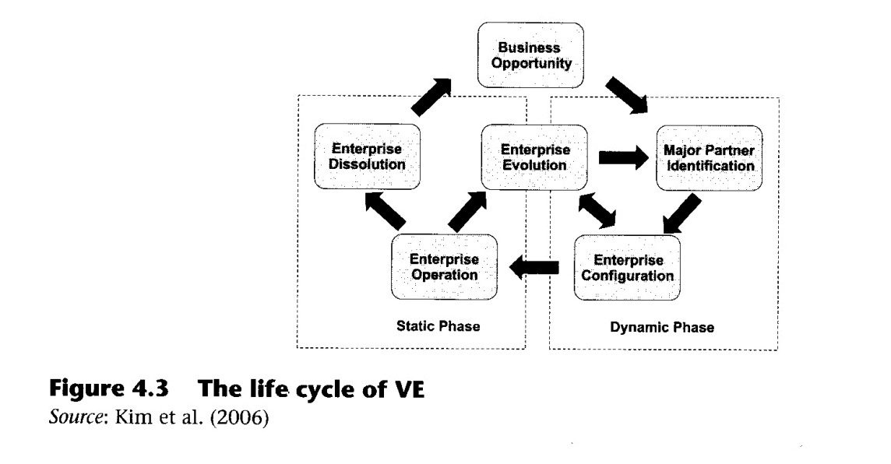

4.2 The Case Study
4.2.1 COMPANY PROFILE
Dongfang Electric Corporation (DEC) is a Chinese state-owned company specializing in power equipment manufacturing and worldwide power project contracting for thermal, hydro, nuclear, wind, gas turbine, combined cycle power plants and power distribution systems. It is located in Chengdu, China. With considerable capacity and advanced technology, DEC is the leader of the power equipment industry in China and has been nominated by the Chinese Central Government as one of the key state-owned enterprises in the national economy. Founded in 1984, after years of development, DEC has been listed among China's top contractors and Engineering News-Record (ENR) Top 225 International Contractors. In 2010, DEC was listed as 80th in the world. Total contract value so far is US$4.5 billion, and the company has 28,000 employees.
Currently DEC has undertaken more than 70 worldwide power projects. With more than 20 years of experience in project contracting, project management, logistic management, as well as import and export operations, DEC has extended its business into various fields. It has business offices located in Vietnam, Pakistan, Bangladesh, Nepal, Indonesia, India, Turkey, Iran and Iraq besides six major manufacturing enterprises located in China. The company's organizational chart is shown in Figure 4.4.
The Export Division of the International Operations department of DEC takes charge of extended international business (see Figure 4.4). This department has several divisions: thermal power, hydraulic power, imports, administration, contracts, warehousing and transportation and export. The export division is currently involved in a diesel electric locomotive project and railway freight wagons project, both of which generate good profits for DEC.

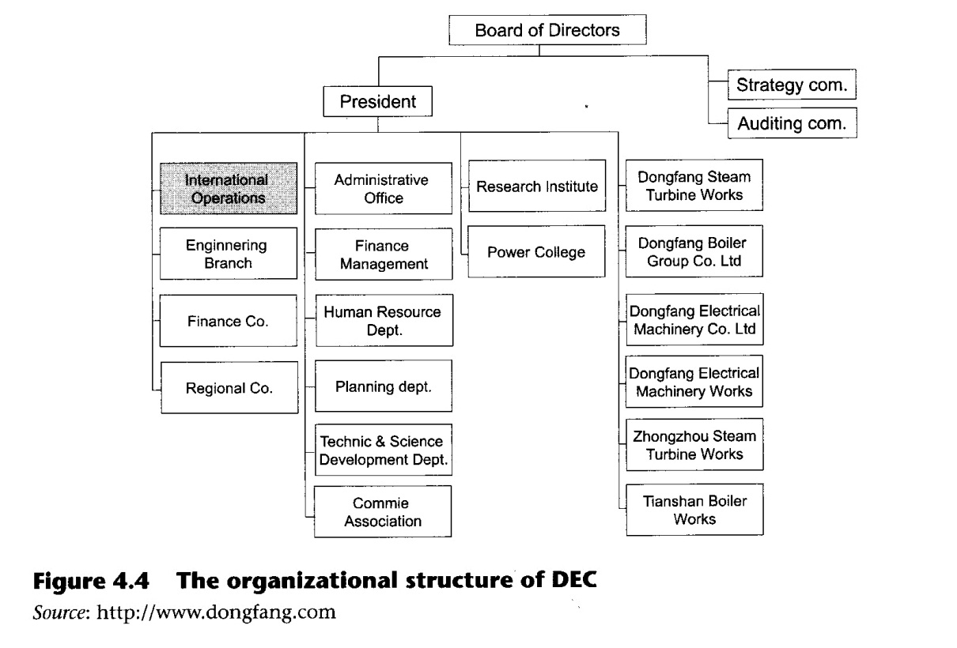
4.2.2 VIRTUAL BUSINESS NETWORK OF DEC'S RAILWAY EQUIPMENT EXPORTING PROJECT CONTRACT FROM CHINA TO PAKISTAN
This case study will describe the virtual enterprise created between companies and institutions from Chinese and Pakistan in order to better accomplish a contract project. In Pakistan the railway system is managed by the Pakistan Railway Company, which has more than 7,700 kilometres of broad gauge railway, the lifeline of the country's cargo and passenger transportation. Pakistan Railway Company is state-owned and deals in railway transportation and the manufacture of railway-related products. It has four main business areas: passenger transportation, cargo transportation, fundamental facilities and service and manufacture. Because of the lack of funds and technical know-how Pakistan Railway's systems did not achieve any improvement, and could not respond to the demands of railway transportation. In order to improve its economic development the Pakistan government gave railway improvement a high priority, hoping that it would bring strong benefits to the economy. On the 29th December 1999 the government of Pakistan approved the 'Urgent Railway Maintenance and General Repair Plan', which was aimed at improving engines, passenger cars, freights, communications, signals, rails, sleepers, railway electrical supplies and fundamental railway facilities.
In November 2001 a contract project for the supply of diesel electric locomotives was signed between the Pakistan Railway Company, DEC, China North Locomotive and Rolling Stock Industry Corporation, Dalian Locomotive and Rolling Stock Works (CNRDLRSW) and other subcontractors. A second contract for the supply of railway freight wagons was signed in September 2003 between the Pakistan Railway Company, DEC, China South Locomotive and Rolling Stock Industry Corporation - Meishan Rolling Stock Company (CSR-MRSC) and other subcontractors.
We now discuss the participants of this virtual enterprise and offer a brief synthesis of their background.
The export division of DEC's international operations department is involved in all of these projects. DEC is the direct business partner of the Pakistan Railway Company and as the leader of these two projects is in charge of commercial work, financing, equipment transportation and coordination with all the other participants.
CSR-MRSC is the leading Chinese large-scale manufacturer of railway vehicles and engines, and also works in R&D. It is the leading railway vehicle exporting company and the largest railway engines, freight, train and R&D company in China and one of the 520 keystone enterprises of China. Since 1990, the company has completed various international projects successfully and its products have been exported to Burma, Thailand and many other countries (China South Locomotive and Rolling Stock Industry (Group) Corporation, 2009). For this project the company is manufacturing equipment and is responsible for technical aspects such as equipment design, manufacture, quality control, customer training and so on. The contract includes 1300 sets of railway freight wagons.
CNR-DLRSW (China North Locomotive and Rolling Stock Industry Corporation-Dalian Locomotive and Rolling Stock Works) is also a keystone enterprise in China and was founded in 1899. It mainly manufactures Dali Brand DF series diesel electric locomotives, city-trans trams, rolling stock, DL240, 280 diesel engines and various locomotive parts and other types of diesel electric locomotives. CNR were the first company to export in significant quantities and also one of the first companies to engage in technology transfer.
After CNR first exported locomotives to Burma in 1992, breaking the record of zero export of artery locomotive, it has also done business with Nigeria, Iraq, Pakistan and has exported 377 sets of locomotives (China North Locomotive and Rolling Stock Industry Corporation, 2009). For this project CNR-DLRSW will be involved in the production of 69 sets of locomotives and will be responsible for all technical aspects of the second project, taking a similar role to that held by CSR-MRSC in the first project.
A shipping company is also involved: the Pakistan National Shipping Corporation (PNSC). PNSC are the Pakistan national flag carrier and manage a fleet of 14 vessels. Their head office is located in Karachi and a regional office based in Lahore caters for upcountry shipping requirements. PNSC also has an extensive overseas network of agents looking after its worldwide shipping business (Pakistan National Shipping Corporation, 2009).
There are two more participants in this project, and their involvement is mainly financial: the Export—Import Bank of China and the Pakistan National Bank. In particular the Export—Import bank of China (Eximbank), founded in 1994, acts as a financing services supplier. It is a fully state-owned policy-oriented bank under the direct leadership of the State Council of China. As an important force in the support system of foreign trade and economy, it plays a very important role in the financial system, above promoting the development of the open and export-oriented economy of the country (the Export—Import Bank of China, 2009).
Business network and virtual enterprise
According to the concepts of VE introduced in the theory section, all the participants in a virtual business network consist of a virtual enterprise. In this case we can consider the terms virtual business network and virtual enterprise as synonymous, because the partners are identified and the network is created intentionally for the purpose of carrying out the project. In order to realize the common business goal, all of these participants are temporarily made up of value chains (the contracts last from 36 up to 42 months). In this case, the equipment supplied by CSR-MRSC and CNR-DLRSW are delivered to DEC, who act as the organizer of this virtual enterprise. The equipment will then be transported to the customer, Pakistan Railway. Each member of the VE is part of the value chain for this railway equipment exporting project. Figure 4.5 shows the business network that exists between participants.
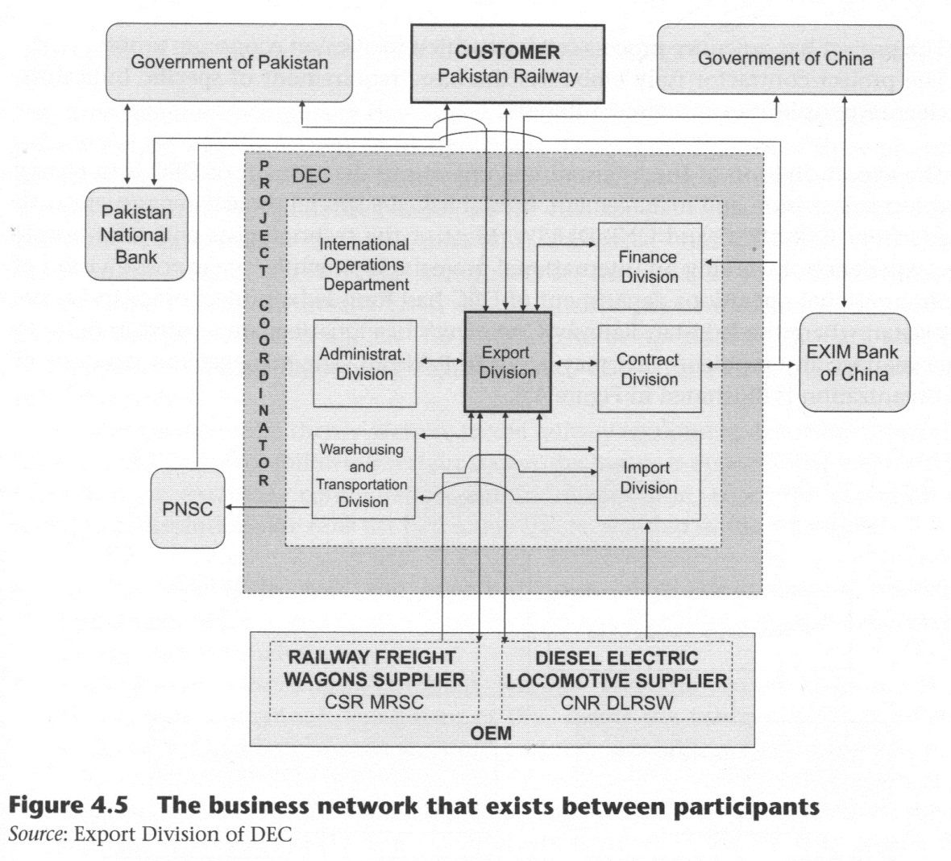
In the Railway Equipment Exporting Project, DEC is the organizer of the VE. The export division of the international operations department of DEC is the core division which takes responsibility for these projects. It contacted CSR-MRSC directly to procure manufacture of the railway freight wagons and CNR-DLRSW to manufacture the diesel electric locomotives. It is also connected with other divisions of the international operations department in order to run these projects. Both the contract and finance divisions of DEC have a direct relationship with EXIM Bank of China to deal with topics related to finance. The payment of the project will be guaranteed by the EXIM Bank and the Government of China and by the Pakistan National Bank and Pakistan Ministry of Finance (which guarantees the payment of the Pakistan Railway). In this VE the role of the Chinese and Pakistan Government is to support the collaboration between DEC and Pakistan Railway and to guarantee to the project through the assistance of EXIM Bank of China and the Pakistan National Bank, both of which act as guarantor for the project. They are guaranteed by their governments and by contracts with each other. They exchange financial information with the finance and contract divisions of DEC.
The import division is in charge of the collection and preparation of the equipment produced by CSR-MRSC and CNR-DLRSW in order to export them to Pakistan. The warehousing and transportation division is responsible for the transportation of the equipment. The equipment manufactured by CSR-MRSC and CNR-DLRSW is transported first to Shanghai, and then is shipped to Pakistan by sea with the support of PNSC.
Virtual business network on project management mode and executive organization
This project adopts a project management approach with the following characteristics:
- The project manager has a specific target and main goal: the construction project;
- The project manager is responsible for the project on affairs related to technical, quality, safety, cost, schedule, finances and so on;
- The project has an entire process contract which focuses on economic profit;
- The project contractor fully embodies the basic requirement of specific indicators, clear responsibilities and direct interests.
The export division of the international operations department of DEC is in charge of project supervision and management. It established a special project department with experts from CSR-MRSC and CNR-DLRSW. Most of the technologists and sales, people have experience of working on international projects. Meanwhile, the export division of the international operations department of DEC had founded a project office in Lahore in Pakistan where the Pakistan Railway Company's headquarters are located in order to better manage any problems that may occur in Pakistan. The management structure of this organization is illustrated in Figure 4.6.

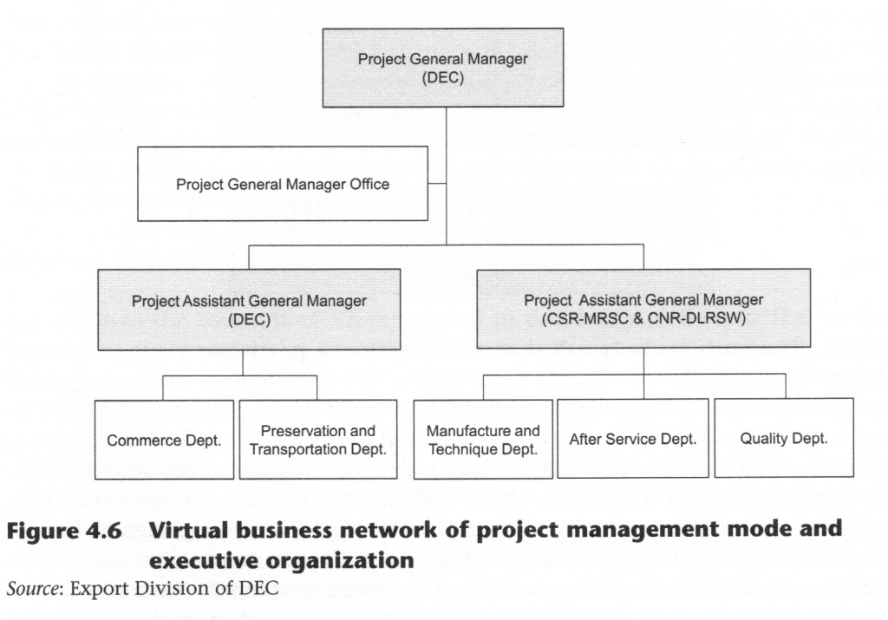

In this diagram, the Project General Manager is working in the export division of the international operations department of DEC, whose role is to represent DEC in these projects and be responsible for them. Another person from the same department works as the Project Assistant General Manager and is in charge of the relationships with the commerce and warehousing and transportation departments, managing the commerce, warehousing and transportation affairs. CSR-MRSC and CNR-DLRSW also assign some people to work separately as a Project Assistant General Manager. Manufacture and technique, post-service and quality departments are also set up, as they are responsible for technical and quality issues. The documents and logistics management are handled by the Project General Manager Office. The finance of the project is treated independently to ensure the security of funds.

Life cycle of the virtual enterprise for the railway equipment exporting project
The time required to complete the project of supplying diesel electric locomotives and railway freight wagons is from 36 to 42 months. The payment mode of these projects is based on credit. An advance payment can be used, such as promissory notes and so on. The participants involved in the finance are the Pakistan government, Pakistan National Bank, the Export—Import bank of China DEC, CSR-MRSC and CNR-DLRSW. The time limits on the loan for the two project contracts are the same: 15 years. This means that the participants will continually focus on the finance payment affairs within 15 years after the project contract is signed. The contract will be operable for 15 years, and there is a long-term relationship among Pakistan, DEC, CSR-MRSC, CNR-DLRSW and other subcontractors.
As mentioned in the theory section, in the railway equipment exporting project, the life cycle of VE evolves following certain stages: the business opportunity, major partner identification, enterprise configuration, enterprise operation, enterprise evolution and enterprise dissolution. We now list how these stages occurred in these projects.
- Business opportunity: first, the export division of the international operations department of DEC opens a new business field and identifies a business opportunity through market analysis.
- Major partner identification: Pakistan Railway and the export division of the international operations department of DEC define the major value chains for the business realization and seize the core business capabilities needed in each major value chain. After identification and classification of the major participants that can take responsibility for the managing of the value chains, they select the most suitable participants, preferentially as major business partners of the VE. The criteria used to select the partners for these projects are according to the experience of former projects, such as product quality, trustworthiness level and so on. Some of these characteristics are essential in creating the competitive advantage needed to win the contracts. All the major partners identified in the projects — CNR-DLRSW, CSR-MRSC, PNSC and EXIM Bank of China — have some international import/export project experience prior to signing the contract with DEC.
- Enterprise configuration: the customer and original equipment manufacturer (OEM) of this case study define the architecture that can be used to develop the VE models including business processes, system, information, resources, and so on. On the basis of this architecture, they concretize the roles and mutual agreements about the business plan among business partners. They define and standardize the business scenarios and processes, and also define the relevant information and communication technologies, systems and shared resources. The products, services, revenue, information and knowledge flows in this case study are introduced in Figure 4.7.
- Enterprise operation: the participants execute the collaborative business processes operating the VE. The business processes and current market situations are monitored continuously.
- Enterprise evolution: re-definition of the VE models to be more efficient depending on the business environment or internal situations, by means of re-designing and optimization of the value chains, business scenarios, business processes or the business partners.

- Enterprise dissolution: dissolving the VE after stopping the execution of the business processes, depending on the disappearance of the business opportunity. According to the contract between DEC and other participants, it takes from 36 to 42 months to complete the project of supplying diesel electric locomotives and railway freight wagons.
Business-related flows between participants in the railway equipment exporting project

The main business-related flows in this case are shown in Figure 4.7. After the project plan and schedule forwarding from the Pakistan Railway Company, the international operations department of DEC analyses and transmits this information to the manufacturers — CNR-DLRSW and CSR-MRSC. When they receive the orders, they will manufacture the equipment according to the plan and schedule, then railway freight wagons, diesel electric locomotives and parts will be produced by CNR-DLRSW and CSR-MRSC. These will be delivered to the Pakistan Railway through the support of the international operations department of DEC and facilitate the product flows in the railway equipment exporting project. Considering post-service flows, the CNR-DLRSW and CSR-MRSC would also provide technical and training support during the project and after the delivery of equipment. Pakistan Railway will receive these services through the help of DEC. Finally, funds would be given by Pakistan Railway to DEC. The CNR-DLRSW and CSR-MRSC will also receive their payment from DEC.

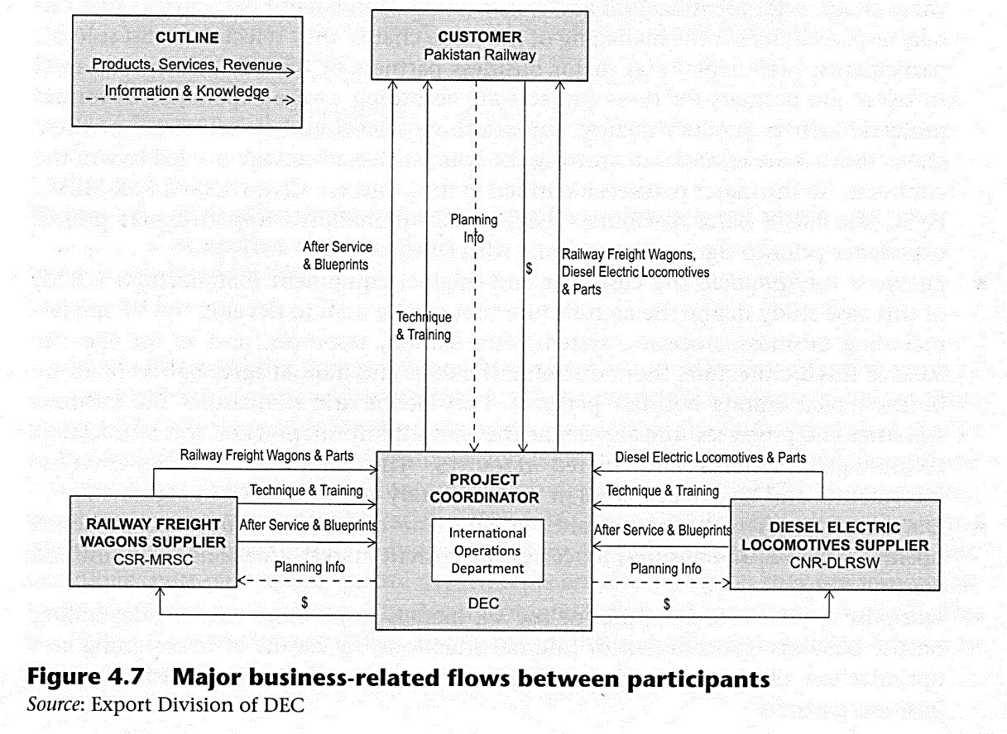
4.3 Conclusions
Enterprises may achieve competitive advantage by building collaborative networks. Virtual enterprise is an active collaborative organization structure which is temporarily made up of value chains. Each value chain consists of loosely coupled business processes of distributed business partners that offer the core complementary functionality and resources.
DEC has established virtual enterprise networks to run the extensive businesses of diesel electric locomotive and railway freight wagons exportation. In the project, the export division of the international operations department of DEC takes the role of main contractor and is the equipment supplier to Pakistan Railway Company. However, its role is more complex: it takes charge of commercial works, financing, equipment transportation and coordination with all participants. It is the leader of these two projects and takes charge of the coordination with other project partners.
The international operations department of DEC plays the role of the project coordinator in the projects, CSR-MRSC and CNR-DLRSW work as the railway freight wagons OEM and diesel electric locomotives OEM respectively, and the final customer is Pakistan Railway. While the information, physical goods and capital and ownership flow smoothly between the participants, the collaboration of this virtual enterprise network becomes more efficient and effective: the customer is satisfied and the project becomes more successful.
Acknowledgement
We acknowledge Dario Franco and Pedro G6mez Gasquet of Universidad Politecnica de Valencia for supplying the theory materials and ideas for this case study. We are truly blessed and show them our deepest gratitude.

LESSON LEARNED
Virtual enterprise as a customer-focused organization in a complex international context
This case study shows how a business network in international project contracting can offer better services to the customer, thanks to collaboration with all of the partners. The Hollywood movie industry represents a virtual business network that is able to dynamically shape a virtual enterprise for every movie project: in this case study DEC is able to manage a virtual network and to create a virtual enterprise, in a far more complex international contract and service project.

QUESTIONS FOR STUDENTS
- What is a virtual enterprise?
- What is the role of DEC in the virtual enterprise?
- What factors promote cooperation between the government of Pakistan, DEC, CSRMRSC, CNR-DLRSW and other subcontractors in this case study? Can you describe the collaborative process between partners?
- Do you think that the virtual enterprise set up by DEC is consistent with a customer-focused strategy? Why?
- What are the inter-enterprise flows in DEC and the flows between the participants?
OPEN DISCUSSION
- What IT tools can support collaboration in a virtual enterprise?
- 2. What kind of concept do you think is more fit to be used in the relationships between the participants of the project in this case study? The virtual network or the virtual enterprise? What is the difference between these two concepts?
References
Barnett, W., Presley, M.J. and Liles, D. (1994). An architecture for the virtual enterprise. In IEEE International Conference on Systems, Man, and Cybernetics. San Antonio, Texas.
Camarinha-Matos, L.M. and Afsarmanesh, H. (1999). The virtual enterprise concept. Infrastructures for virtual enterprises. Networking industrial enterprises. In Camarinha-Matos, L. and Afsarmanesh, H. (Eds), Proceedings of IFIP TC5 WG5.3/PRODNET, Working Conference on Infrastructures for Virtual Enterprises. Alphen aan den Rijn, NL: Kluwer Academic Publishers.
Camarinha-Matos, L.M and Afsarmanesh, H. (2003). Elements of a base VE infrastructure. Computers in Industry, 51(2), 139-163.
Chalmeta, R. and Grangel, R. (2003). ARDIN extension for virtual enterprise integration. The Journal of Systems and Software, 67(3), 141-152.
China Northern Locomotive and Rolling Stock Industry (Group) Corporation (2009). Retrieved 21 November 2009, http://www.dloco.com.
China South Locomotive and Rolling Stock Industry (Group) Corporation (2009). Retrieved 21 November 2009, http://www.msrsco.com.
Cravens, D., Pericy, N.F. and Shipp, S.H. (1996). New organizational forms for competing in highly dynamic environments. British Journal of Management, 7(3), 203-218.
Dongfang Electric Corporation (2009). Retrieved 21 November 2009, from http://www.dongfang. corn.cn.
Fitzpatrick, W.M. and Burke, D.R. (2001). Virtual venturing and entry barriers: redefining the strategic landscape. Society for the Advancement of Management Journal, 66(4), 22-30.
Gou, H., Huang, B., Liu, W. and Li, X. (2003). A framework for virtual enterprise operation management. Computers in Industry, 50(3), 333-352.
Jarillo, J.C. (1988). On strategic networks. Strategic Management Journal, 9(1), 31-41.
Kim, T.Y., Lee, S., Kim, K. and Kim, C.H. (2006). A modeling framework for agile and interoperable virtual enterprises. Computers in Industry, 57(3), 204-217.
Meade, L., Liles, D. and Sarkis, J. (1997). Justifying strategic alliances and partnering: a prerequisite for virtual enterprising. Omega, 25(1), 29-42.
Pakistan National Shipping Corporation (2009). Retrieved 21 November 2009, http://www.pnsc. com.pk.
Porter, M.E. (1980). Competitive Strategy: Techniques for Analyzing Industries and Competitors. New York: Free Press.
Smith, K.G., Carrol, S.J. and Ashford, S.J. (1995). Intra- and interorganizational cooperation: toward a research agenda. Academy of Management Journal, 38(1), 7-23.
The Export Import Bank of China (2009). Retrieved 21 November 2009, http://www.eximbank.gov. cn.
Thorelli, H.B. (1986). Networks, between hierarchies and markets. Strategic Management Journal, 7(1), 37-51.

This is not always true. For example in the Hollywood model there is .a virtual business network that is dynamically shaped as a virtual enterprise for every movie project.

