Keraben Case Study: Service and Product Development
5
CHAPTER

Combining customer needs and network capability in new product/service development

FAUSTINO ALARCÓN, RUBÉN DARÍO FRANCO, M.M.E. ALEMANY AND FRANCISCO-CRUZ LARIO

5.1 Theory
5.1.1 INTRODUCTION
According to the principle of complementing internal and external abilities, companies are advised to arrange operational networks around them. With the network emergence, a closer integration of business firms has become necessary in order to create a 'collaborative network'. The competitiveness of an enterprise and the value it generates cannot be understood if the spectrum of suppliers and customers with whom the enterprise is related is not taken into consideration.
The concept has been extended beyond individual organizations and can be applied to whole supply chains and distribution networks. The delivery of a mix of products and services to the final customer will activate different economic actors, each managing its own value chain. The industry-wide synchronized interactions of local value chains create an extended value chain, sometimes even global in extent. Porter and Fuller (1986) termm this larger interconnected system of value chains the 'value system'. This includes the value chains of a firm's suppliers (and, in turn, the suppliers, suppliers all the way back), the firm itself, the firm's distribution channels, the empty vessel and the firm’s buyers (and presumably extended to the buyers of their products, and so on); all of which form a firm's network.
The idea of the 'value chain' or the 'value network' has, therefore, been affirmed and is now the subject of a growing body of research (Camarinha-Matos et al., 2005). The case study presented here is based also on the results of the ECOSELL (Extended Collaborative Selling Chain) project, developed within the Fifth Framework programme of the EU: Competitive and Sustainable Growth (GRD1-2001-40692). It was conceived with the purpose of responding to the increasing complexity of value chain management and is specially oriented towards business models in which partners from different sectors and different business value chains propose a new jointly designed market offer such as, for example, 'Products/Services Packages' (PS-P).
The Keraben case study explains the details of an Extended Order Management (EOM) process. EOM will be carried out in a collaborative scenario and will control the PS-P orders made by different value chains or enterprises. Basically, the new EOM process will allow the client's requirements, as contained in the order proposal, to be identified. It also provides an analysis of the possibilities of reaching a commitment with the client and activates the order manufacturing/distribution/installation after the proposal is accepted.
This case study is divided into two parts: the first part is useful to clarify the meaning of the three key concepts considered here: collaborative network/ collaborative process and the products/services package; the second part is divided into four main sections. The first includes a description of the Keraben company and its order management process. This is followed by a description of the collaborative scenario at the start of the process, known as the as-is situation. The second section analyses the initial as-is situation in order to identify the possible need for Keraben to create an improved scenario (to-bet by re-designing its existing order management (OM) process. The third section describes the new to-be scenario (which gives rise to the EOM) as evolved from the original OM process. Finally, the fourth section contains some conclusions.
5.1.2 DEFINING A COLLABORATIVE NETWORK
Collaborative networks are emerging as the managerial response to ever-changing market needs. In looking for centralized planning and control of distributed operations, they are considered intermediate organizational forms between markets and hierarchies, originally- proposed in Williamson's transactional cost theory (Williamson, 1985). A network definition was then proposed and its constitutive elements identified and analyzed. Finally, the most important reasons that led more and more companies to interact inside a net structure were highlighted. In order to better understand the benefits of creating networks, someone referred to Porter's value chain (1986) as a device for strategic analysis in order to obtain a competitive advantage.
The definition of collaborative network included in Camarinha-Matos and Afsarmanesh (2005) could be used as a starting point for this case study: 'A collaborative network is formed by a group of autonomous entities, geographically dispersed and heterogeneous in environment, culture, share capital and objectives. They achieve common goals and their interaction is supported by computer networks.' However, after a collaborative network is formed, some questions arise linked to collaborative aspects, such as: what makes a company collaborate? Is it really advantageous to collaborate? What can be won and what can be lost in collaboration? It seems clear that network members seek to share costs and risks, reduce dependency- levels, increase innovation capacity, defend their current position, increase flexibility$. specialization and agility, establish suitable regulations, share social responsibility and so on (Snow et al., 7992).
5.1.3 WHAT IS A COLLABORATIVE PROCESS?
Although the terms cooperation, coordination and collaboration are generally used to mean the same thing, there are important differences between them. According to Winer and Ray (1994) a collaborative stage is achieved once involved agents have evolved from initial cooperative relationships which, in turn, evolve into coordinated relationships.
Cooperation is transaction-oriented and short term in nature, collaboration appears to be more permanent in time, enabling recurring transactions to be carried out. Collaboration usually implies alignment of expectations and mutual interests when organizations agree on a common vision for joint action. When collaborating, principles of governance, authority, risk and even power must be shared and mutually agreed upon among the actors involved (for a detailed comparison of the three terms, see Table 5.1). Table 5.1 gives a detailed description of the evolution of the concepts from cooperation to collaboration and provides a basic definition of the collaborative process. According to Alarc6n et al. (2008), collaboration in a collaborative process implies sharing the tasks involved in that process.

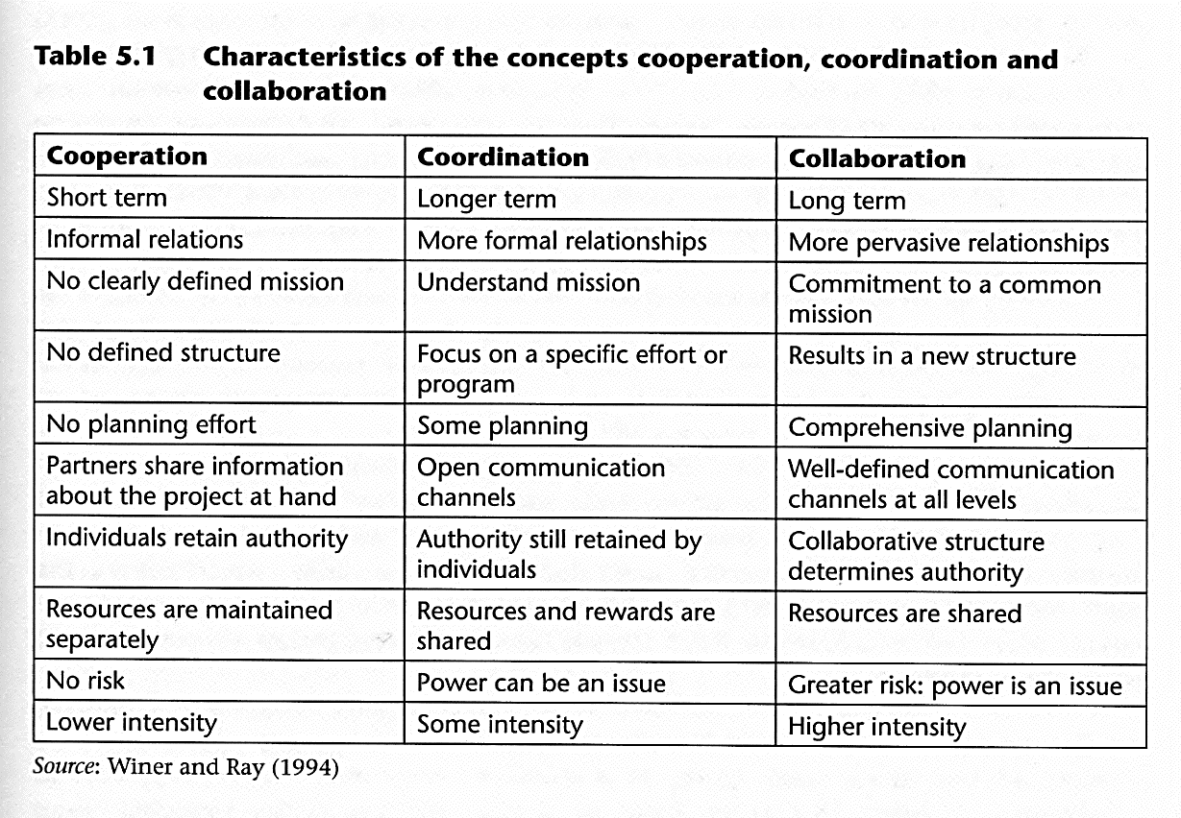

Finally, the definition of the collaborative process used in this case study is the one proposed by Alarc6n et al. (2008), where it is considered as a process in which two or more entities share the work involved in carrying out the process with common and jointly defined objectives.

5.1.4 COLLABORATIVE PROCESS OF SELLING PRODUCTS/SERVICES PACKAGES

The operation of collaborative networks is based on an inter-company vision and on defining new collaboration-based relationship frameworks. Some of those frameworks provide a definition for a new conceptual model including an entire collaboration-based value chain (collaborative value chain). Others focus on the study and re-design of the downstream part of the chain nearest to customers, that is involved with sales and therefore plays a key role in adding value to customers' products. A link is thus formed between the value chain and customers and consists of the so-called collaborative selling chain (Alemany et al., 2OO7).
The concept of the extended collaborative selling chain goes beyond the collaborative selling chain domain and refers to the extrapolation of the collaborative selling chain to the context of business networks, these being composed of an amalgamation of various supply chains (Lamming et al., 2000).
The concept of the extended collaborative selling chain is considered equivalent to the Collaborative Selling Network (CSN), defined as 'a complementary network of businesses that work together to offer new products/services of greater value to customers than if the same companies were to manufacture the same products individually' (Alarc6n et al., 2008).
One of the main functions of the CSNs consists specifically in the design, production and marketing of PS-Ps, that is, new products/services obtained from the amalgamation of the individual products/services of each of the individual sales chains of which the CSN is composed. Some examples of PS-Ps are: 'package tours' including flight tickets, transfer to hotel, hotel booking and car hire, or the 'kitchen ambience' PS-P utilized in this case study, comprising floor and wall tiles, furniture, accessories (such as electrical appliances, sink unit and so on) and installation services.
The most important PS-P characteristic is that it offers added value to the customer as a result of the combination of the individual products. In all cases, the global added value that the product has for the customer must be greater than the sum of the individual product values. This aspect is really the basic business incentive and is, therefore, one of the main justifications for the existence of CSNs.
The design of a PS-P, that unifies the commercial and industrial activities of complementary business chains or networks (from the point of view of the product pack itself and creating value for customers), involves collaboration and coordination of different activities or functions at various levels. Collaboration will be more needful in the definition, design and planning phase of both the commercial aspect and the product/ services pack. In the operational stages (production, marketing, and so on) coordination will be more important.
In this new collaborative scenario, one of the most active functions is the commercial or sales function, since, if the PS-P exists, the possibility of the joint sale of the items included in the package also exists. It is therefore necessary to have a process to collaboratively control PS-P orders made by clients, and this is the Extended Order Management (EOM) process, also known as Collaborative Order Management (COM). The principal input of the process is the order proposal from the customer, which, among other things, must be analyzed in order to decide the extent to which a commitment can be made to this customer. The set of activities carried out to respond to customers' requirements are known as the order promising process (OPP) (Alemany et al., 2005), which plays an important role in order management and is considered as a key element in customer/company relations. Thus, if the packaged items are sold together at the sales point, a commitment to the customer is acquired, in which the supply chains engaged in the production of one or more of the items in the PS-P are also involved. The time that customers are willing to wait for a reply to their requirements is decisive in determining whether the OPP will be treated as an online or offline case. The concept of PS-P, therefore, implies the existence of an EOM within which there is a collaborative order promising process (COPP), from where the activities of the different chains or firms involved in fulfilling customers' orders are coordinated. As a research topic, EOM and order promising are receiving a lot of attention and many works have appeared recently. However, as most of this research is focused either on a specific enterprise or on a single supply chain, this case study aims to provide a possible solution to the EOM and order promising sub-process in this new context of multiple supply chains.
Levels of cooperation in the design and execution of the EOM may vary. It could even be said that the process design is not collaborative, as all members accept the decisions of any of the others. However, a certain degree of collaboration in process execution seems inevitable, at least considering the provision of information on availability of products. All supply chains must provide information on uncommitted product availability (ATP), uncommitted productive capacity and raw materials (CTP) and uncommitted distribution capacity (DTP), as appropriate (for further information on ATP, CTP and DTP see Alemany et al., 2008). The search for or the utilization of the different availabilities of each of the products/services in the PS-P will depend on the production strategy used to obtain each one of them. For example, a make-to-stock (MTS) strategy implies that stocks exist in the inventory, which means that ATP must be calculated. Alternatively, if a make-to-order (MTO) strategy is adopted, CTP has to be calculated in order to know if there is sufficient uncommitted production capacity available to carry out the order proposal. However, any checks carried out prior to ATP and/or CTP will not suffice if there is insufficient DTP to deliver the PS-P to the client at the right time.
Logically, this process becomes more complex than in a traditional system (see Scenario 1 in Figure 5.1): there must be coordination among multiple supply chains and this coordination must be established for supply chains that may use different production strategies, objectives, order promising execution modes (online, offline) or availability types (ATP, CTR DTP) (see Scenario 2 in Figure 5.1). For instance, in the case of a 'kitchen ambience' PS-P, tile manufacturers may work under an MTS strategy, while kitchen furniture manufacturers do the same under ATD (assembly to dispatch). From the customer's point of view, in the collaborative network there is only one point of contact for each order (Scenario 2 in Figure 5.1), while in the traditional network, the customer needs to submit an order to each supply chain and to keep in touch with several points of contact (Scenario 1 in Figure 5.1).
To sum up, industrial activity models based on collaboration provide firms with a series of advantages that seems to help them in adapting to market changes. One of these models considers collaboration in the marketing of PS-Ps, which requires the carrying out of an EOM process. The creation of collaborative sales networks or the incorporation of new members will thus mean redesigning the original order management process.

5.2 Case Study

5.2.1 KERABEN (AS-IS)

The Keraben Group

Keraben is a managerial group dedicated to the manufacture and marketing of ceramic wall and floor tiles, together with other products required for a complete in-house
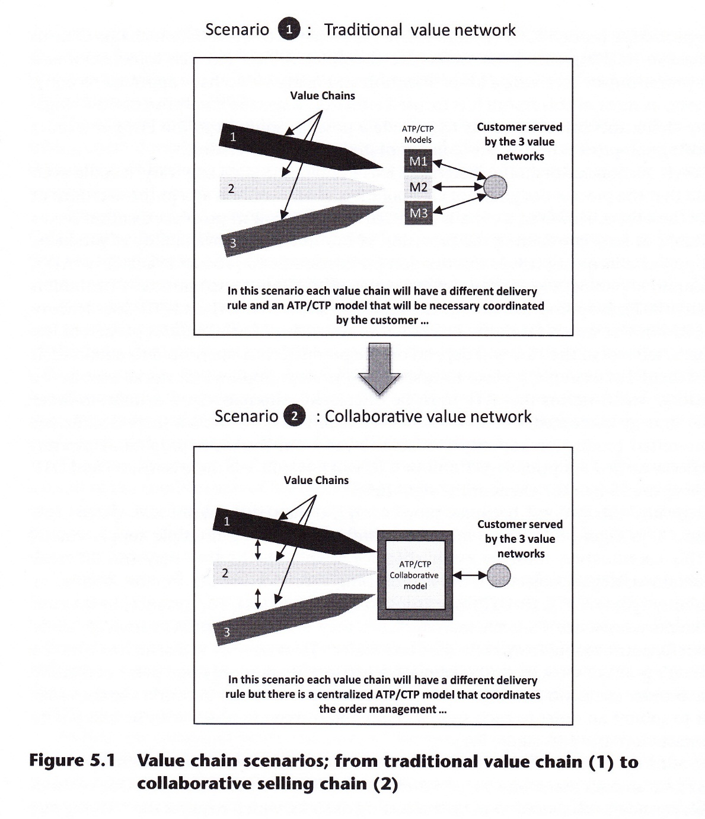

remodeling. The company was founded in 7975 under the name Gres de Nules, Located in the Valencia community, one of the fastest-developing industrial regions in both Spain and Europe, with a team of 700 workers. The 2008 group annual invoicing figures are 160 million and accumulated growth in the last ten years has been 85 per cent. Throughout its history, the Group has been in a position of leadership within the industry, thanks to the rigorous application of quality, technology and service principles that have been the basis of all its activity.
The Keraben Group consists of two main business units (Figure 5.2): Keraben and Metropol. There are two production centers based in Nules, Keraben and Gres de Nules, whose products (wall and floor coverings) are sent to the same warehouse. The third production center, Metropol, sends its products to a different warehouse. There is also a cheaper neutral brand name, known as Proyecta, whose producti6n can be planned according to group requirements, and other satellite factories including varnish production (Wendel), complementary ceramic products (Keratrin), which supplies up to 40 per cent of total group consumption of this kind of product, and a bath factory (Construplas). There are three Keraben sales divisions: international, exclusive group shops (Disacer) and national or independent network (direct competition from the group's exclusive shops). Metropol has two sales divisions: international (providing most of the sales) and the group shops.

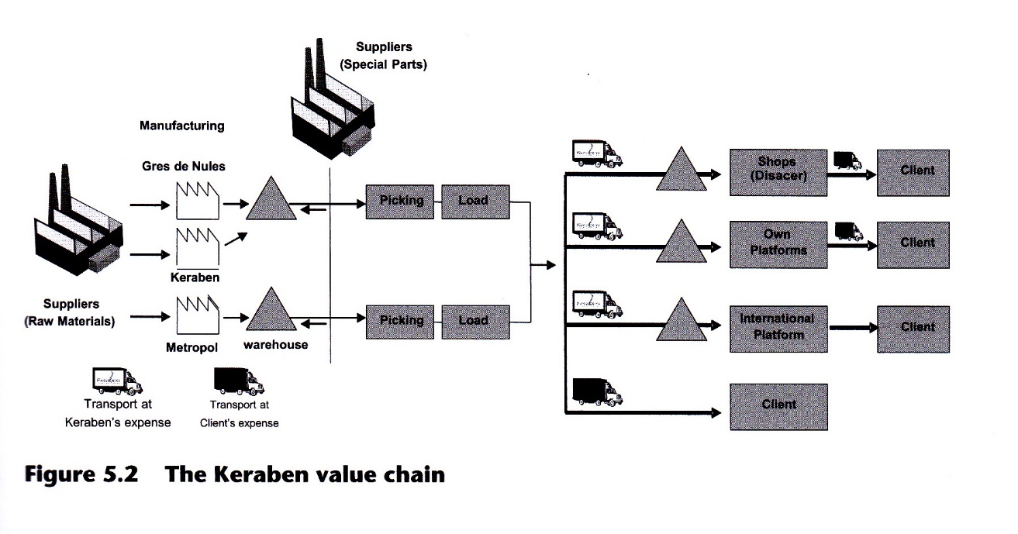

The fourteen Disacer shops are the sales outlets and sell to three different customer types at different prices: private customers, building works and sub-distributors, obtaining the highest profit margin from the first and the lowest from the second (sales to building projects involve large quantities at low margins). Their total sales compose half of the total Spanish production figure and reach 3 million square meters annually. They receive products directly from the group's finished-product warehouses and also non-ceramic complementary products such as taps, baths and so on from other providers.

The order management process

This section explains the original Keraben order management process. First, to give a general idea of the internal workings of the value map, Figure 5.3 gives a general company functioning model, showing the most important departments and their main activities. The commercial department of the Disacer selling points network is responsible for customer management. All customers, both big and small, must go to these shops, although in practice the larger orders tend to be negotiated directly with the sales department due to the larger companies' greater capacity for negotiation. This case study focuses on the order management process for smaller customers. Keraben fixes delivery dates according to customer requirements regarding needs, working methods, order size and so on.
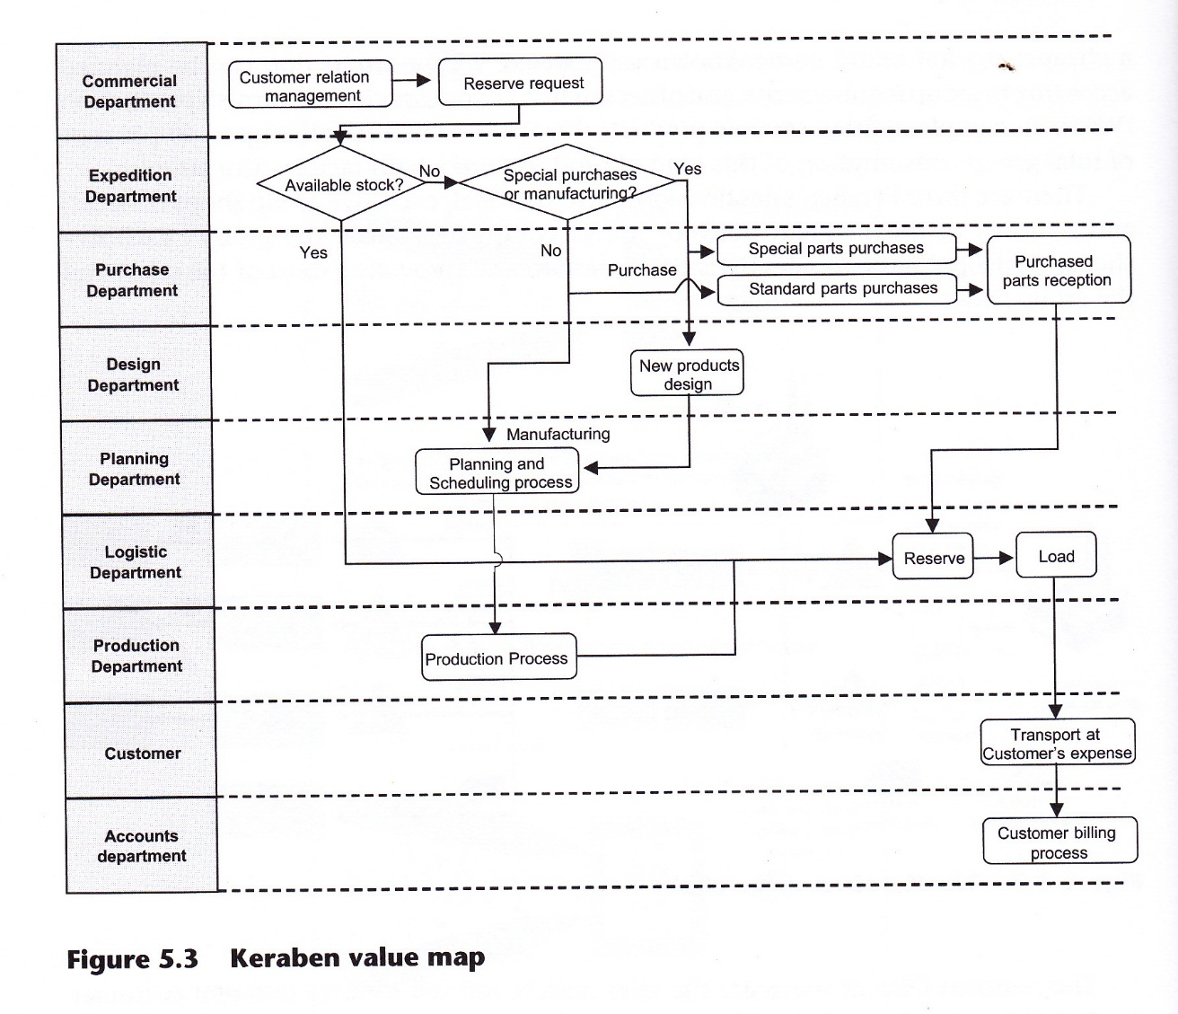

When the delivery date and order characteristics have been determined, order information is sent to the dispatch department, which will reserve the necessary material from existing stocks.
Reserves can only be made against the available stock, which has to be previously checked. If there is no available stock, the planning department will generate the corresponding planning strategies to cover material requirements. When the product has been manufactured and is available, the dispatch department informs logistics, which is responsible for preparing and delivering the order. Most transport is arranged directly by the customer, who contracts a carrier to collect the merchandise. When the process is complete, the accounts department will initiate the customer billing process. The main goal of the company with this order management process is to comply with delivery dates, which are honored whatever the size of the order or the importance of the customer. Modifications should be made in exceptional cases, such as large orders: the company must reassign capacity according to requirements.

5.2.2 VALUE CHAI N ANALYSIS

Understanding the need for change

Renovating a kitchen or bathroom from the customer's point of view in the initial scenario (as-is).
Let us take the example of a small customer who needs to install a new kitchen or bathroom. In the as-is system described, the customer must buy the various individual items needed for the installation: appliances, flooring, wall tiles, decoration, lighting, taps and so on, which normally involves visits to different types of outlets. If one of these articles is not delivered on time, this could affect delivery of the other items. For example, bathroom decorative items and equipment cannot be installed until the walls and flooring have been completed. This means the customer must contact all of the suppliers again to agree new delivery dates. However, the supplier may find it difficult to adapt to the new dates and thus cause problems to the customer: kitchens and bathrooms are vital in any home. In these cases the customer is responsible for solving problems and coordinating deliveries and transport of all items.
After an analysis of the situation from the customer's point of view, Keraben decided to join together with other manufacturers of complementary products (Esmalglass, a glass supplier, Febal furniture manufacturers, Demovave logistics platform, and a team of installers) in order to be able to jointly design and market PS-Ps, such as kitchen ambience or bathroom ambience, which would provide customers with greater value than that inherent in the individual products.

Statement of the problem

With the scenario just described, the problem to be solved can be stated as follows: given current commitments and requests (order proposal), and taking into account existing uncommitted final product availability (ATP) in the multiple supply chains, uncommitted manufacturing capacities and material availabilities (CTP), uncommitted service provider available capacities (CTP) and uncommitted distribution capacities (DTP), the order proposal acceptance of a PS-P relative to each customer's request must be decided in an attempt to ensure that what is offered best satisfies customers' needs, is achievable with a high degree of reliability and is carried out in an efficient manner by the multiple supply chain (see Figure 5.4). Additionally, once the commitment with the customer has been acquired, the network must carry out the necessary activities to track the PS-P order progress to ensure correct order fulfillment.
To solve the above problem, a new PS-P order management process must be developed. This process must obviously be more complex than the original one (Scenario 1 in Figure 5.1). Although there are different possible scenarios to tackle this problem, this study aims to solve the EOM by means of a centralized PS-P management system based on the collaboration of different supply chains (Scenario 2 in Figure 5.1).

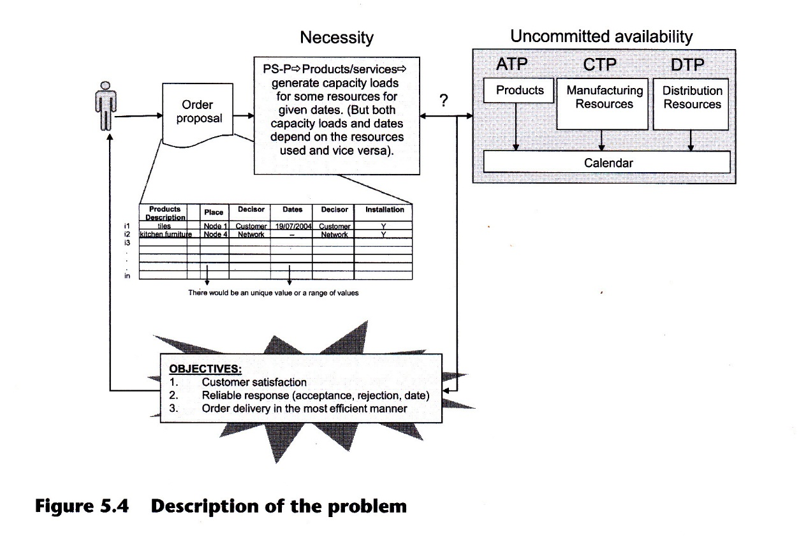

5.2.3 KERABEN (TO-BE)

To provide a solution to the problem explained in the previous section, a collaborative network was defined to market PS-Ps with greater added value for customers than the total value of individually marketed products. To describe the new order management system in the collaborative network, the scheme proposed by Nassimbeni (2004) will be used, divided into three main sections, concerned with the questions: who? what? And how?

Who? Network description

The actors involved in the EOM for this PS-P are Esmalglass as glass supplier, Keraben as tile manufacturer, Febal as furniture manufacturer, Demovave as the logistics platform, Keraben Tiendas (Disacer) as selling points, and a team of installers (Figure 5.5). If we bear in mind that the Febal average order price is approximately 3,000 and that all the firms work in a similar price range and focus on sales to customers who want exclusive products, it is thus logical to operate with a shared PS-P catalogue. All the actors must be involved in EOM to achieve efficient customer service and to offer the value added in the collaborative network shown in Figure 5.6.

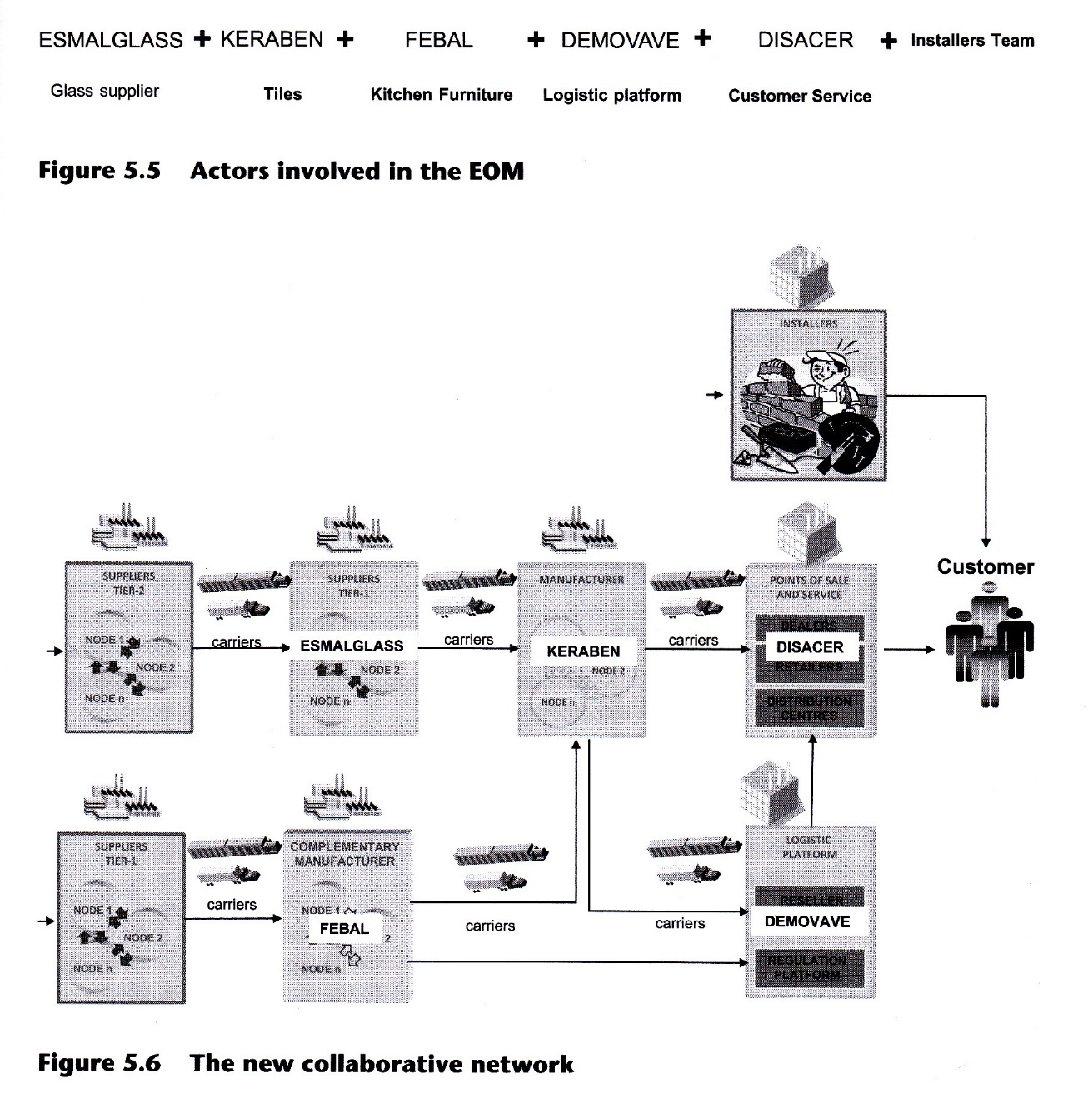

What? PS-P and resources

The above collaborative network offers to the final customer PS-Ps, such as 'kitchen ambience', composed of the following products: tiles, kitchen furniture, services offered to the final customer by the selling point and an installation service. When a customer orders a certain PS-P, individual orders for every sub-product are also generated. The new EOM process will help to coordinate these orders by developing a solution to re-engineer the Keraben-Febal-Demovave selling chain in order to offer to the final consumer new added-value packaged products and services that will provide the company with a competitive advantage and the end customer with an extended value proposition, through the collaboration of the extended selling chains. Furthermore, as can be seen in Figure 5.6, the new network shares the available resources (for example Demovave logistics platform and Keraben shops) in the different supply chains in order to ensure effective and reliable deliveries.

How?

As it has been pointed out above, the joint sale of the products composing the PS-P has an impact on the order management process of all the actors involved, so that it becomes necessary to re-engineer the process. To achieve this objective, a redesign will be carried out. The resulting process in the new collaboration context is the EOM. To adapt, coordinate and safeguard exchanges during the execution of the EOM process, it is necessary to develop technological support and managerial software. The objective of the following sub-sections is to provide the reader with a general understanding of the EOM goals, objectives and benefits, the life cycle of the application that supports the EOM process, its operation and a detailed description of the EOM process.

EOM process

The EOM process is supported by a software module, also called EOM, which will permit orders to be registered and changed, consult the status and track the evolution of an order throughout its life cycle. The EOM software is also linked with other software tools in the companies such as those for the management of extended distribution, extended forecast, extended exception and extended performance. The goal of the design of the new software-supported process is to manage the whole cycle of order management in a collaborative context. This includes all activities to be carried out by the EOM from the arrival of a customer order proposal until the final delivery (that is, when the customer acknowledges reception and checking or even after a guarantee period).
The new collaborative EOM process design must allow a committed delivery date to be offered to the customer, coordinating different production strategies and delivery rules among the partners for the delivery of the PS-P to the final customer. Furthermore, once the order proposal turns into a committed order, a global order flow management of the order (technical validation, bill of materials, orders, services, order acknowledgement, order status and so on) must be possible. Additionally, it is basic to offer visibility to all partners (complementary manufacturers, suppliers, and so on) on orders and potential orders (habits, fashions, customer behavior). However, to achieve this it will be necessary to identify all the factors required to carry out the EOM. Certain questions must be answered, such as: the characteristics of PS-P orders, potential customers (private individuals, builders or business companies), information to be published and how the different actors will be permitted to access this information (security access).
The benefits obtained from the redesigned process can be classified into two major categories: those related to the customers and those related to the partners involved in the network. From the customers' point of view, the EOM process manages in a coordinated manner all the activities required to achieve a feasible commitment with the customer related to delivery date and budget, and to track the order progress to ensure that these conditions are complied with. The customer has to contact a single selling point that centralizes the complete process. Customer satisfaction can therefore be expected to be greater due to the added value of the PS-P itself in relation to the design, the convenience of having to visit only one selling point that manages all the stages in the process, the communication of any incidents, the satisfaction of receiving the PS-P on the committed delivery date and the coordination of each PS-P product delivery. From the network point of view, the benefits obtained are the following: more effective management of production, service and distribution capacity which impacts on reducing costs and, therefore, increasing benefits; the possibility of managing different production strategies in a coordinated manner, reducing overtime for unplanned production cycles, achieving smoother labor scheduling, and so on. Finally, an increase in customer satisfaction should lead to sales increasing.

Life cycle management with EOM software and operation

EOM software is based on two core phases: the definition phase and the operational phase. The definition phase is the phase during which the order is actually placed (customer order and order entry). At the end of this phase, the order should be registered according to the customer's preference regarding possible configurations of the PS-P. The operational phase will manage the different tasks necessary for order fulfillment, according to the characteristics defined during the first phase (order processing, assembly, transport, order received). Figure 5.7 illustrates the management flow of the EOM during its life cycle. The tool developed for the EOM process will provide support for the control of customers' orders from their arrival until deliveries are made to the customer, providing in real time or 'almost' real time an accurate due date and all the information that the customer needs (sales conditions, guarantees and so on). Keraben, Febal, Demovave and the installation team must validate their availability to offer a date in real time to deliver the products or services contained in the PS-P. All the individual dates will then be coordinated before communicating the final date to the customer. The appropriate distribution of the order among the different partners (Keraben, Febal and the installers), taking into account the different organizational methods and information systems, will also have to be decided (that is, customer grouping, items grouping, due-dates grouping, etc.).
Furthermore, the process must be conversant with the management of information sharing and visibility among the different partners in order to convey information about inventory, stock levels, open orders, deliveries already planned, minimal order sizes, financial restrictions and so on. With this information it will be possible to determine ATP, CTP and DTP quantities in real time, to guarantee a delivery date to the final customer.
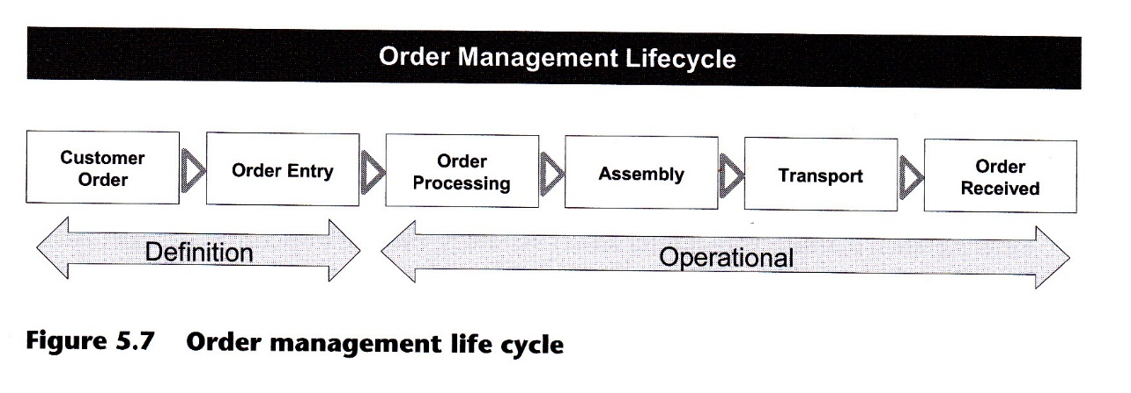
Therefore, the possibility of different partners using different manufacturing models management (MTS, MTO, ATE ...) must be taken into account. Default information for these parameters should be available, but the values must be updated periodically by each partner or by the exception management module in order to provide accurate information and offer the best possible conditions and delivery dates at all times. Once the due dates have been validated for all partners, the data will be sent to all the departments involved (Keraben: manufacturing department, Febal: dispatch department and installers) to facilitate the preparation of the corresponding manufacturing/service orders and carry out order fulfillment.

The new order management process

The new order management process (EOM) begins with the arrival of the customer at the sales outlet (Figure 5.8). The products catalogue shown to the customer depends on the type of customer and the characteristics of the order proposal. By means of the customer configurator, it is possible to identify the type of customer and the rules which will be applied throughout the EOM life cycle. Based on the information provided by the product configurator, the available product configurations for the PS-P and the different distribution and transport rules that will be applied to the pack and client are identified. At this point, the order proposal is filled out according to the customer's requirements and the relevant network rules. Pricing, shipment conditions and other options (the budget) are generated. For defining a feasible and reliable PS-P delivery date, the COPP must be performed based on the ATP/CTP/DTP quantities of all supply chains involved (see Figure 5.8 for a detailed description). Both budget and delivery date are submitted to the customer for approval. If the customer does not accept the conditions, the process ends. If he does, the order proposal turns into an accepted order and a commitment has been made with the customer. When the order proposal has been accepted, the necessary information is generated for its fulfillment through the Bill of Materials (BOM) distribution, which is responsible for issuing the manufacturing, distribution and service orders generated for each product and service included in the PS-P. Should any technical problems arise at this stage, the original order proposal may have to be modified as required, generating a new proposal. When these problems have been solved, the definitive production, distribution and installation phases are initiated (final fulfillment). When the PS-P has been accepted by the customer, the billing process and order filing are carried out, after which the payments received for the order are appropriately distributed among the participating members of the chain.
Because COPP is one of the EOM sub-processes that heavily impact on customer satisfaction, it is analyzed in more detail in the following paragraphs (Figure 5.9). pricing, shipment conditions and any other options required by the PS-P customer order proposal are filtered by product/service and sent to the appropriate partner with the aim of defining a feasible and reliable PS-P delivery date. For the case under study, the data concerning tiles will be sent to Keraben, the kitchen furniture data will be sent to Febal and finally the installation data to the installers team.
Since Keraben manufactures under an MTS strategy, the first step consists of calculating the available stock of final product (tiles), actual or planned, that is not yet committed to existing customers (ATP) for each time period. If there are not enough ATP quantities, Keraben can compute the uncommitted available production capacity (CTP), in order to find available dates for the manufacture of the product requested. This has a direct impact on production planning, and therefore date validation is necessary. However, to ensure on-time delivery, enough uncommitted distribution capacity must be available (DTP). Based on this information, provisional delivery dates are proposed by Keraben.
A similar process is carried out by Febal but with some differences. Since this partner uses an ATE manufacturing strategy, available stock only exists for modular components of kitchen furniture, so that, to propose feasible delivery dates, the ATP quantities for these components has to be computed. The assembly of final products is made for committed customers' orders considering transport constraints to maximize transport efficiency. This is the reason for computing not only ATP but also CTP (uncommitted available assembly capacity). The possible dates obtained could modify the production plan and must be checked with DTP quantities.
Finally, in order to install the kitchen ambience PS-P, the installers team must provide dates for installation of the product based on their uncommitted available installer capacity (CTP).
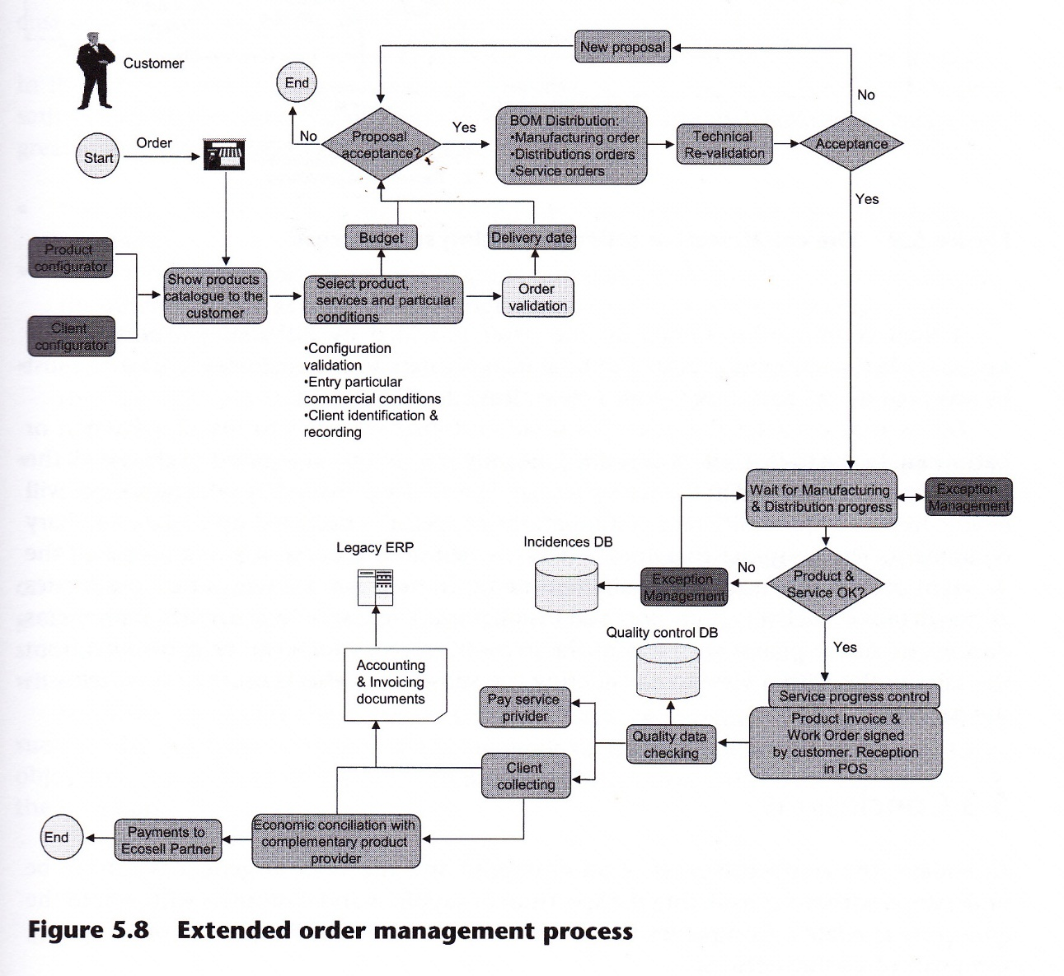
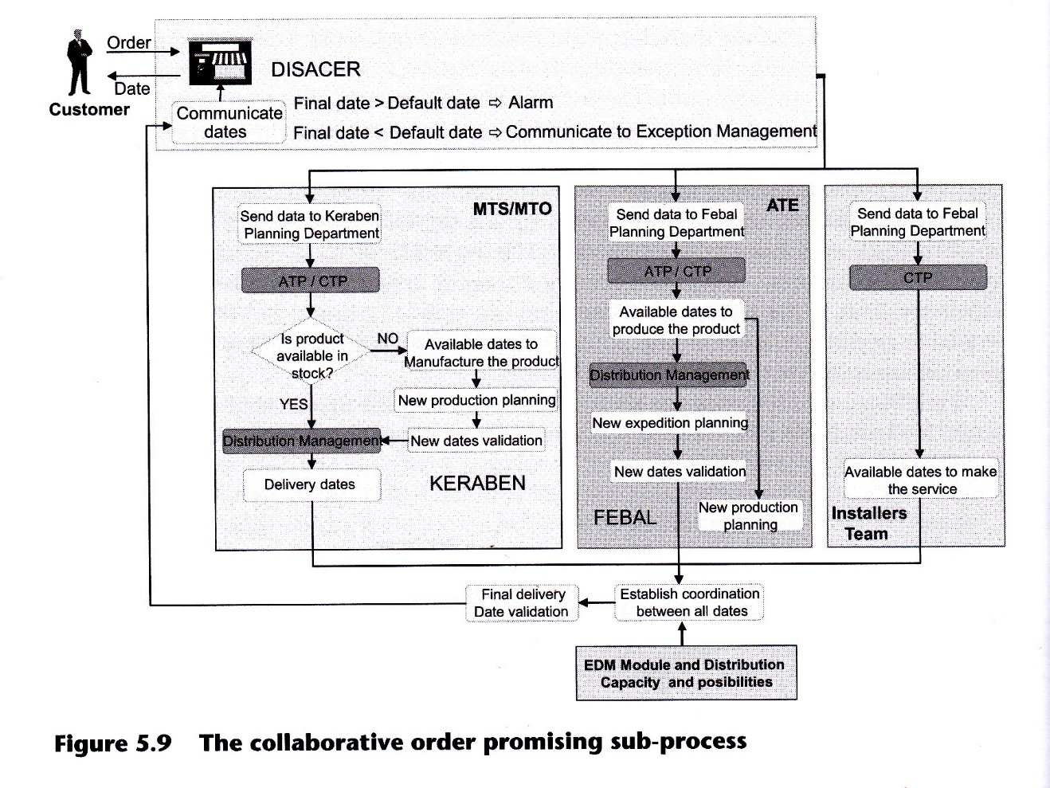

A final coordination among all the dates provided by different partners will be necessary before communicating the final delivery date to the customer. This date must be accepted by the customer before a commitment will be made. Let us now consider the case of a small customer who has to install a kitchen or bathroom. In the to-be context described, he only goes to one sales point to choose all the necessary items included in the sales package. The advice provided by sales personnel will enable him to acquire different combinations of specially designed up-to-date auxiliary equipment. The customer therefore avoids the laborious process of going round all the different providers to acquire the different items. In this case, a single outlet coordinates all the details on delivery, transport and installation. There should be technical problems during any of the phases with any of the items involved, which can be controlled from the sales outlet with a view to considering the subsequent effects on the other items in the package.

5.3 Conclusions

Nowadays, the competitiveness of an enterprise and the value it generates cannot be understood without considering the spectrum of suppliers and customers with whom the enterprise is related. Companies that have accepted, or are in the process of accepting, form part of a value network.
Interest in improving cooperation and collaboration with other members of the network is becoming more evident. One of the best business opportunities that has been derived from collaborative networks is the merchandising of PS-Ps. These sets of complementary goods or services provided by different manufacturers or supply chains provide the customer with greater added value than the individual values of the products of which they are composed. However, the general adoption of collaborative systems, and especially that of the PS-P, requires a restructuring of the business processes of the firms involved.
The Keraben Group decided to put into operation the marketing of PS-Ps in partnership with other firms and supply chains that produced complementary products similar to their own. This case study describes the management of the former order process (as-is). An analysis of this process is then carried out, with special emphasis on the critical sub- process of order promising. The need to consider changing as-is and improving Keraben customers, added value is then dealt with. Finally, a new collaborative business process (EOM) is described which handles PS-P orders for tiles, kitchen furniture and installation services, from order reception to final PS-P delivery at the time and place agreed with the customer.
This new approach has advantages both for the customers and the actors involved in the supply network. From the customer's point of view, the main benefit is a higher satisfaction degree about the products/services provided. The PS-P EOM gives customers greater added value for the following reasons:

- they can choose from a number of possible combinations of carefully designed products;
- EOM avoids the laborious process of going round all the different providers to acquire the different items, as in this case, a single outlet coordinates all the details on delivery, transport and installation;
- delivery dates are agreed with customers based on relevant information concerning the ATR CTP and DTP of the actors involved in the process, giving the dates greater reliability;
- any problem arising during order fulfillment is detected and duly transmitted to the customer.

From the network's point of view, better customer satisfaction has a reinforcing effect on sales of PS-Ps and consequently on profits, which are increased not only because of greater sales but also due to reduced production costs, since more efficient use is made of stock inventories, production units and distribution systems, all of which are considered when delivery dates are promised.
However, to obtain these benefits certain basic requirements must be fulfilled, such as the need for members of the network to reach a consensus on the process objectives, the method of dealing with orders and the information available to each of the members.

LESSON LEARNED

Collaboration for successful design
This case study shows how a company can grab new market opportunities, thus better fulfilling customers' needs, if it develops a collaborative network with other companies in order to design innovative products/services.

QUESTIONS FOR STUDENTS

1. Which are the requirements for the creation of a collaborative network?
2. How can the creation of a collaborative network affect the time to market?
3. Do you think customers are capable of quantifying the benefits involved in purchasing a PS-P from a single sales Point?
4. Identify the activities in Figure 5.8 that correspond to each of the stages in the life cycle management of Figure 5.7.

OPEN DISCUSSION
1. Which tools would be able to support design collaboration?
2. Which incentives would be able to foster collaboration?

References

Alarcón, F., Alemany, M. M. E. Alemany, Ortiz. A (2009). Conceptual framework for the characterization of the order promising process in a collaborative selling network context. International Journal of Production Economics, 120(l) , 100- 114
Alarcón, F., Alemany, M.M. and Esteban, J. (2008). A collaborative planning process modeling methodology. An application to a real case. In Second International Conference on Industrial Engineering and Industrial Management, XII Congreso de Ingenierta de Organizacion, Burgos.
Alemany, M.M., Alarcón, F., Ortiz, A. and Lario, F.C. (2005). Order promising process for extended collaborative selling chain (ECOSELL). In Interactional Conference on Industrial Engineering and Systems Management, IESM, Marrakech (Marruecos).
Alemany, M.M., Ortiz, A., Alarcón, F., Lario, F.C. and Bengochea, M.A. (2007). El proceso de comprometer pedidos de un paquete de productos integrado por productos del sector cer6mico y productos complementarios: Parte I Descripcion y caracterización de la problemática. Boletín de la Sociedad Española de Cerámica y Vidrio, 46(l),21-28.
Alemany, M.M., Alarcón, F., Ortiz, A. and Lario, F.C. (2008). Order promising process for extended collaborative selling chain (ECOSELL). Production Planning & Control, Recent Issues in the Management of Enterprises and Supply Chains, 19(2), 105-131.
Camarinha-Matos, L. and Afsarmanesh, H. (2005). Collaborative networks: a new scientific discipline. Journal of Intelligent Manufacturing, 16(4-5), 439-452.
Camarinha-Matos, L., Afsarmanesh, H. and Ortiz, A. (2005). Collaborative Networks and their Breeding Environments. New York: Springer.
Lamming, R., Johnsen, T., Zheng, J.R. and Harland, C. (2000). An initial classification of supply networks. Interactional Journal of Operations & Production Management, 20(5-6), 675-691.
Nassimbeni, G. (2004). Supply chains: a network perspective. In New, SJ. and Westbrook, R. (Eds) Understanding Supply Chains: Concepts, Critiques and Furfures Understanding, Oxford: University Press, pp. 43-65.
Porter, M.E. (Ed.) (1986). Competition in Global Industries. Cambridge, MA: Harvard Business School Press.
Porter, M. and Fuller, M.B. (1986). Coalitions and global strategy. In Porter, M.E. (Ed.), Competition in Global Industries. Cambridge, MA: Harvard Business School Press, pp. 315-344.
Snow, C.S., Miles, R.E. and Coleman, HJ. $992). Managing 21st century network organizations. Organizational Dynamics, 20, 5-20.
Winer, M.B. and Ray, K.L. (1994). Collaboration Handbook: Creating, Sustaining, and Enjoying the Journey. Saint Paul, MN: Fieldstone Alliance.
Williamson, O.E. (1985). The Economic Institutions of Capitalism: Firms, Markets, Relational Contracting. New York. Free Press.

