CHAPTER
6
Huawei Case Study:
Country-specific Factors
Affecting New Product
Development

Country specific factors (governmental regulations, local standards, customers needs and habits etc.) to be taken into account in the new product development. An example from the telecommunication sector
YUAN LI, CHENLU ZHANG, XIYAO LI AND HENG LIU
6.1 Theory
6.1.1 NEW PRODUCT DEVELOPMENT
Scholars have demonstrated that companies operating in high technology industries consider new product development a critical part of their strategy (Deeds et al., 2000). Companies have begun to compete with each other on the basis of who can be the fastest at realizing the benefits of these technologies.
New product development has become a tremendously important and competitive tool, both in the way that the new technologies are put together into products or services and in the way that organizations are structured to deliver those benefits (Barton, 1992).
6.1.2 FACTORS AFFECTING NEW PRODUCT DEVELOPMENT
Success in product development is a critical management issue for modern firms, especially in technology-driven industries. Companies may gain significant advantage from the successful development of new products, but it is also a big risk. A clearer understanding of the factors that drive product outcome can help a firm to focus on valuable research and development (R&D) resources in order to improve the resources dedicated to the product's start-up process and to increase the market demand for new products. A substantial amount of literature on the subject has suggested a myriad of factors that drive new product performance (Cooper and Kleinschmidt, 2007; Cooper, 1994). It is possible to highlight four major factors that can be used to classify the literature: technology, government, market demand and entrepreneurship.
Technology
The first major factor is technology. The existence of technology resources and the capacity to apply these technologies provide companies with a jumping-off point for new product development. Product success is more likely if the development process was conducted by a competent and skilled R&D department. Many studies found that an innovative product can have a greater chance of success in the market, while some found otherwise. Some studies included patentability of the product or at least 'strong' technology in the product as an important factor for success. Further, studies have shown that in many industries where new product development is important, companies do not even bother to patent their advances. Technological breakthroughs create opportunities for new product development. A technology push strategy in new product development is much easier to accept because the development of new products usually combines well with the advantages and core resource, so the difficulties encountered are less, and the production design is more easily supported by technical experts and accepted by managers (Li, 1993). On the other hand, technology push was not considered as strong a factor as demand pull.
Market demands
Understanding customers' needs was also critical for developing a new product successfully. With in-depth knowledge of their customer's problems, a firm can develop solutions that provide a significant value (Utterback and Abernathy, 1976; Cooper et al., 1987). Value can be manifested in terms of the product's cost savings, quality (Buzzell and Gale, 1987), performance advantages or a combination of features. Since value in high technology markets is often measured in terms of product performance, product success can also be linked with technically superior products in some aspects of their performance (Zirger and Modesto, 1990). Companies can get useful information directly from customers: on their behaviour, their anticipation, their likes and their dislikes about that product. In addition, a company can get new ideas about how to improve or design new products to meet unarticulated needs (Barton, 1992).
Government
Government involvement in the early stages of technological development can provide the boost necessary to launch the technology and to develop an industry. There are a number of significant government programs to assist technological development in many countries, for example the Commercial Ready program in Australia, Malaysia's Multimedia Super Corridor and the Vinnova programs in Sweden (Kropp and Zolin, 2005). Li and Atuahene-Gima (2001) indicate that new technology ventures in China face more complex environmental situations than their counterparts in market economies. The success of Chinese new technology ventures' product innovation may depend not only on how they manage resources within the firm but also on the degree of support they receive from government institutions to alleviate their resource and managerial problems.
The government can support the firm in the forms of direct investment, tax policy, credit policy, government stock, industry policy, risk fund and rudimentary facilities, especially in a situation where market mechanism cannot exert its action. The government can induce innovation projects or help companies innovate directly.
Entrepreneurship
The number of studies focused on entrepreneurship has grown rapidly in recent decades (Dess et al., 2003) and have long been recognized as the key for launching innovative activities. Entrepreneurs contribute toward economic development by introducing new product offerings into the market or through new production methods (Schumpeter, 1954, 1976). On one hand, entrepreneurship promotes a firm's indigenous innovation activities by a high risk of tolerance, being proactive towards market and technological opportunities and receptive towards radical product innovations (Lumpkin and Dess, 1996). On the other hand, entrepreneurship effectively enhances a firm's technical, organizational, administrative and social competencies which build the foundation for replenishing, upgrading and protecting existing knowledge, or creating new knowledge (Zahra, 1999). Rapid technological changes and fierce competition can compel a firm to implement entrepreneurs' activities to accelerate new product innovation.
The Huawei case study shows other external factors that have affected improvement in innovation capability. They include the active role of the government, clustering of R&D functions, an industry trend moving towards configuration technology and sub-sector linkages.
6.2 The Case Study
6.2.1 COMPANY PROFILE
Huawei Technologies Co. Ltd (Huawei) is a global information and communication technology (ICT) company, which has always been dedicated to R&D and has provided innovative and customized products, services and network solutions to create long-term value and potential growth for its telecom operators around the world.
Established by seven people with only RMB 20,000 (about us$2,400) in 1988, Huawei has made the transition from a locally owned business to a potentially competitive global giant. Focusing on customers' challenges, promoting network quality and reducing the construction and maintenance costs with innovative solutions, Huawei has been recognized and accepted by mobile operator all over the world. Today Huawei is been among the top three global mobile equipment vendors, and is number one in digital switches and next generation network, number two in ADSL broadband and number 4 in optical networks in terms of market share (Huawei, 2009). Figure 6.1 illustrates Huawei's product position in the global market. Its products and solutions have been deployed in over 100 countries, and are serving 31 of the world's top 50 operators, as well as over 1 billion users worldwide. Its clients are companies such as China Telecom, China Mobile, China Unicom as well as BT NEUF Telecom, AIS, Telefonica, SingTel, Hutchison Global Crossing, PCCW HKT, SUNDAY, Etisalat (UAE), Telemar (Brazil) and Rostelecom (Russia).
Huawei offers total network products and end-to-end solutions based on its experience in technology and applications. Its full product portfolio covers wireless network products (UMTS/HSDPA, CDMA2000, GSM/GPRS/EDGE and WiMAX), network products (NGN, xDSL, optical transmission, data communications), application and software products (IN, mobile data, OSS/BSS, CDN/SAN) and terminals. Most important of all, Huawei products are based on its independently designed application-specific integrated chip (ASIC). Its ASIC designing capability is among the most advanced in this field worldwide. This allows Huawei to consider the needs of its customers from the start (the need of a single chip) to the end (the network).

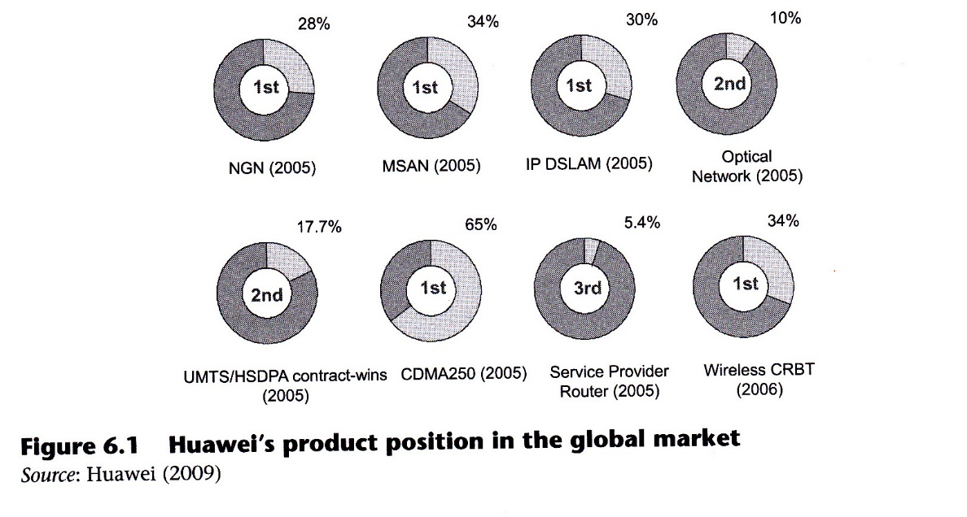
With these advanced products and international services, Huawei's revenue surpassed US$12 million for the first time in 1992 and has expanded rapidly since then. In 1998, its revenue reached US$3.l billion, making it the number one Chinese telecom equipment supplier in the Chinese market. In 2000, it had sales of US$2.5 billion, and was ranked 22nd in the world telecom equipment makers in revenue. The company advanced its turnover further to US$3.1 billion the following year, ranking 16th in the world (IDATE, 2002). Huawei reached US$5.58 billion in contract sales in 2004 and US$8.20 billion in 2005, an increase of 85 per cent over the previous yeaf, ovet 62 per cent of which (US$ 2.47 billion) were from international markets. In 2006, US$11 billion in global contract sales were generated, with an increase of 34 per cent from the previous year with 65 per cent from international markets (see details in Table 6.1).
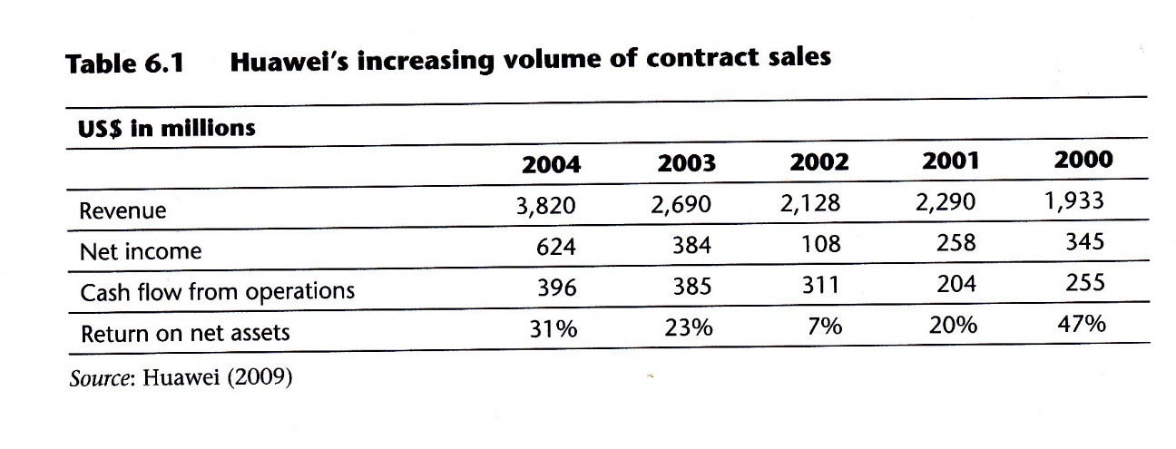
In order to support its global operations, Huawei has established sales and after-sales centers, including 8 regional headquarters and over 100 branch offices outside China: they are located in North America, South America, Russia, Western Europe, Eastern Europe, North Africa and the Middle East, Southern Africa and Asia Pacific (see details in Figure 6.2).
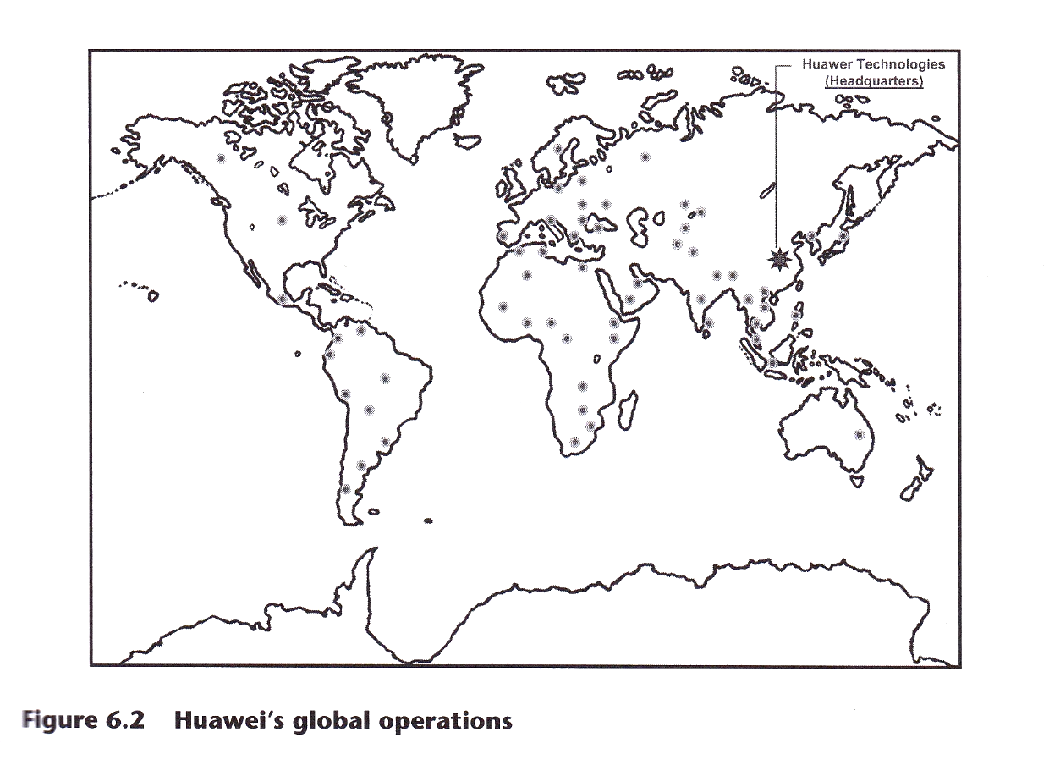
Huawei's efforts in R&D and customer satisfaction have been recognized by its customers. A Gallup survey (Huawei, 2009) found that Huawei has held the number 1 position in terms of service quality and customer satisfaction in the Chinese market for many years. In the international market, by investing in numerous after-sales services, Huawei can ensure high-quality end-to-end solutions and services that enable it to establish long-term partnerships with its customers. According to the survey by Heavy Reading, a London-based research under the LightReading group (Huawei, 2009), Huawei won 16.7 per cent customer recognition in customer service and support in early 2005 compared with less than 1 per cent in their last survey in autumn of 2003, ranking fourth among worldwide vendors.
6.2.2 HUAWEI'S NEW PRODUCT DEVELOPMENT

As a global manufacturer of communication equipment, Huawei's new product development capability is one of the most important elements leading to core competence and keeps Huawei ahead in the domestic and international marketplace. Huawei has always invested in new product development with a long-term perspective that resulted in the registration of patents and product standards which have been applied into the process of new product development. By the end of 2007, Huawei held 7 percent (152 patents) of the world's Universal Mobile Telecommunication System (UMTS) essential patents. By June 2008, Huawei had filed 30,569 patent applications. This powerful patent development capability and knowledge makes the company a marketplace leader and secures the repect of its customers. This is why Huawei continues to implement a development strategy by studying new technologies and innovation intensively.
Figure 6.3 illustrates the strategy of new product development used by Huawei. The first stage, 'acquire primary data', consists of the acquisition of primary data for an investigation of the market in order to grasp the requirements of current or potential customers. Huawei uses its 8 worldwide headquarters and 100 for this research. The second stage is 'to enlarge the inputs for high-tech products' proactively and sufficiently. The third is 'develop new core products': here Huawei concentrates all its efforts in order to develop the products. The fourth stage is to 'obtain independent knowledge' which the company uses to maintain its position leader rather than a follower in the market. Huawei act proactively and develop new products leveraging on independent knowledge and internally developed patents.

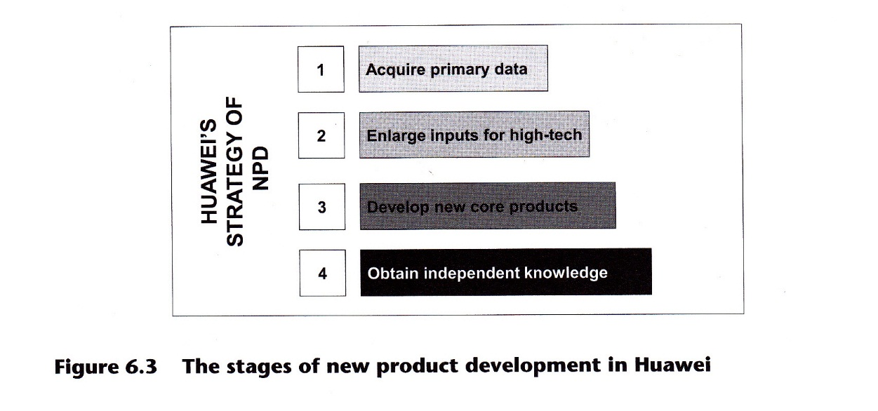

R&D expenditure

In order to achieve successful new product development Huawei has always invested heavily in R&D. In 2002 Huawei invested 18.8 percent of its revenue in R&D, higher than any other Chinese firm or any multinational company (MNC) in China in the telecom-equipment sector. Huawei has the highest 'R&D/Revenue' ratio among all four major telecommunication companies in China and can be compared to the leading MNCs, whose average R&D spending was 6.4 percent of the revenue in 2002, and to the international R&D spending standards in the telecom equipment industry (from 10 percent to 20 percent) (Fan, 2006). As the leader in innovation capability and the industry, Huawei was listed as the seventh largest electronics company in China by revenue, but its R&D expenditure topped all other companies listed in 'China's 100 largest electronics companies' in 2002.

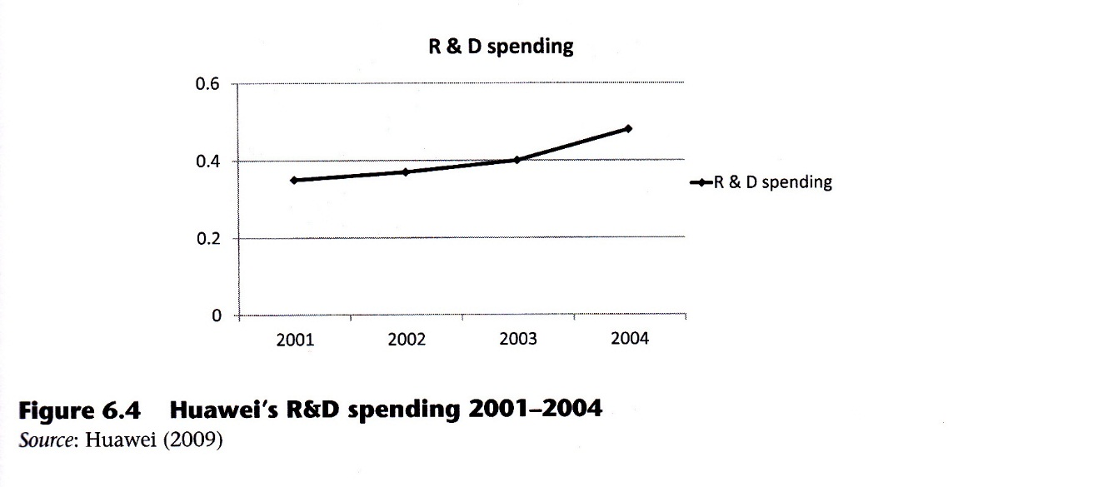
Figure 6.4 shows that the R&D expenditure of Huawei has grown steadily from US$340 million in 2001 to US$480 million in 2004, representing growth of more than 41 per cent.

R&D employee ratio
Since its early trading years Huawei has been famous for its high R&D employee ratio: the company had 500 R&D staff and only 200 production staff. In 2002, 54 percent of the workforce devoted to R&D, a number significantly higher than most MNCs' operations in China. For instance, Lucent, Motorola, Nokia and Nortel each have respectively an R&D ratio of 16 percent, LO percent, 6 percent, and 4 percent. Today, 48 percent of the employee workforce is committed to R&D activities, 6 percent is engaged in management, 8 percent in manufacturing and 38 percent in marketing and service. It is a typical 'smile curve' structure: emphasis on R&D and market at the two ends, representing a characteristic of a knowledge-based firm (see Figure 6.5).
At Huawei nearly every employee is educated to undergraduate level, especially those working in R&D. An examination of the workforce's education level indicates that these companies probably have the most educated workforce in China. Moreover, among Huawei's 35,000 employees, 90 per cent hold bachelor's degrees or higher, and about 60 percent hold a master's or Ph.D. degree.
In R&D, Huawei's ppp-research department receives 10 percent of the company's total R&D investment to keep up with the latest technologies. Employees are well trained in Huawei and despite engineers in the company being highly trained with many holding doctoral qualifications, Huawei also actively recruits engineers from other telecommunications giants, for example, those displaced due to global restructuring. Huawei's research and development laboratories are strategically located around the world in places such as Bangalore in India, Asia's own Silicon Valley.
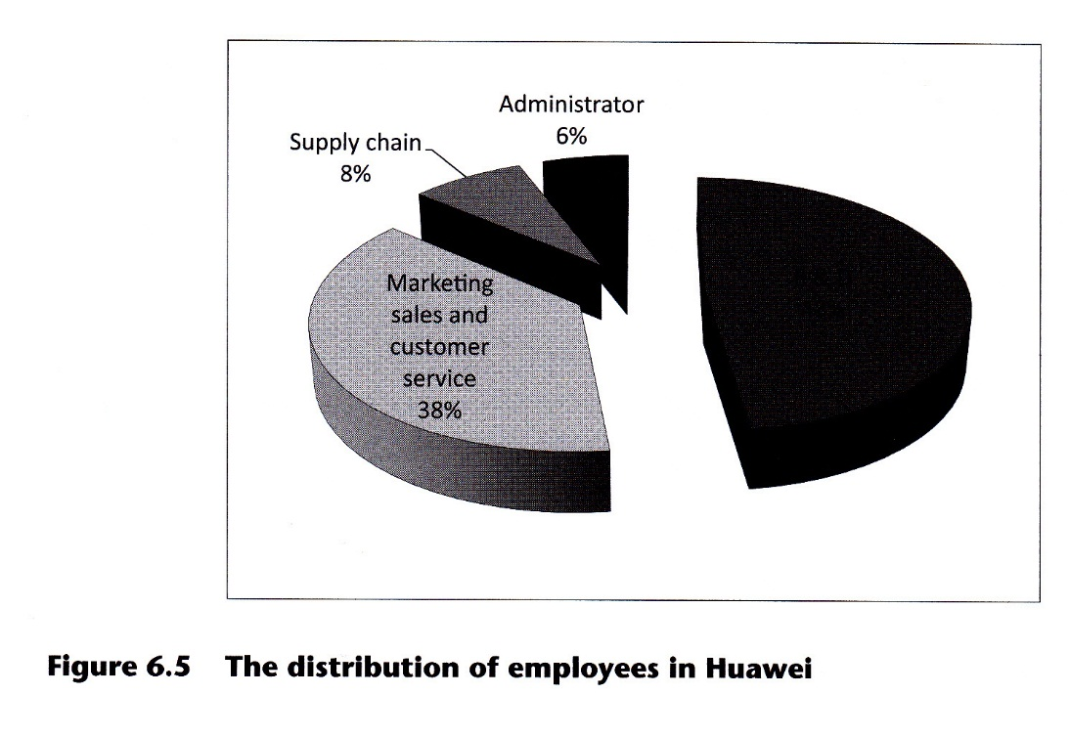

International R&D facilities

Huawei has built a three-level technical support service system, ranging from the headquarters, regional headquarters and each single country or region. There are ten R&D facilities within China and abroad, working round the clock (see Table 6.2). In China, there are R&D centers in Beijing, Shanghai, Nanjing, Hangzhou, Xi,an and Chendu, as well as the Huawei Technology Center in its Shenzhen headquarters. Furthermore, Huawei has many overseas R&D offices, for example in Dallas and Silicon Valley in the United States, Bangalore in India, Stockholm in Sweden and Moscow in Russia.
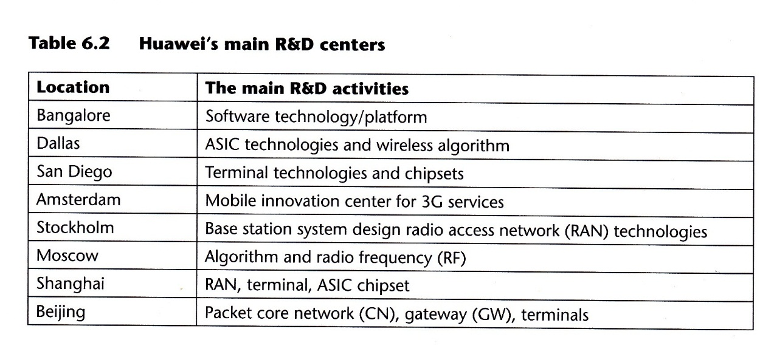
R&D management system

Huawei's innovation in management provides a solid foundation for all other innovations. The company has introduced R&D management models and strengthened the support of its shared platforms, which enables it to rapidly capture the transient market opportunities. With CBB (a hardware and software sharing module), Huawei has established a technology sharing system which comprises various layers such as system design, platform, modules and components. Huawei also promotes standardized, component-based and platform-specific management in their research and development, and simplifies the structure of their systems and organizational framework to prevent the leakage of technology.
With an asynchronous new product development method, Huawei coordinates development progress at various levels, manages the time-to-market of products and speeds up their response time to market demands. It can usually deliver the final product only four days after the contract has been signed. Huawei reaches the top of its field by integrating innovations in various areas as a key competence.

6.2.3 FACTORS INFLUENCING HUAWEI'S NEW PRODUCT DEVELOPMENT

Four major factors which help to classify the literature were presented in our introduction. Here the same factors will be used to highlight the features of the new product development process of Huawei.

Government

Historically, in China technological development has been closely overseen and tightly controlled by the central government through the Ministry of Information Industry (MII). Although it has reduced and continues to reduce its impact and protection of local firms, China's central government still supports Huawei in taking its first step towards international new product development, whether generating high rates of equity investment or stimulating technical progress.
From the financial as well as marketing aspect, for example, Huawei continues to receive soft loans to help with their international expansion. China Development Bank (CDB), the biggest state policy bank, recently extended a credit facility of US$10 billion to help overseas customers' funds with the purchase of Huawei's products (Low, 2007). A similar deal happened between Huawei and Sinosure, the Chinese government insurance company, to export credit financing operations in order to help Telemar Norte Leste SA, Brazil's biggest telecommunications operator, to finance the purchase of equipment from Huawei. MII has also continued to encourage local Chinese operators like China Telecom and China Mobile to purchase telecommunications equipment from Chinese manufacturers, notably from Huawei, TilE (Zhongxing), Datang and Great Dragon (Low, 2007).
With regard to technology and patents, Huawei received the support of the Chinese government for TD-SCDMA, the Chinese 3G standard. With the support of three government agencies - the State Planning Commission, MII and the National Science and Technology Department, in just one week on the 30th October 2002, a total of seven telecom-equipment manufacturers responded to Huawei's announcement and formed the TD-SCDMA Industrial Alliance' (People',s Posts and Telecommunications 2002).
From the culture and legitimacy aspect, china's govelnment has facilitated the R&D of firms through the creation of an innovation-oriented culture. For Huawei specifically, the local government of Shenzhen, where Huawei's headquarters are located, is creating a better environment to promote Huawei's rapid and healthy development' It has set up a special service group to provide one-to-one support and assistance for Huawei's innovation.
Huawei’s development would not exist without extensive support from both central and local government. Ren Zhengfei, the president of Huawei, has been appreciative of those government policies that played a vital role in Huawei's development'

Huawei was somewhat naive to choose telecom-equipment as its business domain in the beginning. Huawei was not prepared for such an intensified competition when the company wis just established. The riyals were intemationally renotwted companies with assets valued at tens of billions of dollars. If there had been no govemment policy to protect [nationally owned companies], Huawei would no longer exist' (Xiao, 2002, p' 127)

Market demands

After rectifying mistakes in market orientation, Huawei's motto is 'do market feasibility and strategic research, and struggle to make all the new products developed by Huawei valuable commodities'. However, it is difficult to provide solutions and services, firms cannot seize market information in the process of new product development, or cannot make a quick and correct decision according to market information. Huawei must be careful to understand the market before it enters, especially in the high-tech communication equipment market where the technological environment is turbulent. For example, Huawei’s distributed base stations, the first developed in the industry, are solely for solving the problems European operators faced, such as difficulties in selecting locations and the huge cost of projects. Customers at different times and in different places may have totally different technological needs. HSDPA (high-speed downlink packet access) services, for example, supported in the same coverage area as premised: in some countries, customers only have one operator, here Huawei should use the hybrid networking mode to build HSDPA networking; in other countries, where there are multiple operators, two options are available: independent networking and hybrid networking.
In order to enlarge the market share in electronic communication fields, Huawei continues with the four steps process shown in Figure 6.3. An example of how this process is implemented follows. After careful investigation, Huawei realized that 80 percent of information in China was transmitted by optical fiber and that since 2004 the number users of China Telecom had been increasing continuously. This network photochemical trend has been extended to the client. At the same time, foreign manufacturers' stocks of optical fiber and cable had basically sold out, the market boomed due to the prosperity of broadband networks and urban development and the average price of optical fiber cables and network equipment products in the market was also stable. Huawei saw this as an opportunity to concentrate its efforts on solving optical transmission technology: ultimately, it successfully provided dozens of sets of large capacity core switching equipment for operators in Brazil, Sweden, and so on. In China, dozens of telecommunication operators, including the city of Guangdong, also adopted Huawei's new equipment to construct the core metro optical layer in provincial capitals. In addition, Huawei launched a long-distance route transmission system which successfully won many operators' contracts, for companies such as Russian Telecom, China Jilin Mobile, Heilongjiang Unicom, Zhejiang Telecom and Guangxi Telecom. In addition, Huawei has always emphasized the importance of gathering customer feedback. To truly understand customers' needs, in 2002, Huawei issued an internal file, Satisfaction Study of Huawei's Customers, and demanded that all staff should study and discuss it conscientiously. From this survey, Huawei achieved a clearer understanding of customers' needs of what the company should do: rather than just paying attention to improving the capabilities of new products and developing new technologies, it is important to really think about protecting their users investment interests, developing new future-oriented products and technologies using existing resources, and face the future using only the current resources.

Entrepreneurship

Ren Zhengfei, a former army officer, founded Huawei as a telecommunications equipment seller in 1988. 'He insists on military-style efficiency and a "wolf spirit" mentality that encourages the sales force to relentlessly attack competitors' (New YorkTimes,2010). Over the past years, Huawei has grown into a multinational company and competes with telecoms giants like Cisco and Ericsson face-to-face on the global stage.
Ren Zhengfei is aware oT prospective opportunities and danger and has acted ruthlessly where necessary to protect the company's interests. For instance, while most were applauding the superiority of China's IT industry amid the global downturn in the year 20O7, Ren Zhengfei was promoting 'Huawei's Winter' inside the company and sold off subordinate Huawei Electricity for RMB 6 billion in cash as a 'cotton-padded coat' for the winter; while other companies were saving for the winter, he bet extravagantly on 3G and seized the opportunity.
Originally an army officer, Ren himself is known to have a charisma reflected in his vision for his company. He has refused media interviews since he started the company. As Huawei's founder and sole leader, he believed that the country's 'exchange market with technology' policy would lead to the loss of the domestic market to the MNCs. Not only were the Chinese unable to obtain foreign technologies, but domestic companies were also put at a disadvantage (Xiao, 2002).
In fact, Huawei's high internal R&D investment is a direct result of its founder's determination to improve the company's innovation capability. From the start Ren Zhengfei set goals for Huawei to develop the national industry rather than set up joint ventures with foreign companies, to closely follow global cutting-edge technology, to insist on self-development, to gain domestic market share and to explore the international market and compete against international rivals. Through these goals, he aimed to build Huawei into a world-class and technologically advanced telecom-equipment manufacturer. He ignored the lucrative stock and real estate businesses in the early 1990s and'was stubborn enough to put all his eggs in one basket'- the heavy investment in R&D has ranged from RMB 80 million to over RMB 100 million ayear in recent years.
Conclusion

By illustrating a case from Huawei, a giant telecommunication manufacturer in China, we examined how the country-speciflc factors (for example technologies, governmental regulations, local standards, customer needs and habits and business leaders) should be taken into account in the process of a firm's new product development. In doing so, this case study helps the students in understanding the issues that affect new product development in high-technology-driven industries.

LESSON LEARNED
International new product development is affected by many variables
New product development is affected by technology, market, governmental and country- specific variables. This case study reflects on the variables that affect new product development in high-technology driven industries. Some country-specific aspects and their impacts on new product development are highlighted in the case'

QUESTTONS FOR STUDENTS
- Which internal and external factors affect the development of innovation capability in Huawei?
- How does Huawei develop in-house R&D?
- What is the relationship between the market demand and technology factors? How well do they fit together?

OPEN QUESTTONS
- How could new product development change in the future?
- Apply the four steps of Huawei's new product development process to another sector.

References

Barton, D. L. (1992). Core capabilities and core rigidities: a paradox in managing new product development. Strategic Management Joumal, 13(Special Issue), 111-126.
Buzzell, R. D. and Gale, B. T. (1987). The PIMS Principles: Linking Strategy to Performance. New York: Free Press.
Cooper, G. R. (1994). New products: the factors that drive success. Intemational Marketing Review, 11(1), 60-77.
Cooper, G. R. and Kleinschmidt, J. E. (2007). Wining business in product development: the oitical success factors. Research Technology Management, 50(3), 52-67.
Cooper, R. G. and Kleinschmidt, E. J. (1987). New products: what separates winners from losers? Journal of Product Innovation Management, 4(3), 169-184.
Deeds, L. D., Decarolis, D. and coombs, J. (2000). Dynamic capabilities and new product development in high technology ventures; an empirical analysis of new biotechnology flrms. Journal of Business Venturing, 15(3), 211-229 .
Dess, G. G., Ireland, R. D., Shaker, A. 2., Floyd, S. W., Janney, J. J. and Lane, p. J. (2003). Emerging issues in corporate entrepreneur ship. Journal of Management, 29 (3), 351-378.
Fan, P. (2006). Catching up through developing innovation capability: evidence from China's telecom-equipment industry. Technovation, 26(3), 359-368.
Huawei (2009). Surfing into the future. Retrieved 15 November 2009, from www.huawei.com.
IDATE (2002). Telecom-Internet-Media: Europe Moving on ... 24th International Conference of IDATE. Montpellier, France, 21-22 November.
Kropp, F. and Zolin, R. (2005). Technological entrepreneurship: the role small business innovation research (SBIR) programs play in developing and commerciatizing technologies. In International Conference on Small Business, 50th World Conference in Washington, USA.
Li, H. and Atuahene-Gima, K. (2001). Product innovation strategy and the performance of new technology ventures in China. Academy of Management Journal, 44(6), 1123-1134.
Li, P. S. (1993). Chinese investment and business in Canada: ethnic entrepreneurship reconsidered. Pacific Affairs, 66(2), 219 -243.
Low, B. (2007). Huawei Technologies Corporation: from local dominance to global challenge? The Joumal of Business & Industrial Marketing, 22(2), 138-144.
Lumpkin, G. T. and Dess, G. G. (1996). Clarifying the entrepreneurial orientation construct and linking it to performance. The Academy of Management Review, 21(l), 135-172.
Markoff, J. and Barboza, D. China telecom giant makes bold push for the U.S. market. New York Times, 26 October.
People's Posts and Telecommunications (2002). Ren Min You Dian (Chinese Newspaper), 31 October.
Schumpeter, J. A. (Ed.) (1954). History of Economic Analysis. New York: Oxford University Press.
Schumpeter, J. A. (1976). Capitalism, Socialism and Democracy. New York: Harper Torchbooks.
Utterback, J. and Abernathy, W. J. G976). The dynamic model of product and process innovation. OMEGA: The Intemational Joumal of Management Science, 3(6), 639-656.
Xiao, W. (2002). Enterprise leaders that influence China's economy. Shenyang: Shenyang Press Ltd. (in Chinese).
Xin, K. R. and Pearce, J. L. (1996). Guanxi: connections and substitutes for formal institutional support. Academy of Management Joumal, 39 (6), 1 64 1 -1 65 8.
Zahra, S. A. (1999). The changing rules of global competitiveness in the 21st century. Academy of Management Executive, l3(l), 36-42.
Zirger, B. and Modesto, A. M. (1990). A model of new product development: an empirical test. Management Science, 36(7), 86 7-883.

