Monalisa Case Study:
8
CHAPTER
Energy-saving Needs
in New Product
Development

Chinese necessity to reduce energy consumption forces to get energy savings and to develop environmental friendly products
LEI YANG, XUEJUN XU, JING ZHA AND WEIQUAN ZHANG
8.1 Theory
Success in new product development is a critical management issue for modern firms, due to an increase in the pace of progress in technology and the desire for customization from the market. Scholars identified several factors which influence successful new product development (NPD), for example organizing the right innovation processes (Veryzer, 1998), managing the NPD team in the right way (Ulrich and Eppinger, 2003), choosing the right time to enter the market, having the right collaboration strategy (Griffin, 1997), having eventual protection mechanisms (Teece, 2003), formulating a marketing strategy for innovation (Cooper and Kleinschmidt, 1995) and so on.
These factors were classified by Cooper (1999) into two ways to win over the market when developing new products:
- By doing the right projects, that is following the right direction during the development stages. For example:
- work out the clear and exact product development strategy and product road map;
- seek differentiated, superior products;
- build an international orientation into new product design;
- consider the targeted market's characteristics in product innovation;
- enhance the skill of project selection and implementation of the portfolio management principle for production innovation.
- By doing the project right, that is applying the right and appropriate method of development management. For example:
- build a harmonious organization and cultivate a spirit of teamwork;

- persist in following a well-planning process such as a stage-gate process or funnel model;
- define the project and product clearly as early as possible.
8.1.1 THE PROCESS MODEL OF NPD
Transforming a good idea into a good product needs a well-planned and, controllable system and process. In order to understand the process of NPD and manage the process effectively, scholars put forward several models. The funnel model and the stage-gate system are two of the most typical and widely applied ones.
The funnel model, proposed by Berenson et al. (2002), regards the NPD process as a funnel, as shown in Figure 8.1. The funnel's inlet is the widest at the beginning. That means it has the greatest numbers of parameters and highest uncertainty at that time. With the advance of the project, a company will start to consider the concrete idea, design and manufacture method, which will decrease the number of parameters and the uncertainty — the diameter of the funnel decreases.
As a rule, the resources and competences of a company are limited and limited resources can not afford to pursue all new product ideas. Therefore, many development projects may be set up earlier. With the fast-changing rate of the market and continuous occurrence of new problems in the development process, many projects will be postponed, replaced, or even cancelled for one reason or another. Finally a few new products can enter the mass production stage, be launched and gain a profit.
Since the 1980s, Cooper has been dedicated to spreading the stage-gate system (SGS). The stage-gate system has been utilized in over half of American companies engaged in NPD, such as P&G, DuPont and Nortel (Cooper, 1998).

Customer's need
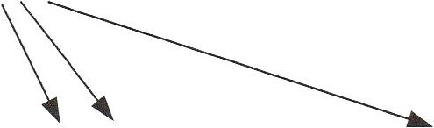
Idea forming and Product prototype Product Mass production
project selection and testing design Try-run and launch

Technology feasibility
Figure 8.1 The funnel model of the NPD process Source: Berenson et al. (2002)

A stage-gate process (see Figure 8.2) is a conceptual and operational road map for moving a new product project from idea to launch — a blueprint for managing the new-product process to improve effectiveness and efficiency. Stage-gate approaches break the innovation process into a predetermined set of stages, with each one consisting of a set of prescribed, cross-functional and parallel activities. The entrance to each stage is a gate, which serves as the quality control and Go/Kill checkpoint in the process. Drilling down into the details of each stage reveals a much more sophisticated set of activities.

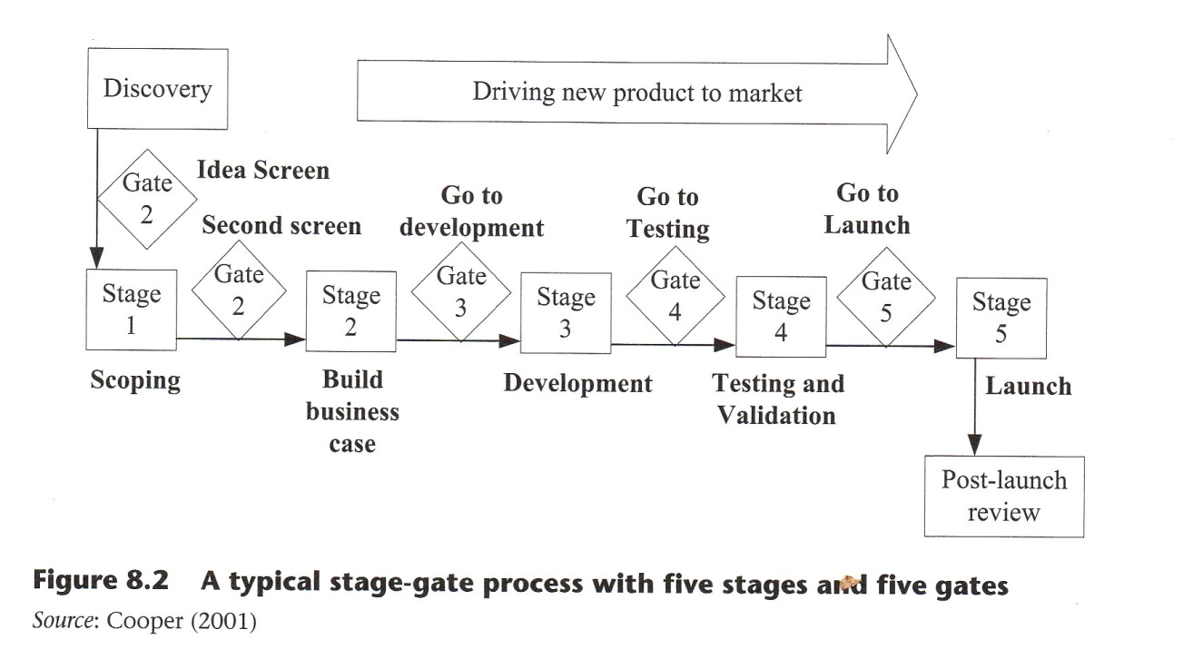
SGS has evolved into a third generation due to Cooper's (1994) work, which was characterized by four Fs:
- fluid: be fluid and adaptable;
- fuzzy: incorporate fuzzy gates that are situational and conditional;
- focus: provide for a much sharper focus of resources and management of the portfolio of projects;
- flexibility: be more flexible than today's process.
A more important characteristic in new green products development based on SGS is to include environmental evaluation as a critical factor at the checkpoint. If the project cannot reach the target, the project team should check and modify accordingly.
8.1.2 THE ORGANIZATION OF NPD
The organization of NPD is a critical part of the process. Here we report some leading authors whose work focuses on this topic.
Teece (1997) claims that only companies that have the capability of rapid product innovation and coordinating and deploying internal and external resources can succeed in the global competitive environment. In his view, companies should adapt, integrate and restructure both internal and external resources and capabilities to conform to rapid environmental changes through the dynamic organization's ability.
Harryson (1998) presents the process of innovation as not only 'seeking for know-how', but also 'seeking for know-who'. The latter capability is more important. If a company wants to remain competitive with a quick response capability, it should pay more attention to learning through cooperation relationships, both internal and external. In other words, a company can accelerate the process of transferring knowledge to new products through internal and external networks. 'Internal network' refers to the whole process of innovation: research, development, procurement, production and marketing activities. 'External network' refers to connecting processes between the companies and their outside technological sources.
Chiesa and Manzini (1998) divide the external technology acquisition organization into nine types based on the integration level of the organization and the interrelationships between the main bodies in the collaborative organizations.
- Technology merger and acquisition. A company acquires other companies' technology by merging with or acquiring them.
- Joint ventures or research corporation. Two or more companies combine their resources, experts and competences to build a new research and development corporation. Each company shares cost and profit based on its own amount of investment stock.
- Minority equity investment. For example, several companies hold stocks in each other; a large enterprise invests in a small enterprise. If the investment has a visible purpose related to technology acquisition, it can be regarded as technology collaboration.
- R&D consortia. R&D consortia consist of different enterprises, universities and research institutions, in addition the government integrates the basic research, applied research and technology development. It aims to retain the leadership of the participators or make the participators close to or exceeding their international competitors.
- Joint R&D. Among enterprises or between enterprises, universities and research institutions make up joint R&D organizations to share technology resources and mutually undertake R&D projects to acquire specific technologies. This type of set-up is typical in Japan. Japanese academies receive R&D employees and expenditure from Japanese enterprises. Academic researchers and R&D employees then cooperate in the same research project equally to promote the creation of outstanding R&D outcomes.
- Networks. In this type, several enterprises are united to build a relationship of loose cooperation. Technical knowledge and information are shared and disseminated freely.
- Outsourcing, R&D contract. In this type, large enterprises usually sign contracts with small enterprises or universities and research institutions. The organization is funded by large enterprises and the task accomplished by small enterprises.
- Technology exchange agreements, including technology sharing agreements and cross-licensing.
- Licensing. In this type, enterprises, universities or research institutions that possess a specific technology carry out technology cooperation or transferring through granting of patents and license issuance to other companies.

8.1.3 GREEN PRODUCT DEVELOPMENT
Companies are constantly trying to find innovative solutions to pressures of all sorts — from competitors, customers and regulators. Environmental standards require innovations of product design that can have an impact on product value and product cost.
Environmentally sound technology
In order to seek human sustainable development, the guideline for sustainable development, Agenda 21, was assigned by governments on the United Nations Conference on Environment and Development, which was held in Rio de Janeiro in 1992. In Agenda 21 (UNCED, 1993), environmentally sound technologies (ESTs) were defined as those technologies which protect the environment by being less polluting, recycling more waste and disposing of waste in a more sustainable manner than the technologies they replace. ESTs are the total systems, which include know-how, procedures, goods and services, equipment and organizational and managerial procedures.
According to the evolution level of EST and the matching difficulties with environment, Faming et al. (1997) divided EST into three levels:
- end of the pipe;
- cleaner process;
- green product.
`End of the pipe' means eliminating pollution from the production process in the final link with environment. 'Cleaner process' claims rational use of resources and reducing pollution in production process. 'Green products' refers to saving energy and preventing pollution during the entire process of design, R&D, production and distribution.
Moreover, with the promulgation of the EuP Directive by the EU,' the treatment and recycling problems of scrapped products have been highlighted. Therefore, Chen (2007) integrated green packaging and green recycling into the concept of green products.
Green products are the highest evolution level of green technology. EST should be used in the entire new product development process in order to save resources and reduce environmental pollution.
Four factors promoting the development of green products
Obviously, new energy saving and environmentally friendly products are significantly beneficial to human sustainable development. The issue concerns how to configure enterprises, whose main goal is to maximize profits, designing and producing new green products.
There are four major aspects that affect the green products development in enterprises. There are two main stakeholders (the government and the customers) pulling the new green product development and two main internal factors (cost and technology) getting benefits from it.
1 Directive 2005/32/EC on the eco-design of Energy-using Products (EuP).
- From the government viewpoint (both domestic and foreign). Governments are supervisors of environmental damage's actions. They are also advocates of sustainable development. On the one hand, all countries gradually strengthen the administration of environmental protection. Most countries have already set down a series of laws and regulations on environmental protection. For example, if a company does not comply with the domestic government's laws about clean production and pollution emission, it will be closed by the government. According to Restriction of Hazardous Substances program (RoHS) launched by the UN, if the hazardous substances in products exceed the standards, the products are forbidden to enter or be sold in areas regulated by the UN. On the other hand, governments also offer various preferential policies to encourage enterprises to develop green products, such as preferential loans, import and export tax rebates and so on (Bras, 1997).
- From the customer's viewpoint. The growth of green consumption need has become one of the direct impetuses for green technology innovation in enterprises. The market demand brings more added values to energy saving and environmentally friendly products. Surveys by the EU in 1992 showed that 60-80 per cent of consumers tend to purchase green products and were willing to bear the added costs of green product innovation. Developing environmentally sound products conforms to the consumption trend, but also indicates that corporate social responsibility is seriously considered within the company. As a result, the company establishes a good image, strengthens its reputation and enhances the product's market share.
- From the cost viewpoint. By developing energy saving products, enterprises can enhance production processes efficiency (using less raw material, energy and other resources), reducing the cost of products as a consequence. Therefore, an enterprise can gain competitive power in the international market competition.
- From the aspect of technology. ESTs are the fruits of human wisdom and often associated with technology innovation. An enterprise can set down technical barriers and obstacles against competitors by patent, or it can choose to alienate the technology to gain profits (Hu, 2006).
In sum, new energy-saving and environmentally friendly products mean huge business opportunities for companies.

8.2 The Case Study
Innovation ability is a company’s vitality.

Hua Xiao, President of Monalisa Ceramic (Group) Co. Ltd of Guangdong

8.2.1 COMPANY PROFILE

Monalisa Ceramics (Group) Co. Ltd of Guangdong is a large-scale ceramic manufacturer that integrates scientiﬁc research and development with professional production and marketing; Monalisa is one of the few key high-tech enterprises of the national Torch Program within China’s building ceramics industry. The headquarters of the Group are located in Foshan, the ceramics center of southern China.

The history

Monalisa, formerly QiaoDong Ceramics Co. Ltd, was established in March 1992, its ﬁrst batch of ceramic products launched in September of that year. The company started with three production lines, a spray tower, three kilns and three presses. The average length of the production line was about 120 meters with a productive capacity of 2,500 square meters for each line. The main product was colourful glazed tile with a red kernel made of laterite and an initial dimension of 300 >< 300 mm. At that time, China's building ceramic industry was new with few manufacturers and demand outstripped supply. As a result Monalisa gained rapidly a solid market share. Fortunately, the ﬁrst-year revenue covered the initial investment.
QiaoDong Ceramics Co. Ltd successfully transformed from collective ownership to a private enterprise in 1998, taking its current name, Monalisa Ceramics Co. Ltd. i
The company was one of the ﬁrst building ceramic manufacturers to go abroad, giving its salesmen the opportunity to participate in the China Import and Export Fair (Canton Fair) in early April 2000, taking its ﬁrst and important step into the international market. The Foshan Monalisa Industrial Co. Ltd was founded after this with the aim of providing specialized export services to better exploit the international market.
In order to increase production capacity, the company invested in the creation of the Monalisa Qingyuan production site, which became later in March 2004 Monalisa Ceramics Co Ltd of Qingyuan Guangdong. The area was 120,000 square metres wide and was expected to hold from 20 to 25 production lines requiring a 500~700 million Chinese yuan (CNY) investment. It is now one of the most highly productive bases for the production of wall bricks and ground tiles in the world. Starting from three production lines, the Qingyuan site has grown to ﬁve lines being able to manufacture from 48,000,000 to 60,000,000 square meters of wall tiles and ground tiles per day.
Today, with a capitalization of 28.87 million CNY, Monalisa Ceramics Group owns two modern production sites in Foshan and Qingyuan, holding three exclusively invested subsidiary companies, Monalisa Ceramics Co. Ltd. of Guangdong, Foshan Monalisa Industrial Co. Ltd. and Monalisa Ceramic Co. Ltd of Qingyuan Guangdong. The site has an area of 230,000 square meters, 22 production lines, approximately 3,000 employees, and average daily yield of 1 10,000 square meters. In 2007 Monalisa sold almost 1.2 billion CNY worth of products, of which exports accounted for almost 300 million CNY.

Global marketing networks

Monalisa’s global marketing network covers 78 countries and regions and the company’s wall and ground tiles have been sold all over the world. Seventy per cent of exported products are sold under the Monalisa own brand, while the other 30 per cent is supplied to OEM.
The Monalisa trademark has been registered in the sixth, ninth and twentieth categories of the Madrid system. The trademark is now protected in more than 50 countries including Italy and France. The brand strategy and registrations lay the solid foundation of the internationalization of the Monalisa brand. At present, its brand value has risen to 1.68 billion CNY.
Monalisa brand products belong to four different categories: polished tile series, renaissance series, glazed tile series and dry ﬁxing exterior wall series. The company continues with new product innovation and regularly launches distinguished new products.
In 2006, the ﬁrst piece of the large-scale Laminatic Porcelain Panel (PP) was developed, with a size of 800 >< 1800 >< 3 mm. The green products in Monalisa’s catalogue demonstrate that the company's NPD strategy has considered the environmental protection trend and policy. In 2009, Monalisa brand tiles were included in ‘the ﬁrst environmental procurement list of the Chinese Government’.

8.2.2 BUILDING CERAMIC INDUSTRY BACKGROUND
The trend of energy saving and environmental protection One notable characteristic of the building ceramics industry is high energy consumption and high pollution. Figuline and fuel, which are critical materials for this industry, are non- renewable resources. Moreover, the waste water, exhaust gas, dust, all kinds of cast-offs, noise and heat pollution which are produced in the manufacturing process are harmful to our environment. The quantity of exhaust emission from building ceramic industry ranks number one in all industries and accounts for 50 per cent of total exhaust emission. The quantity of exhaust emission of sulphur dioxide ranks second in all industries and accounts for 25 per cent of total sulphur dioxide emission. The quantity of industrial dust from building ceramic industry ranks number one and accounts for 99 per cent.
In China, the building ceramic industry has developed rapidly due to its entering into the commodity economy era. In recent years, the problems of environmental pollution and resources wastes have received growing attention.
The Chinese Government decided to change its economic growth direction from an industrialization characterized by high energy consumption, pollution and emissions to a new road to industrialization, aware of the necessity to reduce these elements. As a high consumption and pollution industry, the building ceramic industry immediately enters into the government’s environmental agenda. The Chinese Government disclosed the Eleventh Five-Year Plan for Economic and Social Development in April 2007 and deﬁnitely conﬁrmed the targets for energy savings for the next ﬁve years (setting up a reduction goal of 4.4 per cent), in part through the development of alternative and renewable energy's sources, and for environment’s safeguard. In response to this policy, the Chinese building ceramic industry will release a key indicator, called ‘the units’ energy consumption quota in building ceramic’, allowing for the regulation and monitoring of the energy consumption within the industry. The Chinese Government wants to enhance the ability of manufacturers’ decreasing energy consumption by enhancing the entry barriers in building ceramic industry. Moreover, the Chinese Government has lowered the export rebate rate from the old 13 per cent to the current 5 per cent since 2006.
As to the international market for building ceramic products, the European Economic and Monetary Union have set up a strict standard to limit the content and emission of hazardous ingredients in the materials and products, and have also asked for cleaner manufacturing processes as far as energy consumption, usage of natural resources and the disposal of waste materials are concerned.

Homogenization and low cost
Ceramics are one of the main symbols of Chinese civilization. In recent years, with the development of the building ceramic industry, both the number of manufacturers and the annual yield ranked number one 1 in the world. At present, the annual output of the Chinese building ceramics industry is more than 2.5 billion square metres. The entry barriers to the ceramic industry are relatively low. As a result, many manufacturers joined the business in the past 15 years. In Foshan alone there are nearly 400 manufacturers and 1000 brands. In China, these number rise to over 3000 manufacturers and 6000 brands. However, it is regretful that the average of a single brand's yearly revenue does not exceed 2 billion CNY.
At present, the Chinese manufacturers in building ceramics mainly manufacture and sell to international markets products of medium- and low-level range. They can only rely on the low-cost advantage to enter into and expand their overseas market. However, this doesn’t mean these products are of low quality. In fact, the technology of Chinese building ceramic products has been developed in recent years and has gradually caught up with large-scale international enterprise’s manufacturing level. In addition, more and more famous overseas enterprises come to China and ask Chinese enterprises to manufacture products with their brand (OEM cooperation model). This cooperation model is very popular in today's building ceramics industry.
The main problem for Chinese manufacturers in the building ceramics industry, which prevents the products reaching the top range, is homogenization of products. There are many companies that produce products with little or no differentiation on the same market, and competition is frercer, which results in lower prices and poorer proﬁtability. The wall tiles and ground tiles are mainly used for decoration, and so innovation in tiles is traditionally focused on colour, patterns and appearance. The appearance is easy to copy because there are no technology barriers. Sometimes a product with a new pattern is launched and immediately gains the customer's interest. Unfortunately, many copies appear on the market just the next day. The feeling of novelty disappears immediately and the only strategy that manufacturers can choose is low cost, but the small proﬁt achieved can not support a long-term brand development.
On the other hand, the sources of raw material, ﬁguline for ceramic products in Foshan and surroundings, have been greatly depleted after many years of exploitation. Foshan ceramic manufacturers need to procure raw materials from more distant areas, even outside of Guangdong province, thus increasing costs. Moreover, manufacturing ceramic products requires fuel, whose cost accounts for about 30 per cent of the total manufacturing cost. In the last two years, the fuel price has increased by 40 per cent and strongly affects the building ceramic industry. At the same time, and as a consequence of petroleum price increases, prices of chemical materials, glaze colour and packaging material, together with logistic fees, continue to rise. In addition, labour cost also increases due to the shortage of skilled employees. All of these factors gradually decrease the low- cost advantage of China's building ceramic manufacturers in the international market.
In its participation in the international market competition the Chinese building ceramic industry also faces many disadvantages, such as anti-dumping measures, appreciation of the CNY and so on. The old low-cost manufacturing strategy, with no product differentiation and mass production, can not sustain any more companies long- term development.

8.2.3 THE ORGANIZATION OF NPD
Monalisa focuses on cultivating its own expertise and skills in NPD but still values cooperation with the external technology network.

Internal organization
Since its foundation, the company's management board has devoted considerable attention to NPD, encouraging innovation during the process. In 1999, Monalisa invested about 15 million CNY to set up a research and development (RSID) center, the ﬁrst in the industry to be equipped with a special spray tower. Specialized personnel worked only on technology innovation taking responsibility for NPD as researchers and developers. Subsequently the management board separated the R&D center from the manufacture technology department: the R&D center focused on the development of Monalisa’s main products, and the technical department took responsibility for extended products — those products based on main items that have already been mass produced.
Main products are entirely new products and are obviously different from those previously manufactured. They might for example introduce new materials, utilize more advanced manufacturing technology or improve current equipment. Development of these products usually needs more resources and always poses more technological difﬁculties. Extended products are series products based on main products which have been mass produced before. They are similar to main products but will usually have small changes or improvements, such as colour, size and so on. Development of extended products usually requires less resources and technological innovation.
The company chose this organizational structure for R&D, based on the distinction between main and extended products, in order to improve development efﬁciency.
The unit responsible for main products is organized as a matrix structure, with several projects being addressed at the same time; an R&D engineer is assigned to each of them, taking the role of project leader, together with other members coming from various departments and functions according to the characteristics of the products and the expertise required. The project leader is responsible both for the technological matters and for project management activities such as planning, monitoring and controlling the overall development processes and coordinating all team members. Marketing personnel are responsible for collecting and arranging the information related to the products, they also set up market surveys. If the development involves new materials and equipment, the procurement function is involved in the team in order to seek more proficient suppliers. Manufacturing engineers need to deal with the NPD process too; in particular they provide suggestions on the design for manufacturability (DFM). The early participation of manufacturing engineers helps to transfer the development process from the design stage to mass production smoothly and rapidly.
Extended products only have few differences from current products and require only minimal technical support, so few departments need to be involved. The biggest change affects the manufacturing process: however, sometimes a single manufacturing engineer can complete the work and this individual will be tasked with development of the extended product. If necessary, other functional departments can be asked for the assignment of additional resources.
The company places a high value on technical talent. Through intensifying internal training and introducing external talent, the company has 19 advanced technical staff and 78 middle rank technical staff.

External network
In addition to depending on internal technical resources, the company actively searches for external resources to co-work with in order to gain more technology innovation.
In order to increase research resources and ensure the smooth transfer of research ﬁndings into real products, the company signs cooperating protocols with many universities, including Wuhan University of Technology, Jindezhen College, Shanxi University of Technology and South China University of Technology. The company also collaborates with many famous international ﬁrms in the building ceramic industry, such as Ferro (USA), System (Italy), Salquisa (Spain) and Mark (Germany). It also has alliances with equipment suppliers to co-develop new products and apply patents as technology barriers.
More importantly, the company's technology innovation receives considerable support from the Chinese Government; Monalisa’s R&D center qualiﬁed as the Guangdong province enterprise technology center. In 2003, the company was qualiﬁed by the Ministry of Science and Technology of the People's Republic of China as one of the key high-tech enterprises in the Chinese Torch Plan, a unique position in the ceramics industry. It also qualiﬁed as one of Guangdong high-tech enterprises by the Guangdong Science and Technology department. Moreover, it is qualiﬁed to be charged with the national ‘Eleven ﬁve’ scientiﬁc and technological project.
Based on its strong internal and external resources, the R&D center develops at least one or two main products at a time. Sixteen pieces of research ﬁndings have passed the evaluation and certiﬁcation from Guangdong province or all of China. At present, Monalisa Group owns three patents for invention, 8 patents for utility models and 366 design patents.

8.2.4 THE DEVELOPMENT OF ONE PRODUCT - THE LAMINATIC PORCELAIN PANEL (PP)

Idea creation
When developing a new product, manufacturers in the building ceramic industry tend to focus on colours, pattern, size or materials and so on. The Monalisa management board does not wish to imitate its competitors, and has set a goal for the development of different products from competitors. The requirements state that the product can be launched in both international and domestic markets and should have a technology advantage so that the competitors can not copy it easily and quickly. The new product is also required to become a source of future products by being the basis of the future products series.
Having analyzed the industry background and trends, researchers started to focus on ideas of energy saving and environmental protection as means of differentiation from competitors. The question was how to transfer the idea to real products? Researchers realized that one of the trends of company's NPD, which is designing products for making processes smaller, leaner and more integrated, is positively related to the concept of environmental protection. The aim of this type of design is to lower the cost, reduce power consumption, decrease the dimensions and improve handling features.
Today ceramic products tend to be bigger and thicker. The biggest polished tile is 1,800 mm long, 1,200 mm wide with a thickness of 20 mm. If the thickness of the tiles could be reduced from 20 mm to 6 mm, there would be a cost saving of 40 per cent on raw materials and energy consumption. Moreover, it would reduce the scraps generated from cutting the bigger tiles to required dimension and lower transportation fees. Excessive resource consumption and environmental damage in the building ceramics industry mean that the design of bigger and thicker tiles clearly does not sit well with the international trend of sustainable development.
If the product is solid enough, redundant thickness means waste. So why not to decrease the thickness of the tiles?

The development process of PP
Figure 8.3 is the standard ﬂow chart in main products development and shows the development process of PP.

Feasibility evaluation
At the beginning of 2006, the company decided to developing the thinner tiles and evaluated project feasibility by collecting information regarding market needs, technology veriﬁcation and so on. After this evaluation, the management board approved development of the thinner tiles and the new product was called the Laminatic Porcelain Panel (PP).
The feasibility evaluation operated from four different perspectives: technology, finance, market and environment.

- Regarding technology, Monalisa's R&D center has accumulated a great deal of experience in making tiles in its seven years of operation. The crystals of ceramic tiles are mostly comprised of quartz, porzite, amorphous compound and glass phase. Researchers found that the thinner tiles could be as strong as the thicker ones and meet the requirement of standards by decreasing the proportion of amorphous compound and glass phase and increasing the proportion of porzite. The researchers worked in alliance with Keda Industrial Co. Ltd, a professional equipment provider of building ceramics products, to produce the special equipment necessary to produce PP.
- The total budget for the development of PP was 20 million CNY: the expected investment return period is 4.1 years and the break-even point is 60 per cent. The project passed its ﬁnance feasibility evaluation.

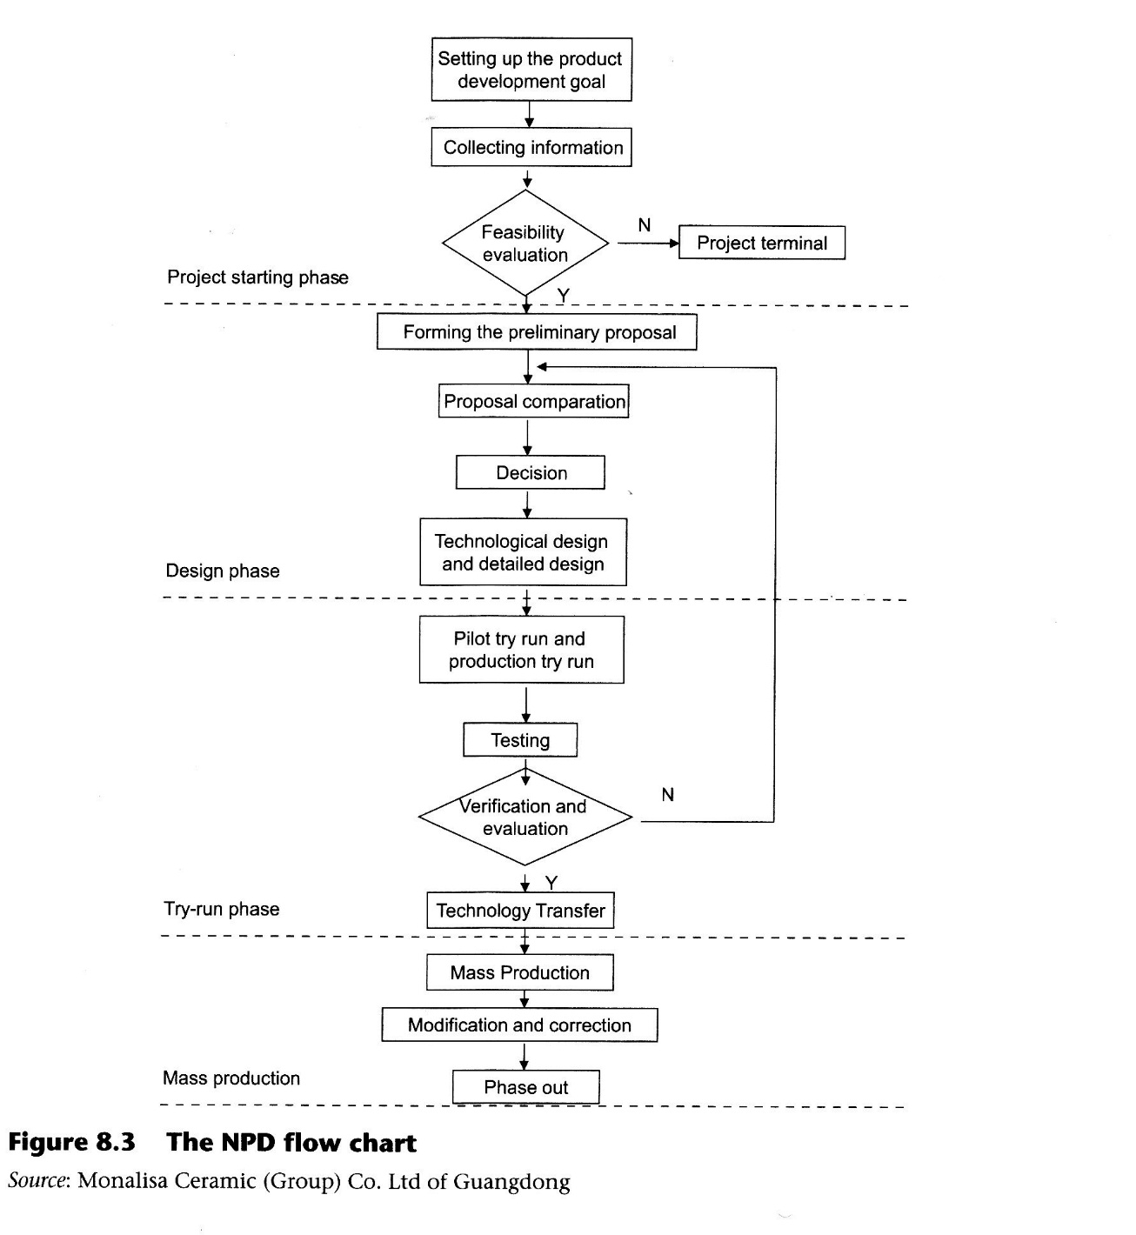
- Market investigation showed that products with more added values using limited resources, but still able to meet the customers requirement, are a potential market demand.
- Regarding environmental protection, the new product has the following advantages: the capacity for saving a non-renewable resource like ﬁguline; easier manufacturability, affecting the kilns process stage so that it will save fuel; reduction of the production of waste water; exhaust gas and waste residue; less weight which will reduce logistics fees; and ﬁnally, the thinner ceramic tile is easier to stick to other materials such as heat insulation material, which extends its application ﬁeld.
- The formal project mission of developing PP for the Monalisa group was given in August 2006. The project was asked to decrease the thickness of tiles by one-third ~one-half: the tile should meet all of the standards of the industry, especially in terms of environmental protection. In addition, the manufacturing technology and installation method of the new product should not be complicated. The management board appointed manager Liu as a project leader. The project leader assigned the team members including salesmen/saleswomen, R&D personnel, manufacturing engineers, equipment engineer, procurement, ﬁnancial accountant and so on. The project to develop large-scale PP manufacture had begun.

Design scheme
After the pre-test and feasibility evaluation, the project team collected all feasible schemes, and following ﬁltering and veriﬁcation. They conﬁrmed the scheme:

- First, utilize the new formula and select special raw materials to be the compound, which can generate porzites in PP twice in the ﬁring stage and enhance the PP’s performance.
- Second, ball milling.
- Third, spray drying.
- Fourth, utilize an innovative large-scale press moulding machine with double piston and print system to press the dry compound to the ﬁxed form.
- Fifth, ﬁring at 1200°C will produce a kind of large-scale PP with low water absorption.

As to the product's diversity, PP’s surface can be ﬁne polished like a mirror or coarsely polished to a matt ﬁnish; it can be printed with all kinds of colours or pictures and cut into all kinds of dimensions. All of these can meet the customizing need.
In December 2006, the pilot trial run of PP with the scale of 800 >< 1600 >< (3.5~6) mm was completed successfully and the production trial run was successfully performed for 20 days. All these successful trial runs laid the foundation for the mass production of PP. In January 2007, the project team set up the technology speciﬁcation of PP including terms, deﬁnition, category, technological requirements, testing method, inspection rule, logo, construction and installation method, packaging speciﬁcation, transportation requirement and storage requirement.

Effect evaluation on energy saving and environment protection
After test and evaluation, PP’s performance on energy saving and environmental protection is satisfactory and better than the traditional titles’ performance. In fact, compared to the traditional titles PP:

- saves 66.7 kg raw material per square meter (75 per cent)
- saves 1 12.86 kg clean water per square meter (63.2 per cent)
- saves 1.23 KWh electrical power per square meter (26.57 per cent)
- uses clean liqueﬁed petroleum gas rather than diesel oil. The integrated energy consumption was then lowered to 4.3 kg standard coal per square meter (84.3 per cent)
- decreases waste water consumption to 1 10.4 kg per square meter (63.3 per cent)
- decreases waste residue to 4.77 kg per square meter (91.7 per cent)
- decrease of 2,460 tons carbon, 9,000 tons CO2, 60 tons SO2, 57.6 tons NOX and 33.6 tons of dust
- each vehicle can transport 4,307 square meters; consequently the usage rate of the vehicle increases to 76 per cent.

External technology cooperation and intellectual property rights

The development of PP involved the introduction of new dry and ﬁring equipment. The project team contacted equipment providers at an early stage and selected Keda Industrial Co. Ltd as a partner. Two companies signed an agreement to develop dry and thermal equipment especially for the production of PP. The patent for the thermal equipment belongs to Keda Industrial Co. Ltd. but the company can not sell the special equipment to other clients for two years.
PP is very thin and can not be installed using the traditional method with cement. In order to solve this problem and provide full support to customers for installation, the project team co-worked with Laticrete International, Inc. After many experiments and testing, the project team conﬁrmed the exclusive use of bonding admix and the special thinner installation process. The bond admix is green and helps to reduce installation thickness even more.
In March 2007, Monalisa Company submitted the patent of PP's formula to the State Intellectual Property Ofﬁce of the People’s Republic of China (SIPO): it was authorized on the 10th October 2007. The patent number is CN 101050107 A.
Keda Industrial Co. Ltd submitted the patent of PP's production technology to SIPO and it was authorized on the 13th February 2008. The patent number is CN 101122168 A.
Samples of PP have been put on the market and gained good feedback from the international customers: the product is particularly strong in the overseas market. Interest from dealers suggests the material has bright prospects.

Conclusion
Along with the improvement of policies and regulations on environmental protection in all countries, increased customer awareness of issues surrounding green consumption, the growing cost pressure, developing energy saving and environmentally friendly products have all affected NPD. In order to transfer a good product idea to a popular product that can be launched internationally, we still need to follow a well-planned and controllable process and integrate internal and external development resources. This case illustrates how Monalisa successfully developed a green product - the laminatic porcelain panel.

LESSON LEARNED
Cost savings with green strategy Implementing green strategy standards can not only increase the product value (connecting the brand to the idea of ecology) but also reduce product and process costs (redesigning the product).

QUESTIONS FOR STUDENTS
- Which factors contributed to the success of NPD in Monalisa?
- What are the possible organizational structures of an NPD function? Which of them does Monalisa utilize?
- Which are the reasons behind the development of PP? Why did Monalisa choose PP as the development goal?
- How was the funnel model of the NPD process applied in PP’s development?
- What benefits can a company obtain from new green products development?

OPEN DISCUSSION
- Set up a NPD strategy for Monalisa providing explanations for your choices.
- After two years, the technology agreement of Keda and Monalisa will have expired. This means Keda can sell the special equipment to other ceramic manufacturers, who will soon be able to produce similar products. How should Monalisa handle the situation?

References

Berenson, C., lansiti, M., Kosnik, T.]., Rangan, V.K., Thomke, S., Lynn, G.S., Mohr-Jackson, l., Tabrizi, B., Walleigh, R., Wheelwright, S.C. and MacCormack, A. (2002). New Product Development, Business Fundamentals Series, 2nd Edn. Boston, MA: Harvard Business Publishing.
Bras, B. (1997). Incorporating environmental issues in product design and realization. Industry and Environment, 2O(1-2), 5-13.
Chen, Q. (2007). EU’s EuP directive and trends in China's development of green manufacturing technology. Light Industry Machinery, 4, 1-5.
Chiesa, V. and Manzini, R. (1998). Organizing for technological collaborations: a managerial perspective. R&D Management, 28(1), 199-212. Cooper, R.G. (1994). Perspective: third-generation new product processes. Iournal of Product Innovation Management, 11(1), 3-14.
Cooper, R.G. (1998). The new product process: a decision guide for managers. journal of Marketing Management, 3(3), 238-255.
Cooper, R.G. (1999). The invisible success factors in product innovation. Iournal 0fPr0duct Innovation Management, 16(2), 115-133.
Cooper, R.G. (2001). Winning at New Products: Accelerating the Process from Idea to Launch, 3rd Edn. New York: Perseus Publishing.
Cooper, R.G. and Kleinschmidt, EJ. (1995). Benchmarking the f1rm's critical success factors in new product success. Iournal of Product Innovation Management, 12, 374-391.
Faming, Y., Qingrui, X. and Yan, L. (1997). Research on functional sources of green technology innovation. Science Research Management, 18(3), 56-61.
Griffin, A. (1997). PDMA research on new product development practices: updating trends and benchmarking practices. Journal of Product Innovation Management, 14, 429-458.
Harryson, S. (1998). Japanese Technology and Innovation Management: From Know-how to Know-who. Cheltenham: Edward Elgar Publishing Limited.
Kusz, J. (1991). Integrating environmental goals and the product development process. In Proceedings of The Design Actions and Resources for the Environment Conference, Boston, MA, 8-1 1 December.
Teece, A. (2003). Expert talent and the design of (professional services) ﬁrms. Industrial and Corporate Change, 12(4), 895—916.
Teece, D.]. (1997). Dynamic capabilities and strategic management. Iournal of Strategic Management, 18(7), 509-534.
Ulrich, K.T. and Eppinger, S.D. (Z003). Product Design and Development. New York: McGrawHill/Irwin series in marketing.
UNCED (1993). United Nations Conference on Environment and Development, http://www/ un.org/esa/dsd/agenda21.
Veryzer, R.W. (1998). Discontinuous innovation and the new product development process. lournal of Product Innovation Management, 15(4), 304-321.

The Madrid system for the international registration of marks established in 1891 functions under the Madrid Agreement (1891), and the Madrid Protocol (1989). It is administered by the International Bureau of WIPO located in Geneva, Switzerland. Thanks to the international procedural mechanism, the Madrid system offers a trademark owner the possibility of having his trademark protected in several countries by simply ﬁlling one application directly with his own national or regional trademark ofﬁce (www.wipo.int/madrid).

